


Exor Corporation Limited
The Global Leader in
Infrastructure Asset Management
Network Manager
User v4.5

This page intentionally blank

Quality Assurance Statement

Document Details
File:  Network Manager User v4.5.doc | Prepared by:  T.C. Stewart
Manual Name:  Network Manager User Guide | Reviewed by:
Version:  1.0 | Approved for issue by:  L.Darke
Date of Issue:  Feb 2007 | Product Manager:  T.C. Stewart
File Name:
Document Centre/Exor/Product Manuals/4.5.0.0 Product Manuals/4.5.0.0 completed documentation/Network Manager User v4.5.doc

Document Version Control
Revision | Date | By | Chapter / Page | Description
2 | May2011 | IS | None | No Changes for 4.4
3 | Nov 2011 | IS | None | No changes for v4.5

CONTENTS

Quality Assurance Statement i
Location Referencing 2
Nodes - NM0101 8
Nodes 8
Elements - NM0105 10
Elements 11
Attributes 14
Additional Data 15
Network Element Functions 16
Network Element Membership 16
Extend Route at Start 18
Extend Route at End 19
Groups of Sections – NM0110 20
Group Panel 21
Members Panel 23
Node Details 27
Attributes Panel 28
Additional Data 29
Toolbar 30
Rescale 30
Resequence 32
Local Rescale 32
Add Distance Break 33
Elements 33
Close 34
Route Check 35
Route Details 35
Create Node 36
Resize Route 37
Distance Breaks 41
Partial Groups 44
Groups of Groups – NM0115 45
Group Panel 46
Show/Hide Hierarchy 48
Sub Groups 49
Attributes Panel 50
Additional Data 51
Closing a Group of Groups 52
Network Selection - NET1119 58
Network Selection 58
Selection Criteria 59
Criteria Window 60
Road Network Criteria 60
Features/Survey Criteria 62
Defect Criteria 63
Enquiry Criteria 64
Selected Sections 65
Gazetteer – NM1100 68
Standard Gazetteer 68
Advanced Gazetteer 70
Groups 72
Restrict / Filter 73
Extents 75
Filter 76
Filtering a Route between specified Start and End Offsets 77
Extent Limits 79
Sub Class 80
Restrict to Exclusive 80
Ambiguous References 81
Point Items Filter 83
Filtering a Route by an Asset / Network Attribute Query 84
Example 1 - Filtering on Network Attributes 85
Example 2 - Filtering on Single Asset Type 85
Example 3 - Filtering on Multiple Asset Types 86
Item Types Panel 87
Attributes Panel 88
Values Panel 89
Create a Saved Extent from a Gazetteer Filter 90
Create a PBI Query from a Gazetteer Filter 91
Restrictions 92
Group/Network Type Membership 93
Drilling through the Group Hierarchy 94
Network Hierarchy Browser 95
Network Element Membership 98
Element Details 99
Gazetteer Toolbar 100
Setting the Default Region of Interest 101
Create Network Extent – NM0120 102
Extent Details 103
Add Elements / PBI Results 104
Extent Limits 106
Sub Class 107
Restrict to Exclusive 107
Ambiguous References 108
User Entered 110
Radio Buttons 111
Other Field Definitions 112
Datum 113
Create Group 115
Creating a Network Extent from a PBI query 117
Network Walker – NM0500 118
Intersection Details Tables 119
Walking a Network 121
SLK Calculator – NM1200 122
Offset Calculator - NM1201 123
Split Element – NM0200 125
Split Element 129
Undo Split – NM0203 134
Undo Split 135
Merge Elements – NM0201 136
Merge Elements 137
Undo Merge – NM0204 139
Undo Merge 140
Replace Element – NM0202 141
Replace Element 142
Undo Replace – NM0205 143
Undo Replace 144
Close Element – NM0206 145
Close Element 147
Undo Close – NM0207 148
Unclose Element 149
Recalibrate Element – NM2000 150
Recalibrate 151
Shift 153
Reclassify Element – NM0220 155
Change the Sub-Class of an Element 158
Change the Parent Route of an Element 159
Rename an Entire Route (within the same Group Type) 161

cHAPTER
1
Introduction

This Guide provides information on the use of Network Manager V3. It is aimed at general users. A brief introduction is provided on Location referencing for context.

Location Referencing

Location referencing is used to assign a unique address to each location on a Network. A commonly asked question is ‘where do I find it?’. For example, if you want to get a work crew to go out and repair a pavement you must tell them where to find the problem. A close second would be the question ‘where am I’. Both of these questions are addressed through location referencing.

There are two key definitions associated with locational referencing:

- The location is the point on the Network
- The address is a string of characters used in a management system which uniquely and unambiguously defines a location.

The underlying principle is that every location on a Network should have a unique address.

There are several different types of linear location referencing methods. These can be broadly defined as :

- Kilometer/Mile point (e.g., 9.29)
- Kilometer post (e.g., 9.29 Equations)
- Reference post (e.g., xx + 0.29)
- Reference point (e.g., xx+0.29)
- Link – Node (this is a special application of the reference point method. Nodes refer to specific locations on a Network; the links are unique Network segments between the Nodes. Thus, any referencing method can be applied with a Link-Node system, such as Exor.

In general, all methods have the following components:

- Identification of a known point (e.g. kilometer/Mile post)
- Direction
- Distance measurement (i.e. a displacement or offset)

Another fundamental principle of location referencing is that one location on a network can be described in potentially many ways. Common terms for the way in which a location may be described are (Linear Referencing) Methods (LRM’s) and/or Addresses. Figure 1 shows that the same location could be described by five different LRM’s or addresses – all of which describe the same location.

Figure 1
Locational Addressing
0.9 Km
1.0 Km
Reference Post
0
500
1
2

0.5 Km
0.4 Km

Sign
Id - SG1

Location

The location marked by the could the following descriptions

Km point: 1.3
Ref post: 1 + 0.4
Ref post: 2 – 0.6
Ref point: SG1 + 0.8

This page Intentionally Blank

cHAPTER
2
Network Manager Components

3 basic objects define a simple Network Structure within Network Manager. These are:

- Datum Network Elements
- Assets/Asset Items or ‘events’
- Locations

Figure 2 shows the relationship between these objects.

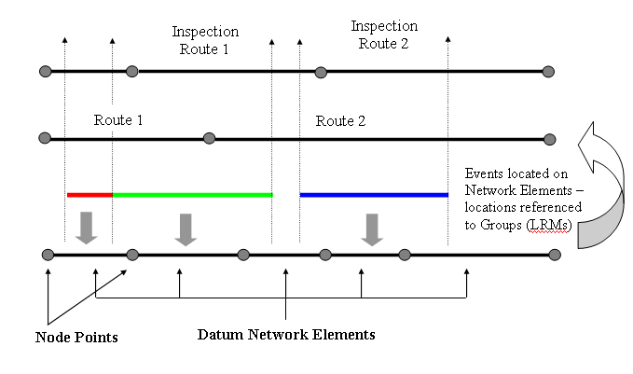
Figure 2

The underpinning concept of Network Manager by Exor’s Multiple Linear Referencing capability is the Linear Datum Network Element. This provides the required Direction and Connectivity information that Network Manager by Exor needs to derive each of the required Linear Referencing Methods that can be assigned as views or layers on this Datum. Datum Network Elements are located between Node Points that are known locations on a Network. These are typically (but not necessarily) at Intersections or Junctions. Node Points may also be required at ‘notional’ boundaries, e.g., maintenance or regional boundaries, depending on how security and Network maintenance activities are to be administered.

Sets of Datum Network Elements may be ‘Grouped’ together to form a linear referencing method. These sets of Elements or Groups will have a ‘Cardinal’ Direction. This ensures that the Datum Network Elements that form a linear referencing method or Group, need not be configured in the same direction. The Cardinal direction of a Group is deemed to be that of increasing measure, the Datum

Elements linear reference direction is deemed to be from Start to End Node and this may be a reversal of the Group direction. These Groups may contain Elements that are ‘wholly’ contained within the linear extent of the Group or a mixture of Elements that are ‘wholly’ or partially contained within the linear extent of the Group.

An Asset Item or other Events location is held against the Datum Network Elements. (It is also possible that an event will have no location, i.e., it is not ‘pinned’ to any Network). The location of an Asset Item or Event may consist of one or more Elements or partial Elements allowing a single Asset Item to span multiple Elements or Routes. Although the locations are stored in the database ‘against’ the underlying Linear Datum network Element, the User may load and view an Item or Events location relative to a Group or LRM.

cHAPTER
3
Network Management
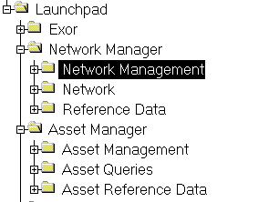
Figure 3
Network
Management Menu

This chapter describes the forms and processes that are used for managing a Network. The forms covered in this chapter are the following:

- Nodes – NM0101
- Network Elements – NM0105
- Groups of Sections – NM0110
- Groups of Groups – NM0150
- Network Selection – NET1119

The form descriptions provide you with detailed information about reference data in Network Manager by Exor, including:

- an overall description of the form.
- a detailed explanation of each field, including available features (such as List of Values, default values and other characteristics).
- helpful information for using the form

Nodes - NM0101
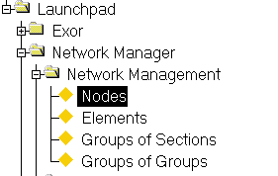
Figure 4
Nodes Menu
Option

This module is used to manage Node Points used as unique points on a Network, at which Network Elements may be connected. Each Network Element must have a defined Start and End Node as well as a measured length. Where there is connectivity between Network Elements, the End Node of one Element must be the Start Node of the next, i.e. the Node Point is shared.

Note that connectivity may be derived through the use of Distance Breaks. Distance Breaks allow ‘logical’ connectivity along a Route where points of physical discontinuity exist, for example at staggered intersections or Junctions. These Distance Breaks, although not physical objects, will also have Node Points locating their Start and End positions on a Network For more information on Distance Breaks refer to page 42.

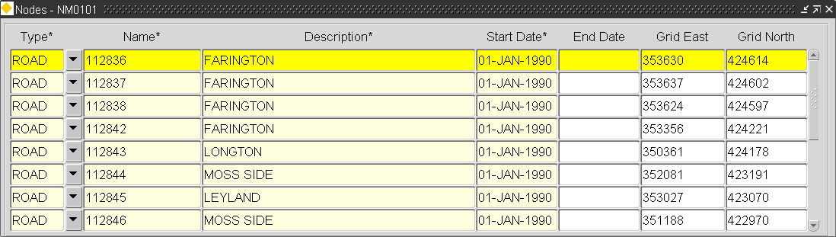
Figure 5
Nodes

Nodes
When you enter this window the cursor sits in the ‘Node Type’ field waiting for a new Node to be entered or existing Nodes to be queried back. To query back an existing Network Type press the [Enter Query] button on the menu toolbar (or press F7), enter some selection criteria, then press the [Execute Query] button (or press F8).

Node Type (Required) (List)
Enter the Type for this Node point. Node Types will have been previously defined using Node Types – NM0001 and are associated with a Network Type using Network Types - NM0002 (Refer to the Network Manager System Administration Manual for more details about Node and Network Types).

Node Name (Required)
Node names will be automatically generated from a sequence thus ensuring Uniqueness within the Node Type. These Node Names will follow the Node Format defined in Node Types - NM0001. If no Node Format has been defined for a Node of this type, it is assumed a ‘free hand’ text entry will be made.

Note that if a format has been specified for a Node Type the Node name cannot be updated.

Description (Required)
Enter a description for the Node Point. A maximum of 80 characters is allowed.

Start Date (Required)
Enter the date from which the Node Point may be used.

End Date (Required)
Enter the date to which the Node Point may be used. A Node may only be ‘Closed’ if it is not associated with any Network Elements or the Network Element is first End Dated.

Grid East (Optional)
Enter the East-West Grid Reference. If you enter the East-West Grid Reference you must also enter the North-South Reference.

Grid North (Optional)
Enter the North-South Grid Reference. If you enter the North-South Grid Reference you must also enter the East-West Reference.

Elements - NM0105
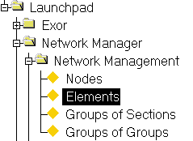
Figure 6
Elements
Menu Option

This module is used to view or maintain Datum Network Elements and/or Groups of Elements. The Form allows attributes associated with the selected Network or Group type to be maintained and also allows Additional Data to be created and maintained using the ‘Additional Data’ tab.

Note that depending on the Network Type Columns and any Type Inclusions defined for a Network Type using Network Types - NM0002, the ‘parent’ Group of which an Element is a member may have to be created prior to the creation of the first Network Element within the Group or the Auto Creation functionality utilised.

Several buttons are available on the Network Element Function toolbar to assist in the viewing and management of a Network. The Network Element Functions toolbar may be ‘toggled’ on and off by pressing the [Toolbar] button (Figure 7) on the Exor menu toolbar.
Figure 7
Toolbar button

The Elements form may be used to display Datum Network Types and their associated Attribution, but may also be used to display Non Datum Network Types, for example Network Type used for Groups. Non Datum Network Elements (i.e. Groups) may be queried by using the ‘Unique’ field to enter the selection Criteria or via the Gazetteer.

For example, to query a Route Element and view any defining Attributes press the [Enter Query] button on the menu toolbar, enter the Unique Route reference e.g. H001, then press the [Execute Query] button on the menu toolbar. To query the Route Element and all of the associated Network Elements which are members of the Route add the wildcard character ‘%’ after the Route name i.e. H001%.

Figure 8
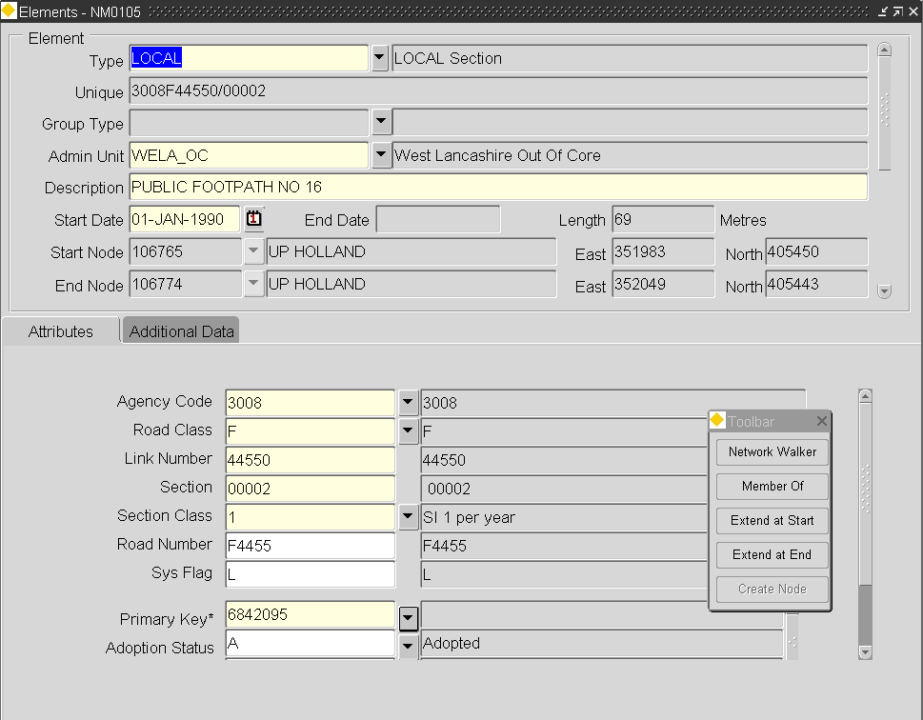
Elements

Elements
When you enter this window the cursor sits in the ‘Type’ field waiting for a new Element to be entered or existing Elements to be queried back. To query back an existing Network Element press the [Enter Query] button on the menu toolbar (or press F7), enter some selection criteria, then press the [Execute Query] button (or press F8).

Alternatively pressing the [Gazetteer] button on the menu toolbar will call the Gazetteer from where Elements, Groups or Network Extents may be queried.

For more information on using the Gazetteer and Network Extents refer to pages 72 and 108 respectively.

Type (Required) (List)
Enter the Network Type for this Element or Group. Network Type will have been previously set-up using Network Types - NM0002 (refer to the Network Manager System Administration Manual for more details on Network Types).

The Network Type description will be displayed in the adjacent field.

Unique (Variable)
Each Network Element or Group must have a unique reference. If the Network Type selected has been flagged as automatically generating the unique reference, (by checking the ‘Pop Unique’ option in Network Types - NM0002) based on the attribution of an Element or Group (set up using the Type Columns window of Network Types - NM0002), the ‘Unique’ field will be grayed out and the reference will be displayed once all of the appropriate Attribute values have been added. If this is not the case the Unique reference should be manually added.

Group Type (Required for Groups Only)
If the Network Type selected in the ‘Types’ field is a non-Datum Network Type, enter the Group Type of the Group of Elements to be created.
The Group Type Description will be displayed in the adjacent field.
Admin Unit (Required) (List)
Enter the Admin Unit associated with the Network Element or Group. Only Admin Units of the Admin Type associated with the Network Type selected in the ‘Type’ field will be available for selection. Only Users with sufficient Admin Unit security levels will have access to the Element.

Description (Optional)
Enter a description for the Network Element or Group. A maximum of 80 characters is allowed.

Start Date (Required)
Enter the date from which the Network Element or Group is valid.

End Date (Display Only)
If a Network Element or Group has been ‘Closed’, the date on which it was closed, i.e. End Dated’ will be displayed. Network Elements are End Dated using Close Elements – NM0206 and Groups are ‘Closed’ using the [C] – Close Route function available on the Floating Toolbar in the Groups of Elements – NM0110 module.

Note that End Dated Element or Group may be viewed by setting the Effective Date (using the User Preferences window) to a date which preceeds the End Date of the Element or Group.

Length (Datum Elements Only)
Enter the measured length of the Network Element. Once saved this measure is non-updateable.

Note that an Element Length may be amended using Recalibrate/Shift Element –NM2000 (Page 162).

Start Node (List)
Enter the Start Node of the Network Element or Group. The Start Node entered must be of the Node Type associated with the selected Network Type. Node Types and Network Types are associated using Network Types - NM0002. Nodes will have been previously defined using Nodes - NM0101.

To create a new Node point press the [N] button on the Network Element Functions toolbar (Page 16). This will call Nodes - NM0101 and allow the creation of new Node points.

The Node Description, Easting and Northing Grid References will be displayed in the adjacent fields.

If the list of values is called a Nodes window will be displayed as in Figure 9.

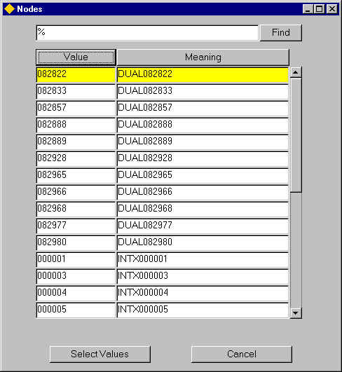
Figure 9
Nodes

This list will display the Nodes of the Node Type associated with the Network Type selected in the ‘Type’ field.

The Display of the available Nodes may be ordered by the Node Name or by the Node Description by pressing the [Value] button or the [Meaning] button respectively.

This will also determine which field (Node Name or Description) will be used when refining the search criteria to limit the Nodes displayed. For example, to search for all Node points of the Selected Node type that begin with ‘01’, press the [Value] button then enter 01% in the ‘Find’ field and press the [Find] button on the Nodes window.

Click on the required Node Point to select, and press the [Select Values] button on the Nodes form. To close the window without selecting a Node press the [Cancel] button.

End Node (List)
Enter the End Node of the Network Element or Group. The End Node entered must be of the Node Type associated with the selected Network Type. Node Types and Network Types are associated using Network Types - NM0002 . Nodes will have been previously defined using Nodes - NM0001 (page 8).

To create a new Node point press the [N] button on the Network Element Functions toolbar (Page 16). This will call Nodes - NM0101 and allow the creation of new Node points.

The Node Description, Easting and Northing Grid References will be displayed in the adjacent fields.
Figure 10
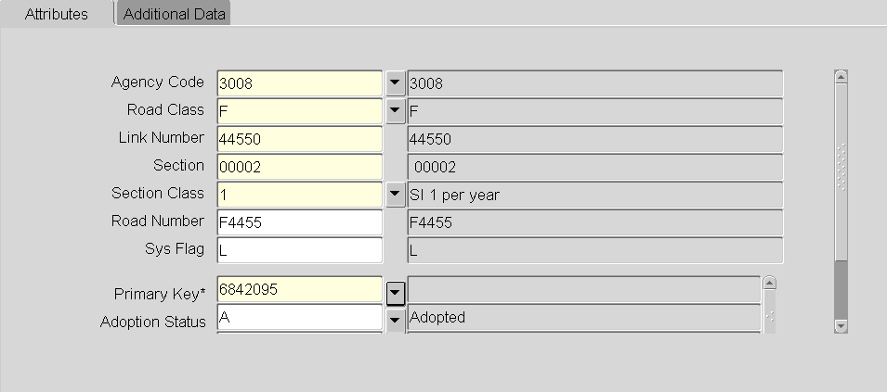

Attributes
The panel is divided into 2 areas, with the top area displaying those Attributes associated with the Group Types’ associated Network Type and the bottom panel displaying any Attributes from the Primary Additional Data Type if applicable (see the Network Manager System Admin Guide for details).

The Values entered for the Attributes which have a sequence number populated in the ‘Unique Seq’ field of the Network Types – NM0002 module, will be used to ‘derive’ the Unique Reference for the Element or Group.

The attribute values should be entered as required. Mandatory Attributes are signified with a ‘*’.

Notes

- Attribute values for Attributes used in the formation of the Element Unique or specified a the Child Auto-inclusion column may not be updated.

- Attributes for Groups are also displayed within the Group of Sections - NM0110 and Groups of Groups – NM0115 modules.

Figure 11
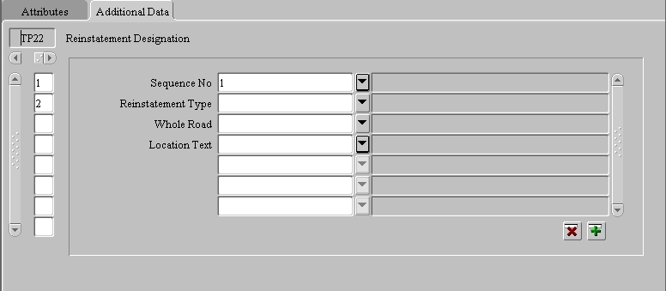

Additional Data
Supplementary information relating to a Network Element may be added or maintained using the Additional Data Tab. Additional Data may include such information as ‘Traffic Sensitivity’ on a Street or any ‘Reinstatement Designations’ that may apply to a section of Network. Additional Data is set up using the AD Types – NM0700 module (Network Manager System Admin Guide).
Figure 12
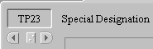
If more than one type of Additional Data has been defined for a Network / Group Type, the data is displayed in the ‘Display Order’ defined within the AD Types – NM0700 module. The different Types of Additional Data may be selected by scrolling through the available options using the horizontal scroll bar shown in Figure 12.
Figure 13
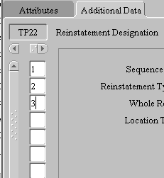
To add a new Item of Additional Data scroll through the available list to select the AD Type required and press the [Create Record] button on the bottom of the Form. The attributes for the selected AD Type will be displayed allowing the appropriate attribute values to be entered. To save the record, press the [Save] button on the menu toolbar. Once saved a record counter will be displayed on the left hand side of the form indicating the number of AD Items of the selected Type that have been added for the currently selected Network Element as shown in Figure 13. Clicking on the required record counter will display that AD Item.

Note that only one AD Item of a particular Type may be created if the ‘single allowed’ flag has been checked for the Network / Group Type and AD Type combination in the AD Types – NM0700 module.
To delete (end-date) an AD Item press the [Delete] button on the bottom of the Form.

Figure 14
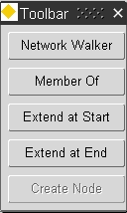
Network Element
Function Toolbar

Network Element Functions
Several buttons are available on the Network Element Function toolbar to assist in the viewing and management of a Network. The Network Element Functions toolbar may be ‘toggled’ on and off by pressing the [Toolbar] button (Figure 15) on the Exor menu toolbar.
Figure 15
Toolbar button

The currently selected Network Element will determine the available functions. For example, the ‘Extend Route at Start’ function will only be available if the currently selected Element is at the Start of the Route.

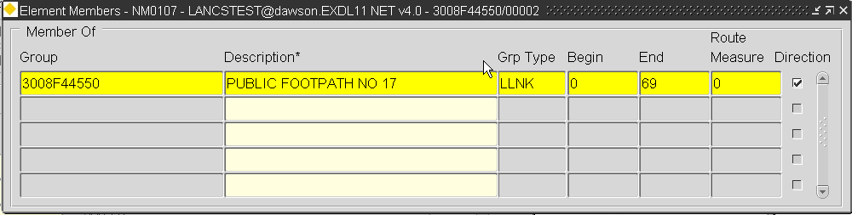
Figure 16
Network Element
Membership

Network Element Membership

This window is called by pressing the [Member Of] button on the Network Element Function toolbar. It displays a list of the Groups of which the selected Network Element is a member.

The Description of any parent Group may be updated directly from within the ‘Element Members’ window. If a Parent Group description is changed press [Save] on the menu toolbar to save the change.

Note that the description of NSG Streets cannot be updated

If the selected Element is only partially contained within the Group the start and end offsets relative to the measured Element length will be displayed in the ‘Begin’ and ‘End’ field respectively. For example, if the first 50 m of Element H001/10-L were contained within a Group the ‘Begin’ and ‘End’ field would be displayed as ‘0’ and ‘50’ respectively.

The Route Offset or SLK will be displayed for Linear Groups in the Route Measure field.

If the Element runs in the Cardinal direction of a Parent Linear Group (e.g. the Route Group) the ‘Direction’ flag will be set.

The Cardinal direction of a Route or Linear Referencing Method is needed to configure the Datum Network Elements that form the Group in the same direction. The Cardinal direction of the route is deemed to be that of increasing measure, the datum elements linear reference direction is deemed to be from start to end node and this may be a reversal of the route direction.

Extend Route at Start

This function allows the creation of a new Network Element at the start of the Parent Route (defined in the Type Inclusion window in Network Types for the Network type of the selected Element) and is called by pressing the [Extend at Start] button on the Network Element Function toolbar. The function will only be available if the selected Network Element is the first Element within the parent Route.

The new Network Element details, for example Network Type, Admin Unit and Description, will be derived from the selected Element. Any Flexible Attributes that have the ‘Inherit’ flagged set in the Type Columns window of Network Types - NM0002 will also be derived from the selected Element. If these are used as part of the prescribed naming convention for the Network Type, the Unique reference of the Element will be automatically populated when the remainder of the field values have been entered.

The default Start Date of the new Element is determined by the value set for Product Option EXTRTEDATE. The allowable values are as follows:

- Leave the default Start Date as Null
- Inherit the default Start Date from the Previous Element
- Set the default Start Date to the system date
- Inherit the default Start Date from the membership date of the previous Element

When the new Element is created at the Start of the Route the ‘End Node’ will be provided. This will be the same Node Point as used for the Start of the originally selected Network Element. This will ensure the Route connectivity integrity is maintained. Route Offset or SLK values for the Route will be recalculated in accordance with any Network Type Subclass precedence defined for the Network Type in Network Types - NM0002.

The User must provide the measured length of the Element and the Start Node reference.

Note that new Node Points may be created by pressing the [Create Node] button on the Network Element Function toolbar.

Any non-inherited Flexible Attributes values may also be entered.

Note that the Extend Route Functionality is only available if the Datum Element Network Type has been defined with a single Auto-Inclusion (defined in the Type Inclusion window in Network Types for the Network type of the selected Datum Element) into a Linear Group. If no or multiple Type Inclusions have been defined for the Datum Network Type the functionality is disabled.

Extend Route at End

This function allows the creation of a new Network Element at the end of the Parent Route (defined in the Type Inclusion window in Network Types for the Network type of the selected Element) and is called by pressing the [Extend at End] button on the Network Element Function toolbar. The function will only be available if the selected Network Element is the last Element within the parent Route.

The new Network Element details, for example Network Type, Admin Unit and Description, will be derived from the selected Element. Any Flexible Attributes that have the ‘Inherit’ flagged set in the Type Columns window of Network Types - NM0002 will also be derived from the selected Element. If these are used as part of the prescribed naming convention for the Network Type, the Unique reference of the Element will be automatically populated when the remainder of the field values have been entered.

The default Start Date of the new Element is determined by the value set for Product Option EXTRTEDATE. The allowable values are as follows:

- Leave the default Start Date as Null
- Inherit the default Start Date from the Previous Element
- Set the default Start Date to the system date
- Inherit the default Start Date from the membership date of the previous Element

When the new Element is created at the End of the Route the ‘Start Node’ will be provided. This will be the same Node Point as used for the End of the originally selected Network Element. This will ensure the Route connectivity integrity is maintained. Route Offset or SLK values for the Route will be recalculated in accordance with any Network Type Subclass precedence defined for the Network Type in Network Types - NM0002 .

The User must provide the measured length of the Element and the End Node reference.

Note that new Node Points may be created by pressing the [Create Node] button on the Network Element Function toolbar.

Any non-inherited Flexible Attributes values may also be entered.

Note that the Extend Route Functionality is only available if the Datum Element Network Type has been defined with a single Auto-Inclusion (defined in the Type Inclusion window in Network Types for the Network type of the selected Datum Element) into a Linear Group. If no or multiple Type Inclusions have been defined for the Datum Network Type the functionality is disabled.

Groups of Sections – NM0110
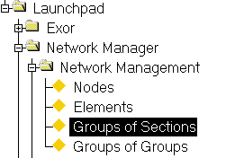
Figure 17
Groups of
Sections Menu

This module is used to create new Groups and maintain existing Groups of Elements. If the Group has User defined Attributes or Primary Additional Data attributes, these will be displayed and are maintainable in the Attributes Panel. Other types of Additional Data may be maintained using the ‘Additional Data’ Tab. Group members will be added automatically if the Network Type for the selected Group Type has been defined as the ‘Parent’ Network Type in the Type Inclusion window of Network Types – NM0002.

Groups may be ‘Linear’ and used as a Linear Referencing method, in which case the member Elements of the Group will be ‘sequenced’ to establish their relative position within the Group and hence allows displacements or Offsets to be calculated. Groups may also be used to describe ‘un-sequenced’ collections of Elements to model such features as Interchanges, Administrative Areas or Inspection Routes. These are referred to as non-linear groups.

Groups may be created by defining a Network Extent and subsequently creating a Group from the results of the Extent or by adding individual Elements from the Gazetteer.

If a Group contains ‘partial’ Elements, i.e. an Element is not wholly contained within the group; the Group Type selected must be flagged as to allow Partial Elements.

When adding Elements to a Group via the Gazetteer, the Network Type associated with the selected Group Type MUST NOT have been defined as the ‘Parent’ Network Type, in a Network Type Inclusion for the Datum Network Element Type. For example, if a Network Type of CRT – was defined as the ‘Parent’ Network Type in a Type Inclusion properties for the Classified Road Datum Network, then Groups whose Network Type is CRT, i.e. Classified Routes, may not be amended by adding Elements via the Gazetteer.

Figure 18
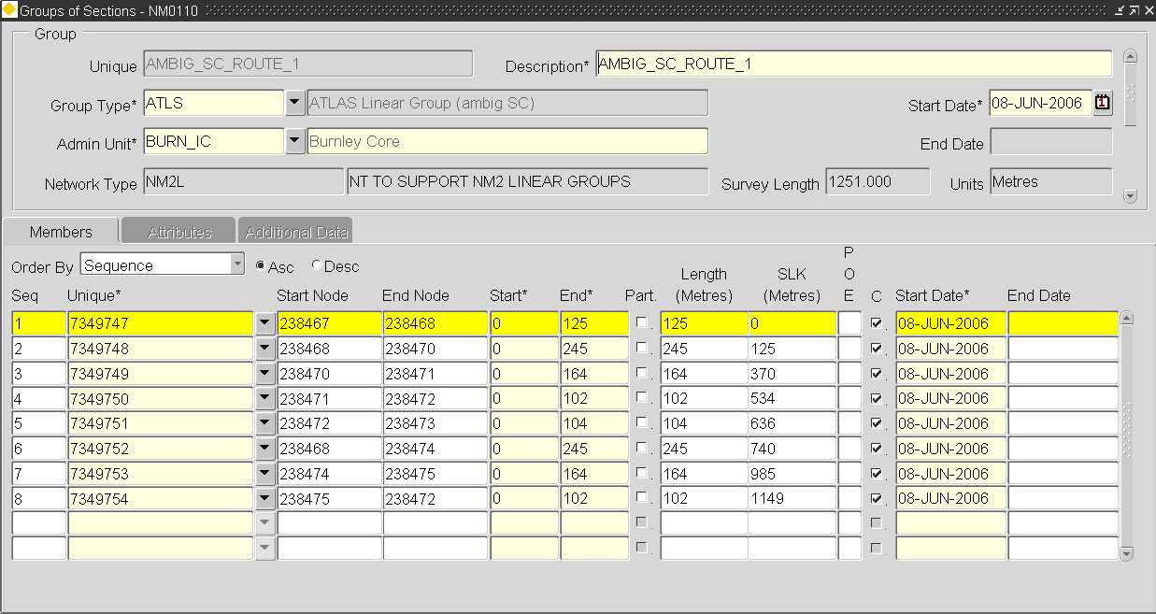
Groups of Sections

Group Panel
The Group Panel is used to create a new Group of Elements and determine its Group Type, Admin Unit etc. When creating a new Group of Sections where the Unique is derived from its Network Attributes, the Attributes panel will be automatically displayed when the Group Type is added allowing the Attribute values to be added. In this is the case any Unique value entered by the User will be disregarded.

When you enter this window the cursor sits in the ‘Unique’ field waiting for a new Group to be entered or existing Groups to be queried back. To query back an existing Group of Elements press the [Enter Query] button on the menu toolbar (or press F7), enter some selection criteria, then press the [Execute Query] button (or press F8).

Alternatively pressing the [Gazetteer] button on the menu toolbar will call the Gazetteer from where Groups may be queried.

Unique (Required)
Enter a Unique reference for the Group of Elements. A maximum of 30 characters is allowed.

Note that care should be taken if the Unique reference of a Group is to be wholly contained within part of the Unique Element reference to ensure that the String Length specified for the attribute column, e.g. NE_GROUP, is of sufficient length to contain the Unique of the Group.

If the Unique reference is derived from its Network Attributes the appropriate values may be added in the ‘Attributes’ Panel after entered the appropriate values in the other mandatory fields.

Description (Required)
Enter a description for the Group. A maximum of 240 characters is allowed. The Group description will be displayed along with the Group Unique and Group Type when using the Gazetteer.

Group Type (Required) List
Enter the Group Type to be used for this Group of Elements. The Group Type selected must be associated with a Network Type suitable for the characteristics of the new Group, e.g. Units of measurement, Linear, Partial etc.

The Group Type description will be displayed in the adjacent field.

The Network Type associated with the selected Group Type will be displayed in the ‘Network Type’ field.

The Units of Measurment associated with the Network Type which in turn is associated with the Group type selected will be displayed in the ‘Units’ field.

Start Date (Required)
Enter the date from which the Group of Elements is effective.

Note that the date may be selected from the calendar by right clicking the mouse and selected the appropriate option from the context menu.

Admin Unit (Required) List
Select the required Admin Unit for the Group. Only Admin Units of the Admin Type associated with the Network Type used when defining the Group Type of the selected Group of Elements will be displayed in the list of values.
Only Users with sufficient Admin Unit privileges will be permitted to use the Group.

End Date (Display Only)
This field is non-updateable. If a Group is closed using the [Close] – Close Route facility, the selected date on which the Group was closed will be displayed. Refer to page 35 for more information on Closing a Route.

Surveyed length (Display Only)
For Linear Groups only, the length (max slk value) will be displayed.

Figure 19
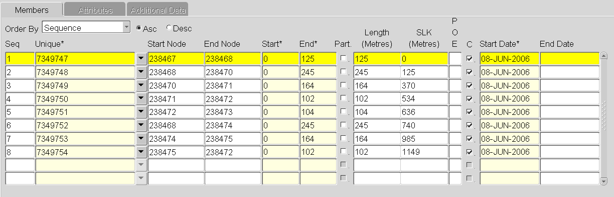
Members Panel

Members Panel
The Members panel is used to display and maintain the member Datum Elements of the Group. Group members may be added, by selected the required Elements from the Gazetteer by pressing the ‘Drop Down List’ icon adjacent to the ‘Unique’ field (except for Groups whose Group Type is a parent in a Network Type Inclusion).

If the Group is a ‘Partial’ Group, i.e. at least one of the member Elements is not wholly contained within the Group, the extent of the Datum Element that is contained within the Group may be defined by updating the ‘Start’ and/or ‘End’ fields for the ‘partial member’. See page 47 for more information on creating partial Groups of Elements.

If the Group Type of the selected Group has been flagged as ‘Exclusive’ in Group Types – NM0004, a Network Element may only be a member of one Group of the selected Type. For example, if a Network Element may only be a member of one Route Group the exclusivity flag should be checked. If this exclusivity rule is broken when Group members are being added to a Group the message displayed in Figure 20 will be displayed.

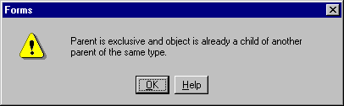
Figure 20

The following information is displayed for each member Element

- Sequence Number
- Element Unique
- Start Node
- End Node
- Start Offset (relative to the Datum Element)
- End Offset (relative to the Datum Element)
- Partial Element indicator
- Length (the extent of the Element contained within the Group)
- SLK (Offset) measure (Linear Groups only)
- POE – Point of Equation indicator
- Cardinality indicator
- Membership Start Date
- Membership End Date

The order in which group members are displayed may be set using the [Order By] field.

Sequence
If the selected Group is ‘Linear’ and therefore member Elements are connected via shared Nodes Points or by means of Distance Breaks the Elements will be ‘sequenced’ to establish their relative position in the Group and hence allows displacements to be calculated. The Sequencing of Member Elements will be in accordance with any Type Subclass rules defined for the member Datum Elements in the Network Types form.

Unique (Required) List, Gaz
Enter the Unique reference of the member Element.

Start Node (Display Only)
The Start Node of the selected Network Element will be displayed.

End Node (Display Only)
The End Node of the selected Network Element will be displayed.

Start (Updateable)
This field displays the start position, relative to the member Element, of the extent of the Element that is contained within the Group. For non-partial groups this value will always be ‘0’. For Partial Groups this value may be updated.

End (Updateable)
This field displays the end position, relative to the member Element, of the extent of the Element which is contained within the Group. For non-partial groups this value will always equate to the Element length. For partial Groups this value may be updated.

Part. (Checkbox)
If the Group is a ‘Partial’ Group and the selected member Element is not wholly contained with the Group, i.e. the ‘Start’ or/and ‘End’ fields have been amended, the system will automatically ‘check’ this partial indicator.

Length (Display Only)
The total Length of the extent of the member Element contained within the Group will be displayed.

SLK (Offset) (Linear Groups Only)
The SLK value or Route Offset for the start of each member Element will be displayed. This value is the measured distance value of the start of the Element, relative to the parent Group in increasing measure from its start. The SLK calculation rules will be dependant on any precedence set by the sequence number of the Type Subclass’s defined for the Datum Network Type in Network Types – NM0002.

POE (Point of Equation indicator)
If a Point of Equation exists at the Start Node of an Element (the End Node if the member Element is not in the Cardinal direction of the Route) the type of POE will be indicated in Red.

A POE is a discontinuity in the measured distance of a Route at a known point on the ground, i.e. a Node point, and can either be a GAP or an OVERLAP. Points of Equation may be created as a result of the Network operations needed to model a Road Realignment or as a result of a ‘Shift’ or ‘Recalibrate’ operation. Points of Equation may be removed by ‘Rescaling’ the Route. This will cause the Route SLK values to be recalculated based on the current Element lengths.

Consider an example

Figure 21 shows an existing Route and a proposed realignment scheme. When the realignment is modeled in the database it will cause a Point of Equation (a GAP) at the Start of Element 4, as the new Element length will be less than that of the existing Element length.

Figure 21
POE (Gap)
1
2
3
4
5

New Realigned Element

The following table shows the Element Length and SLK prior to the Realignment

Element | Length | SLK
1 | 950 | 0
2 | 1080 | .95
3 | 1600 | 2.03
4 | 680 | 3.63
5 | 2200 | 4.31

To remodel the Network to account for the Realignment of the Route, Element 3 will be End-Dated and a new Element (6) will be added in its place. The length of the new Element will be 950m. This will cause a GAP POE of 0.65 m at the Start of Element number 4. The following table shows the Element Length and SLK after to the Realignment.

Element | Length | SLK | POE
1 | 950 | 0
2 | 1080 | .95
6 | 950 | 2.03
4 | 680 | 3.63 | Gap of 0.65m
5 | 2200 | 4.31

To display the POE details select the Element on which the required POE exists and select the ‘Node Details’ option from the context menu (called by clicking the Right Mouse Button). The Node Details window will be displayed as shown in Figure 22.

Asset Items or other database objects may not be located on a POE.

C (Cardinality Indicator)
If a member Element is in the Route Cardinal Direction, i.e. the Element is increasing in measure value from its Start Node to it’s End Node in the same direction as the increasing measure of the Route from it’s Start, this box will be checked.

Note that the 'Reverse Allowed' flag must be selected for the Group Type if 'non-cardinal members are to be allowed.

Start Date (Required)
Enter the Date from which the Element is a member of the Parent Group. If the Group is a Parent in a Type Inclusion for a Datum Network the Start Date will be automatically populated as the date the Element record was created. If the Group is ‘Rescaled’ the Start Date will be set to the Date the Rescale operation took place.

Note that a complete history is kept of Group Memberships and associated SLK’s etc. To view the membership details at a Temporal stage use the [Effective Date] functionality on the ‘Preferences form.

End Date (Optional)
Enter the Date from which the Element is no longer a member of the Group. If the Group is a Parent in a Type Inclusion for a Datum Network, the member Elements will be End Dated if the Parent Route is Closed using the [C] – Close Route facility.

Note that this field will be non-updateable if the Datum Element is a member of the Group by virtue of a Network Type inclusion. The Datum Element may be End Dated therefore also End Dating the membership of the Group.
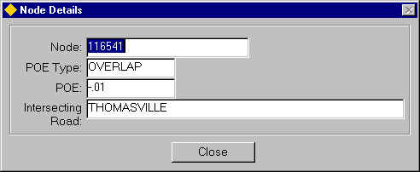
Figure 22
Node Details

Node Details
The Nodes Detail window is for display purposes only and can be called when a Node or POE field is selected, by clicking the right mouse button and selecting ‘Node Detail’ from the context menu. The following details are displayed:

- Node Name
- POE Type (if a POE exists at the Node Point)
- POE (extent of POE if one exists)
- Intersecting Road Name

To exit the Node Details window, press the [Close] button.
Figure 23
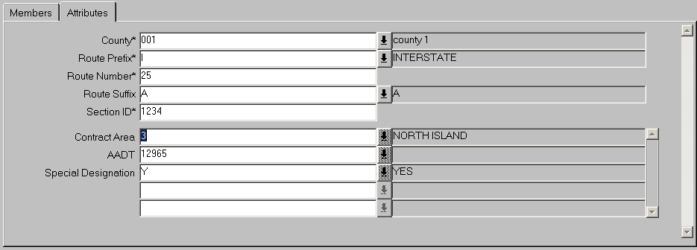

Attributes Panel
The Attributes Panel is used to display and maintain a Groups Attributes if applicable. The panel is divided into 2 areas, with the top area displaying those Attributes associated with the Group Types’ associated Network Type and the bottom panel displaying any Attributes from the Primary Additional Data Type if applicable (see the Network Manager System Admin Guide for details).

These Attributes may be updated if the User has been granted the appropriate Admin Unitand Role based access.

If the current Group Types associated Network Type has been defined as having Nodes (using the Network Types – NM0002), these will be displayed at the top of the panel as shown in Figure 24. New Nodes may be created if required by pressing the [Create Nodes] – Nodes button on the Floating Toolbar as detailed on page 37. This will call Nodes - NM0101 and allow the creation of new Node points.

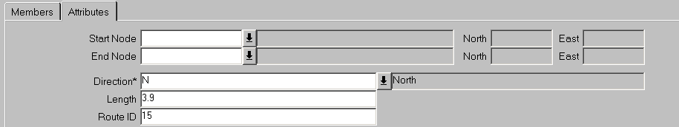
Figure 24

Note that any Network Attributes which are used in the derivation of the Group Unique or Attributes used in a Network Type Inclusion may not be updated.

Figure 25

Additional Data
Supplementary information relating to a Network Element may be added or maintained using the Additional Data Tab. Additional Data may include such information as ‘Traffic Sensitivity’ on a Street or any ‘Reinstatement Designations’ which may apply to a section of Network. Additional Data is set up using the AD Types – NM0700 module (Network Manager System Admin Guide).
Figure 26

If more than one type of Additional Data has been defined for a Network / Group Type, the data is displayed in the ‘Display Order’ defined within the AD Types – NM0700 module. The different Types of Aditional Data may be selected by scrolling through the available options using the horizontal scroll bar shown in Figure 27.
Figure 27
To add a new Item of Additional Data scroll through the available list to select the AD Type required and press the [Create Record] button on the bottom of the Form. The attributes for the selected AD Type will be displayed alowing the appropriate attribute values to be entered. To save the record press the [Save] button on the menu toolbar. Once saved a record counter will be displayed on the left hand side of the form indictating the number of AD Items of the selected Type that have been added for the currently selected Network Element as shown in Figure 28. Clicking on the required record counter will display that AD Item.

Note that only one AD Item of a particular Type may be created if the ‘single allowed’ flag has been checked for the Network / Group Type and AD Type combination in the AD Types – NM0700 module.
To delete (end-date) an AD Item press the [Delete] button on the bottom of the Form.

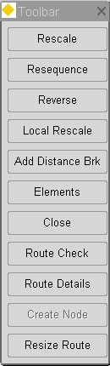
Figure 28
Toolbar

Toolbar
A floating Toolbar exists on the Groups of Elements form and may be toggled on and off using the [Toolbar] button on the Exor menu toolbar.

Each Button on the Toolbar will either perform a discreet Group related operation or call another Exor form.

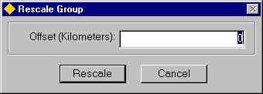
Figure 29
Rescale

Rescale
A Rescale operation on a Group will cause the SLK or Offset measurements to be recalculated. The SLK value is the measured distance value of the start of the Element, relative to the parent Group in increasing measure from the Route Start point. The SLK calculation rules will be dependant on the precedence set by the sequence number of the Type Subclass’s defined for the Datum Network Type in Network Types – NM0002.

When the [Rescale] – Rescale button is pressed on the Floating Toolbar, the Rescale Group dialog will be displayed as in Figure 29. The value entered in the ‘Offset’ field, will be the value used for the SLK value for the first Element in the Group, e.g. if a value of 10 was entered, the SLK of the first member Element would be 10. All other SLK’s will be based on this Start Offset. Rescaling a Group will remove all POE’s. The default value for the Start Offset will be set to the minimum Offset value for the Group (this will be be Zero if the Route has not previously been rescaled).

If the Group being Rescaled is a ‘Circular’ Group, i.e. the Start and End of the Route occur at the same Node Point, for example at a Roundabout, a dialogue will be displayed as in Figure 30 asking the User to select the Starting Datum Network Element. Once this is done pressing the [OK] button will allow the Rescale operation to continue.

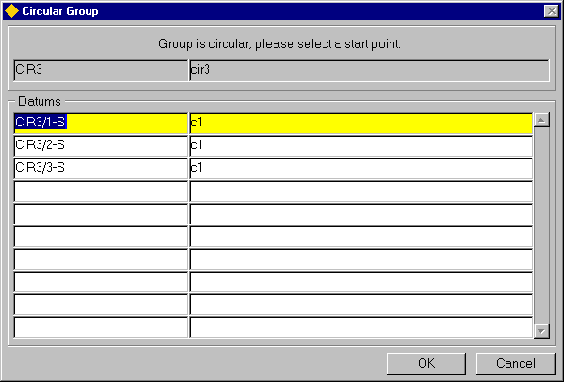
Figure 30
Circular Group

When a Group is Rescaled the Group membership Start Date will be ‘reset’ to the date of the Rescale operation. A complete history is kept of Group Memberships and associated SLK’s etc. To view the membership details at a Temporal stage use the [Effective Date] functionality on the Preferences form.

Note that this function is disabled if the Linear Group has no membership records.
Resequence
If the Group is a ‘Linear’ group, pressing the Resequence button will cause the Group members to be Resequenced in increasing distance value from the Start of the Route in accordance with any Type Subclass rules defined for the member Datum Elements in the Network Types form.

If the Group being Resequenced is a ‘Circular’ Group, i.e. the Start and End of the Route occur at the same Node Point, for example at a Roundabout, a dialogue will be displayed as in Figure 31 asking the User to select the Starting Datum Network Element. Once this is done pressing the [OK] button will allow the Resequence operation to continue.

Figure 31
Circular Group

Local Rescale
If the Group is a ‘Linear’ group, the SLK values for individual Element may be recalculated by a Local Rescale operation. To carry out a Local Rescale operation select the required Element and press the [Local Rescale] button on the floating Toolbar. The SLK values for any suqsequent Elements will be unaffected be a Local Rescale. If the select Element contained a Point of Equation, this will be removed for the selected Element, but will be ‘moved’ to the next connected Element.

Note that this function is disabled if the Linear Group has no membership records.

Add Distance Break
This button allows a Distance Break to be added to the Group. A Distance Break allows logical connectivity over a physically discontinuous Network. For more information on Distance Breaks refer to page 42.

Note that this function is disabled if the Linear Group has no membership records.

Elements
This button will call the Elements – NM0105 and make the selected member Element current.

Note that this function is disabled if the Linear Group has no membership records.

Figure 32
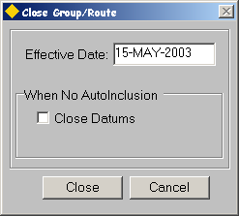
Close Route

Close
This button allows an entire Route or Group of Elements to be Closed and is only available to User flagged as 'Unrestricted' in the Users - HIG1832 module (refer to the General System Admin Guide). When the button is pressed the ‘Close Route’ dialogue will be displayed as shown in Figure 32.

If the selected Group is of a Type whose associated Network Type has been defined as a ‘Parent’ in a Type Inclusion record for another Network Type in Network Types-NM0002, the 'Close Datums' checkbox in the When No AutoInclusion panel will be automatically checked and disabled. This will results in each of the 'child' member Elements being End Dated when the 'parent' Group is End Dated.

If the selected Group is not a 'Parent' Group in a Network Type Inclusion the member Datum Elements may optionally be End Dated by selecting the 'Close Datums' Checkbox in the When No AutoInclusion panel.

Note that End Dating Datum Elements will cause a discontinuity in the connectivity of the other Route Groups of which the affected Datum Elements are a member. This connectivity may be re-established by using Distance Breaks.

If member Datum Elements are End Dated any Asset Items which are located on the Closed Route will either be ‘End Dated’ if the Asset Item Type has been flagged as ‘Replaceable’ in the Asset Metamodel – NM0410 module, or the Asset Item Location will be End Dated if the ‘End Location Only’ flag has been checked, leaving the Asset Item ‘Open’.

Note that a Route cannot be ‘Closed’ (End-Dated) if any Asset Items which are either wholly or partially located on any member Elements are of an Asset Type which HAS NOT been flagged as ‘Replaceable’.

The date on which the Route is to be Closed may be entered in the ‘Effective Date’ field.

To Close the Route press the [Close] button. A warning message will be displayed to the User. To cancel the Close operation press the [No] button or [Yes] to proceed.

A message will be displayed when the operation is complete.

Route Check
The Route Check function allows physical breaks (not POE’s or Distance Breaks) to be detected on a Route. If ‘breaks’ are detected the message displayed in Figure 33 will be displayed.

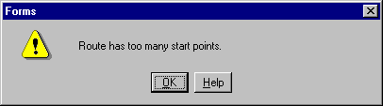
Figure 33

Breaks may be ‘bridged’ by use of Distance Breaks (page 42).

Route Details

The Route Details function provides details of the various length measures associated with a Linear Group or Route. The details are displayed in the Unit of Measurement associated with the Group Types Network Type.

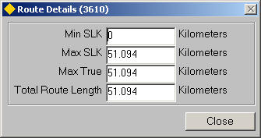
Figure 34

The following details are displayed:

Min SLK The minimum SLK or Offset of the Linear Route. Note that this may not always be zero.

Max SLK The maximum SLK or Offset of the Linear Route. Note that this may not always be the same as the Total Route Length.

Max True The maximum True Offset of the Linear Route. This differs from the Max SLK in that the True distance does not take any POE's into consideration.

Total Route Length The sum of the lengths of the Datum Elements which are members of the Group.

Create Node
To create a new Node point press the [Create Node] button on the Group Functions toolbar (Page 30). This will call Nodes - NM0101 and allow the creation of new Node points.

The Node Description, Easting and Northing Grid References will be displayed in the adjacent fields.

If the list of values is called a Nodes window will be displayed as in Figure 35.

Figure 35
Nodes

This list will display the Nodes of the Node Type associated with the Network Type selected in the ‘Type’ field.

The Display of the available Nodes may be ordered by the Node Name or by the Node Description by pressing the [Value] button or the [Meaning] button respectively.

This will also determine which field (Node Name or Description) will be used when refining the search criteria to limit the Nodes displayed. For example, to search for all Node points of the Selected Node type that begin with ‘01’, press the [Value] button then enter 01% in the ‘Find’ field and press the [Find] button on the Nodes window.

Click on the required Node Point to select, and press the [Select Values] button on the Nodes form. To close the window without selecting a Node press the [Cancel] button.

Resize Route
The Resize Route tool allows a Linear Group or Routes’ ‘calculated’ length to be corrected by automatically recalibrating its member Datum's, to ensure the maximum offset of a linear group is equal to the sum length of its constituent Datum Element members.

This is particularly usual where the length of a Route or Section is a known surveyed length, but the length of its members have been derived from their spatial geometry and therefore may not be totally accurate. An example of this is where Elementary Street Units are used to Underpin maintenance Section that have an accurate known Surveyed Length.

When ‘Resizing a Route’ the member Datum Elements are recalibrated (ensuring that Assets located on the Datum are also recalibrated) proportionately based on the known length of the linear group supplied. The example given below show a Route that has a calculated length of 300 (based upon the length of its members), but it is known to be 500 long. Table 1 shows the length of each Datum member and its percentage of the overall length.

133.33
100
66.67
300
Before Resize
Figure 36

E1
E2
E3

Table 1

Known Route Length = 500
‘Calculated ‘ Route length = 300
Datum | Length | % of length
E1 | 133.33 | 44.4
E2 | 100 | 33.3
E3 | 66.67 | 22

Figure 37 shows the Route after it has been ‘Resized’ to its known length of 500.

Figure 37
222
166.50
110
Figure 36
Leg Orientation button
500
1
After Resize

Known Route length = 500
‘Calculated ‘ Route length = 500
Datum | Length | % of length
E1 | 222 | 44.4
E2 | 166.5 | 33.3
E3 | 110 | 22

The Resize Route functionality is only available when a Linear group is selected. To carry out the operation enter the known length of Route or Section and press the [Resize] button.

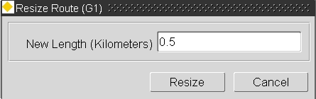

The member Datum's will be recalibrated and the Route or Section will be Rescaled automatically. To save the changes press the [Save] button on the menu toolbar.

If the Route or Section being Resized is a ‘Circular’ Group, i.e. the Start and End of the Route occur at the same Node Point, for example at a Roundabout, a dialogue will be displayed as in Figure 38 asking the User to select the Starting Datum Element. Once this is done pressing the [OK] button will allow the Resize operation to continue.

Figure 38
Circular Group

Add Connected Section
Elements may be added as members of a Group using their connectivity to an already existing member Element. This is done using the ‘Add Connected Section’ option on the context menu (called by Right Clicking the mouse button).

Note that this option is only available when a blank row is currently selected on the members panel.

For example, if the H052/116-S was already a member of a Group the connecting Elements could be added by pressing the [Create Record] button on the menu toolbar, then selecting the ‘Add Connected Section’ option from the context menu.

Figure 39
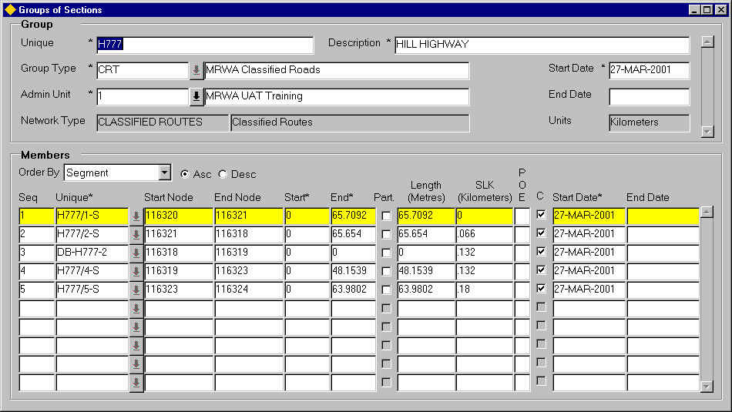
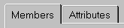
Groups of Sections
(Distance Breaks)

Distance Breaks
A Distance Break is a point of discontinuity in a physical Route. They exist in order to allow logical connectivity over a physically discontinuous Route. Discontinuities may occur at a ‘Staggerred’ Intersection or ‘Common’ Routes (Figure 40) for example.

Figure 40
Common Route

Road 1
Road 2
Road 1
Road 2
Common
Element
Distance
Break
Common Element
(Shared by 2 Routes)
Distance Break provides connectivity for Road 2

Distance Breaks are displayed in Groups of Sections – NM0110. Their appearance is similar to that of a Network Element in that they have a Unique Reference, a Start and End Node,a Length measure and an SLK or Offset, but as they are not physical entities on a Network, no objects, e.g. Asset Items, may be located on them.

Distance Breaks can be identified on a Route by means of the naming convention they adopt. For example, a Distance Break added to a Group called the H777 will have the following name: DB_H777-8 where DB represents ‘Distance Break’, H777 is the Unique Route reference on which the Distance Break exists and ‘8’ is the occurance of Distance breaks on the route network.

Distance breaks on a Route group will normally have a Length of ‘0’ meters. This will allow the SLK or Offset values for the Route to be Derived as if no discontinuity existed. If Distance Breaks are added to an Inspection Route group for example, they may have a measured value, as the ‘Break’ in the Inspection Route must still be driven or walked. This will allow the SLK or Offset values for the Route to be derived, based on the actual route driven or walked.

The Start SLK or Offset of each Element within a Group will have been derived based on the Route connectivity and the member Element Lengths.

Note that when a Distance Break is added the Group must be ‘Resequenced’ using the [Sq] ‘Resequence’ button on the Floating Toolbar.

This will order the member Elements correctly within the Route.

To add a Distance break to a Linear Group press the [DB] - Add Distance Break button on the Floating Toolbar.

An Add Distance Break dialogue box will be displayed as shown in Figure 41.

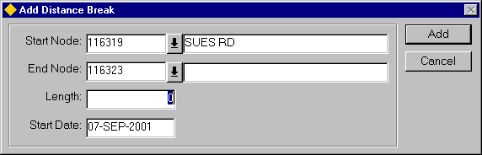
Figure 41
Add Distance Break

Enter the following details.

Start Node (Required) List
Enter the Start Node of the Distance Break. The list of values will display all of the Node Points, along with the associated Intersecting Road Names, which are located on the selected Route. This will ensure that the Distance Break cannot span multiple Routes or Network Types.

End Node (Required) List
Enter the End Node of the Distance Break. The list of values will display all of the Node Points, along with the associated Intersecting Road Names, which are located on the selected Route. This will ensure that the Distance Break cannot span multiple Routes or Network Types.

Length (Required)
Enter the required length of the Distance Break. Note that a value of ‘0’ is valid.

Start Date (Required)
Enter the Group membership Date of the Distance Break. To select a date from the calender or to select the system date, click the right mouse button and selected th appropriate option from the context menu.

To add the Distance Break to the Route press the [Add] button on the Dialogue box.
The Distance Break will be added with a ‘0’ Sequence Number.

To ‘Resequence’ the member Elements within the Route group, press the Resequence button on the Floating Toolbar.
This will order the member Elements and Distance Break within the Route by cardinality and connectivity.

If required the SLK or Offset values for the member Elements should be recalculated by using the Rescale functionality.

Figure 42
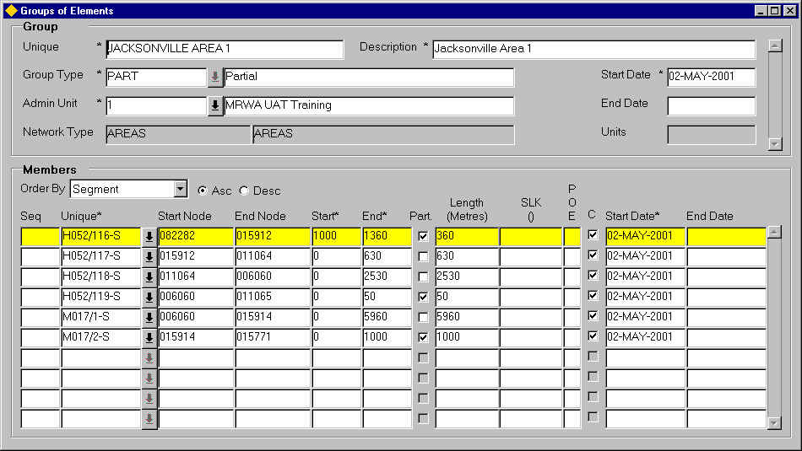
Partial Group of
Elements

Partial Groups
Partial Groups of Elements may be created by selecting the member Elements from the Gazetteer by pressing the ‘Drop Down List’ icon adjacent to the ‘Unique’ field or manually entering the Element Unique, then specifying the ‘Start’ and ‘End’ measures (relative to the Element) of the portion of the Element which is contained within the Group. If the Element is not wholly contained within the Group the ‘Part’ flag will be automatically set to indicate that the Element is only partially contained within the Group. The extent of the Element included will be displayed in the ‘Length’ field.

Partial Groups may contain a mixture of Elements which are either wholly contained within the Group or only partailly contained within the Group.

The Group Type selected for the Group must have been flagged as ‘Partial’ in Group Types – NM0004.

Notes on Partial Groups:

- Partial Groups may be created from a partial Network Extent
- Partial member Elements should only exist as the first or last member Element when the Group is a Partial Linear Group.

Groups of Groups – NM0115
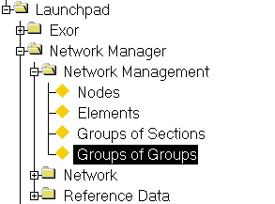
Figure 43
Groups of Groups
Menu

The Group of Groups - NM0115 module is used to create and maintain Network Groups that have other Network Groups as members, i.e. Groups of Groups. Only those Group Types flagged as 'Sub Group Allowed’ in the Group Types - NM0004 module (see the Asset Manager System Admin Guide) may be maintained in this module. Groups of Sections (Datum Elements) and their memberships are maintained using the Groups of Section - NM0110 module (page 20).

Groups of Groups are useful when searching for Regions of Interest using the Gazetteer as the User may Drill down through the Group Hierarchy to find the required interest region. Groups of Groups are also useful for reporting purposes.

Consider the example Group Hierarchy in Figure 44.

Figure 44
Groups of Groups

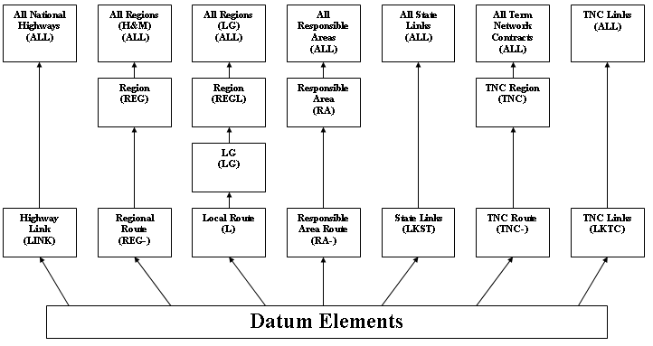
Groups of Groups
Groups of Sections

In the example shown in Figure 45 several of the Network Groupings contain multiple Groups of Group levels culminating in a Group of Groups which represents All network of the associated type. For example, the Groups of Groups named All Regions (LG) (Group Type ALL) represents ALL Local Roads.

The Group Hierarchy may be used to assist the selection of a Region of Interest by allowing the User to Drill down through the Hierarchy in the Gazetteer. For example, to select a Regional Route, the User could select the Top Level ALL Regions Group of Group and drill down a level. The Gazetteer would then display all of the Regions which are sub groups of the ALL Region Group of Groups. Selecting the required Region and drilling down would enable the User to select the required Regional Route within the selected Region.

If the Group has User defined Attributes these will be displayed and are maintainable in the Attributes Panel.

Sub Groups will be added automatically if the Network Type for the selected Group Type has been defined as the ‘Parent’ Network Type in the Type Inclusion window of Network Types – NM0002 for a Network Type associated with a Group of Sections.

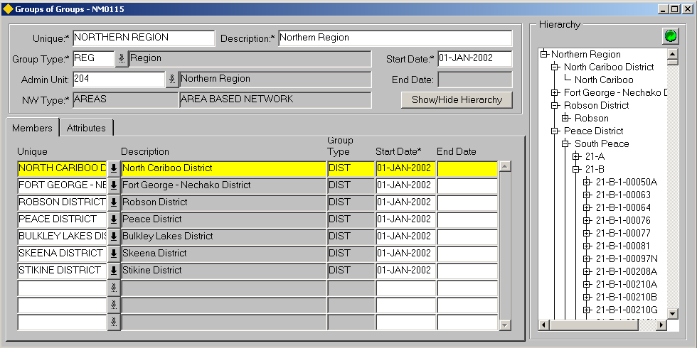
Figure 45

Group Panel
The Group Panel is used to create a new Group of Groups and determine it’s Group Type, Admin Unit etc.

When you enter this window the cursor sits in the ‘Unique’ field waiting for a new Group to be entered or existing Groups to be queried back. To query back an existing Group of Groups press the [Enter Query] button on the menu toolbar (or press F7), enter some selection criteria, then press the [Execute Query] button (or press F8).

Alternatively pressing the [Gazetteer] button on the menu toolbar will call the Gazetteer from where the Group may be queried.

Unique (Required)
Enter a Unique reference for the Group of Groups. A maximum of 30 characters is allowed.

Description (Required)
Enter a description for the Group of Groups. A maximum of 80 characters is allowed. The Group description will be displayed along with the Group Unique and Group Type when using the Gazetteer.

Group Type (Required) List
Enter the Group Type to be used for this Group of Elements. The Group Type description will be displayed in the adjacent field. The List of allowable values will be restricted to those Group Types flagged as 'Sub Group Allowed' in the Group Types - NM0004 module (see the Asset Manager Admin Guide).

The Network Type associated with the selected Group Type will be displayed in the ‘Network Type’ field.

Start Date (Required)
Enter the date from which the Group of Elements is effective.

Note that the date may be selected from the calendar by right clicking the mouse and selected the appropriate option from the context menu.

Admin Unit (Required) List
Select the required Admin Unit for the Group. Only Admin Units of the Admin Type associated with the Network Type used when defining the Group Type of the selected Group of Groups will be displayed in the list of values.
Only Users with sufficient Admin Unit privileges will be permitted to use the Group.

End Date (Display Only)
This field is non-updateable. If a Group of Groups is closed using the [C] – Close facility, the selected date on which the Group of Groups was closed will be displayed. Refer to page 55 for more information on Closing a Group of Groups.

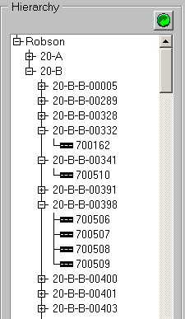
Figure 46

Show/Hide Hierarchy
The [Show/Hide Hierarchy] button toggles on and off a graphical representation of the Group of Group Hierarchy. A Road Icon depicts datum Elements, e.g.

The Hierarchy may be expanded or Collapsed by pressing the required expand [+] or collapse [-] icon. To expand the entire Hierarchy press the [Refresh] button

Note that it is advised that the Hierarchy is swithed off when Querying large Group Hierarchies or when scrolling through a number of selected Groups of Groups. This will improve the performance of the Module.

Figure 47
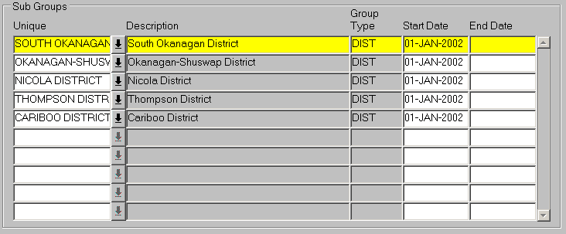

Sub Groups
The Sub Groups panel is used to add member Groups to, or End Date member Groups from the selected Group of Groups. Sub Groups may be added as members of a Group of Groups automatically if the Group of Groups has been defined as a Parent in a Network Type Inclusion. For more information on Autoinclusion refer to the Network Manager System Admin Guide.

Unique (Required) List
Enter the Unique of the Group to be added as a Sub Group. The list of allowable Groups will be restricted to those Groups of the Group Type defined in the Group Relations Panel of the Group Types - NM0004 module for the selected parent Group Type.

Description (Display Only)
The description of the member Sub Group will be displayed.

Group Type (Display Only)
The Group Type of the member Sub Group will be displayed.

Start Date (Required)
Enter the Date from which the Sub Group is a member of the Parent Group of Groups. If the Group of Groups is a Parent in a Type Inclusion for the Sub Group the Start Date will be automatically populated as the date the Sub Group record was created.

End Date
Groups which are no longer members of the selected Group of Groups may have their Group Membership end dated by pressing the [Delete Record] button on the menu toolbar. This will enter the current system date as the End Date for the membership record. This date may be amended if required.

Note that if the Sub Group is a member of the Group of Groups by virtue of a Network Type Inclusion, the membership cannot be End Dated and the [Delete Record] button is disabled. The End Date field is also made non-updateable. The membership will be End Dated only when the member Group is End Dated.

Figure 48

Attributes Panel
The Attributes Panel is used to display and maintain a Groups Attributes if applicable. The panel is divided into 2 areas, with the top area displaying those Attributes associated with the Group Types’ associated Network Type and the bottom panel displaying any Attributes from the Primary Additional Data Type if applicable (see the Network Manager System Admin Guide for details).

These Attributes may be updated if the User has been granted the appropriate Admin Unit and Role based access.

Note that any Network Attributes which are used in the derivation of the Group Unique or Attributes used in a Network Type Inclusion may not be updated.

Figure 49

Additional Data
Supplementary information relating to a Network Element may be added or maintained using the Additional Data Tab. Additional Data may include such information as ‘Traffic Sensitivity’ on a Street or any ‘Reinstatement Designations’ that may apply to a section of Network. Additional Data is set up using the AD Types – NM0700 module (Network Manager System Admin Guide).
Figure 50

If more than one type of Additional Data has been defined for a Network / Group Type, the data is displayed in the ‘Display Order’ defined within the AD Types – NM0700 module. The different Types of Additional Data may be selected by scrolling through the available options using the horizontal scroll bar shown in Figure 50.
Figure 51
To add a new Item of Additional Data scroll through the available list to select the AD Type required and press the [Create Record] button on the bottom of the Form. The attributes for the selected AD Type will be displayed allowing the appropriate attribute values to be entered. To save the record press the [Save] button on the menu toolbar. Once saved a record counter will be displayed on the left hand side of the form indicating the number of AD Items of the selected Type that have been added for the currently selected Network Element as shown in Figure 51. Clicking on the required record counter will display that AD Item.

Note that only one AD Item of a particular Type may be created if the ‘single allowed’ flag has been checked for the Network / Group Type and AD Type combination in the AD Types – NM0700 module.
To delete (end-date) an AD Item press the [Delete] button on the bottom of the Form.

Closing a Group of Groups
Groups of Groups may be closed (End Dated) by using the [Close] - Close Group of Groups button on the Floating Toolbar which is toggled on/off using the [Toolbar] button on the Exor Menu Toolbar. This feature is only available to Users who have been flagged as 'Unrestricted' in the Users - HIG1832 module (refer to the General System Admin Guide).

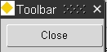
Figure 52

When the [Close] button is pressed a Close dialogue window will be displayed as shown in Figure 53.

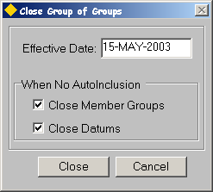
Figure 53

When a Group of Groups is Closed (End Dated), the closing of member Groups will cascade down through the Group Hierarchy, closing each member Group, which is a member of the parent Group by virtue of a Network Type Inclusion. This will continue until the Auto inclusion 'chain' is broken. This could potentially cascade down to the Datum Element level, therefore End Dating the Datum Elements and all Assets, etc located on the affected Datum Elements.

Two additional check boxes are provided to cater for the optional Closure (End Dating) of Groups and Datum Elements within the selected Group Hierarchy that are not 'children' within a Network Type Inclusion (Auto Inclusion).

Close Member Groups
If this option is selected then any Sub Groups within the Group Hierarchy which do not exist within a Network Type Inclusion (Auto Inclusion) will also be End Dated. If this option is not selected the [Close Datum] checkbox will be disabled.

Close Datums
This option is only available if the [Close Member Groups] check box has been selected and Datum Elements exist within the Group Hierarchy. If selected, any Datum Elements that do not exist within a Network Type Inclusion (Auto Inclusion) but are members of a Group within the Hierarchy which is to be End Dated will also be Closed.

If Datum Elements are End Dated any Asset Items which are located on the Closed Elements will either be ‘End Dated’ if the Asset Item Type has been flagged as ‘Replaceable’ in the Asset Metamodel – NM0410 module, or the Asset Item Location will be End Dated if the ‘End Location Only’ flag has been checked, leaving the Asset Item ‘Open’.

Consider the following examples.

Example 1

Figure 54

District
County
Inspection Routes
County Routes
Datum Elements
Auto Inclusion
Membership manually added
Key:

Figure 54 shows a Group Hierarchy model where Datum Elements are Auto Included into a Group of Sections of Type County Route. County Routes are in turn Auto Included into a Group of Groups of Type County that is Auto Included into another Group of Groups of Type District.

Datum Elements are also manually added as members of a Group of Sections of Type Inspection Routes. These Inspection Routes are manually added as members of the Group of Groups of Type County.

Figure 55 shows an example of this Group Hierarchy where District 1 contains 2 Sub Groups (Auto Included) namely County 1 and County 2. County 2 also contains 2 Sub Groups, namely County Route 1 (Auto Included) and Inspection Route 1 (membership manually added). County Route 1 contains 3 member Datum Elements (Auto Included). Inspection Route 1 contains the same member Datum Elements but were added manually, i.e. not by Auto Inclusion).

Figure 55
District 1
County 1
County 2
County Route 1
Inspection Route 1
D123
D124
D125
D123
D124
D125

In this example the [Close Member Groups] (when No AutoInclusion) option is NOT selected as shown in Figure 56.

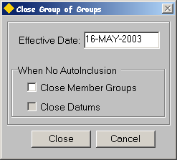
Figure 56

If District 1 was Closed (End Dated) it would also close County 1 and County 2 plus County Route 1 and the 3 Datum Elements which are members of County Route 1. Inspection Route 1 would remain open (as it was not Auto Included into the County Group Type) but the 3 membership records would be End Dated.

Figure 57 shows the result of closing the District Group of Groups with this configuration. End Dated Groups, Datum’s and Group memberships are highlighted in Red.

Figure 57
District 1
County 1
County 2
County Route 1
Inspection Route 1
D123
D124
D125
D123
D124
D125
Group memberships
End Dated

Example 2

Figure 58
District

County

Inspection Routes
County Routes
Datum Elements
Auto Inclusion
Membership manually added
Key:

Figure 58 shows a Group Hierarchy model where Datum Elements are manually included into a Group of Sections of Type County Route. County Routes are Auto Included into a Group of Groups of Type County that is Auto Included into another Group of Groups of Type District.

Datum Elements are also manually added as members of a Group of Sections of Type Inspection Routes. These Inspection Routes are manually added as members of the Group of Groups of Type County.

Figure 59 shows an example of this Group Hierarchy where District 1 contains 2 Sub Groups (Auto Included) namely County 1 and County 2. County 2 also contains 2 Sub Groups, namely County Route 1 (Auto Included) and Inspection Route 1 (membership manually added). County Route 1 contains 3 member Datum Elements (membership manually added). Inspection Route 1 contains the same member Datum Elements and were also added manually, i.e. not by Auto Inclusion).

Figure 59
District 1
County 1
County 2
County Route 1
Inspection Route 1
D123
D124
D125
D123
D124
D125

In this example the [Close Member Groups] (when No AutoInclusion) option is selected but the [Close Datums] is NOT as shown in Figure 60.

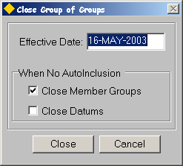
Figure 60

If District 1 was Closed (End Dated) it would also close County 1 and County 2 plus County Route 1 (by virtue of AutoInclusion) and Inspection Route 1 (by virtue of the [Close Member Groups] flag).

The Datum Elements would remain open as they are not AutoIncluded into either the County Route or Inspection Route Groups and the [Close Datum] flag was not selected.

Figure 61 shows the result of closing the District Group of Groups with this configuration. End Dated Groups, Datum's and Group memberships are highlighted in Red.

Figure 61
District 1
County 1
County 2
County Route 1
Inspection Route 1
D123
D124
D125
D123
D124
D125
Memberships would be End Dated as parent group is End Dated

The date on which the Group(s) are to be Closed may be entered in the ‘Effective Date’ field.

To Close the Group of Groups press the [Close] button. A warning message will be displayed to the User. To cancel the Close operation press the [No] button or [Yes] to proceed.

A message will be displayed when the operation is complete.

Network Selection - NET1119
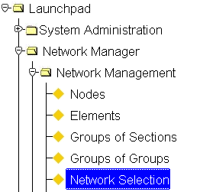
Figure 62
Network Selection

The Network Selection - NET1119 module allows a User to create 'Criteria Based' Road Group. The selection criteria used to create these Road Groups is determined by the 'Criteria Area' selected in the Selection Criteria window. These Criteria Areas include Road Section Characteristics, Survey Details, Defect Details and Public Enquiries.

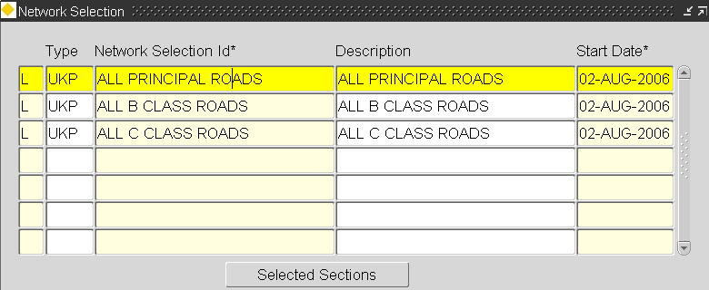

Network Selection
When you enter this form the cursor sits in the 'Flag' field waiting for the User to create a new Road Group or to 'Query back' an existing Selection. To 'query back' an existing Selection, press the [Enter Query] button on the toolbar and enter some selection criteria followed by [Execute Query].

Flag (Required) List
Enter either 'D' for a DtP Road Group or 'L' for a Local road group

Type (Required) List
Enter the Group Type to be created.

Network Selection (Required)
Enter the name for this Criteria Based Road Group.

Description (Optional)
Enter a Description for this Criteria Based Road Group.

Start Date (Required, Default)
Enter the date that the Road Group will become effective. This date may be in the future if you require for the Group NOT be used until a later date. The default date is the system date.

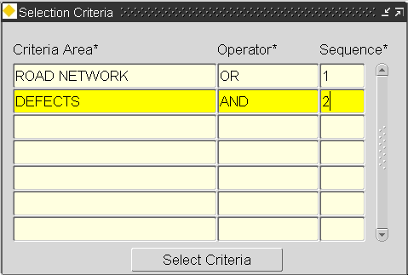
Figure 63

Selection Criteria
The Selection Criteria window is used to specify the 'Criteria Area' used to select Road Sections. If multiple 'Criteria Areas' are used, as in Figure 63 this window is also used to define the relationship between them. Valid Selection Criteria Areas are set-up in Domains - HIG9120 by updating UKPMS_SEL_CRITERIA. These values are supplied as metadata during Installation.

Criteria Area (Required) (List)
Enter the type of record held within Exor to use as a selection criteria area. Valid entries include Road Network attributes, existing Road Group membership, Inventory, CVI/DVI Surveys, Deflectograph Results, HRM and SCRIM Results, Road Maintenance Defects (RMMS) and Public Enquiries.

These criteria areas can be used in isolation or in any combination to select the required network extent. An example where multiple criteria area would be useful would be where a network selection was created based on all Road Sections on Route 1 (existing Road Group), that have a surface of Hot Rolled Asphalt (Inventory Item), have CVI BRUT Defects recorded (Survey data), have recorded > 5 potholes and have received public enquiries about Surface Defects.

This would create a group of whole road sections that met that criterion. This Group could then be used as the basis of an Automatic Pass, or be used to define a Road Scheme, or be used to create a Works Order to repair defects.

Operator (Required) (List)
If using more than 1 Criteria Area, enter the operator value to define the relationship between them. If using only 1 Criteria Area the operator will be 'OR'. The valid operators are:

OR In addition to resulting previous query (Union)
AND In common with results of previous query (Intersect)
EXCLUDE Subtracted from results of previous query (Minus)

Sequence (Required)
Enter the sequence number of the criteria area. The sequence order will affect the selection results.

To add another Criteria Area press the [Create Record] button on the toolbar.

Criteria Window
The Criteria window is used to define the selection criteria for the record type selected in the 'Selection Criteria' window. The selection parameters displayed will depend on the selected 'Criteria Area' on the previous window.

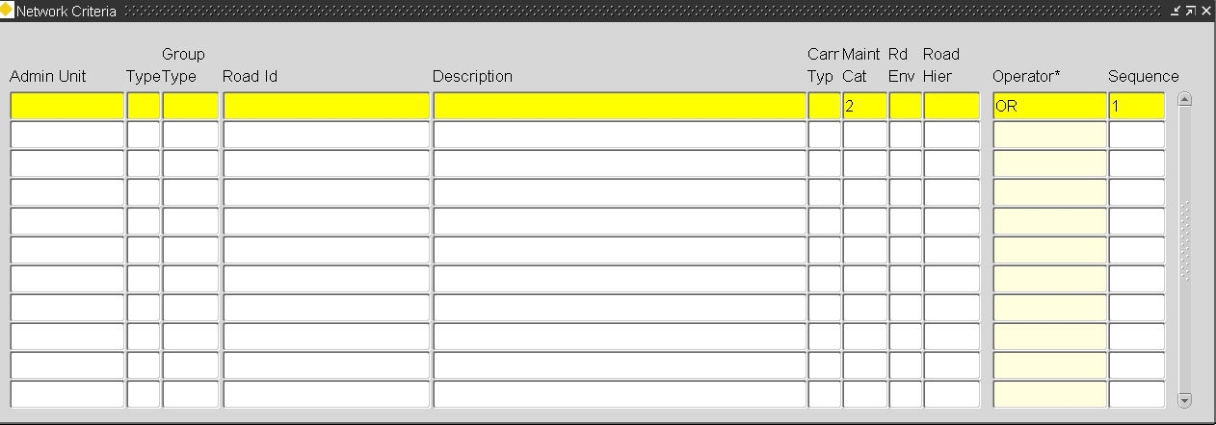
Figure 64

Road Network Criteria

The 'Road Network' Criteria Area allows Road Groups to be selected based on a Road defining characteristics. A single selection parameter or a combination of available parameters may be used.

Figure 64 shows the selection criteria available for creating Road Groups based on Road Network attributes.

This example would select all Road Sections that have a Maintenance Category of '2' – Regional and Primary Routes.

Multiple Selection Criteria may be used to create the required Road Group. If multiple Criteria is to be used the relationship between them is defined by the 'Operator' and 'Sequence' fields as for the Selection Criteria Window.

These are the attributes available to use as selection criteria for the Road Network Criteria Area.

Attribute | Meaning | List Available
Admin Unit | Administration Unit | Y
Sys Flag | System Flag (D or L) | Y
Typ | Record Type (Road Section or Group) | Y
Group Type | Group Type | Y
Road Id | Road Section Id | Y (Gaz)
Carr Typ | Carriageway Type | Y
Main Cat | Maintenance Category | Y
Rd Env | Road Environment | Y
Road Hier | Road Hierarchy | Y

To execute the selection, press the [Save] button on the toolbar.

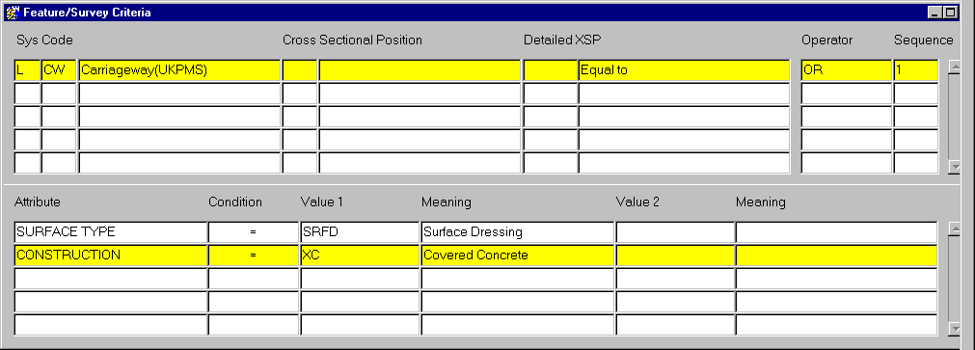
Figure 65

Features/Survey Criteria
The 'Feature/Survey' Criteria Area allows Road Groups to be created on the basis of an Inventory Item or Survey result or a combination of both. It allows the selection of Road Sections that have a Feature or Survey characteristic that matches the selection criteria entered in criteria window. The example in Figure 65 would select all Local Road Sections with a concrete carriageway which have been surfaced Dressed.

To execute the selection, press the [Save] button on the toolbar.

Figure 66

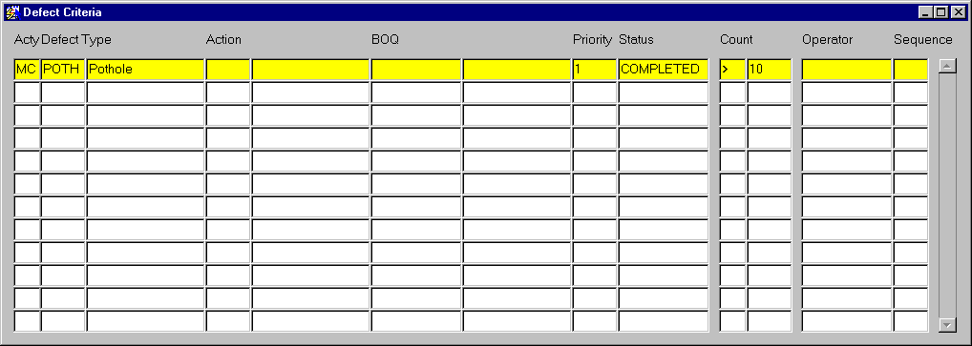

Defect Criteria
The ‘Defect’ Criteria Area allows Road Groups to be selected according to the defects that have occurred on them. A single selection parameter or a combination of available parameters may be used. The example in Figure 66 would select Road Sections with Completed Priority 1 defects that were potholes. A threshold value has also been defined meaning that in order to be included in the Road Group, more than 10 of these defects must exist on a Road Section.

These are the attributes available to use as selection criteria for the Defect Criteria Area.

Attribute | Meaning | List Available
Acty | Activity Area | Y
Defect | Defect Type | Y
Action | Treatment Type | Y
BOQ | Bill Of Quantity item used in repair | Y
Priority | Defect Priority | Y
Status | Defect Status | Y
Count | Threshold Value to qualify for inclusion | N

To execute the selection, press the [Save] button on the toolbar.
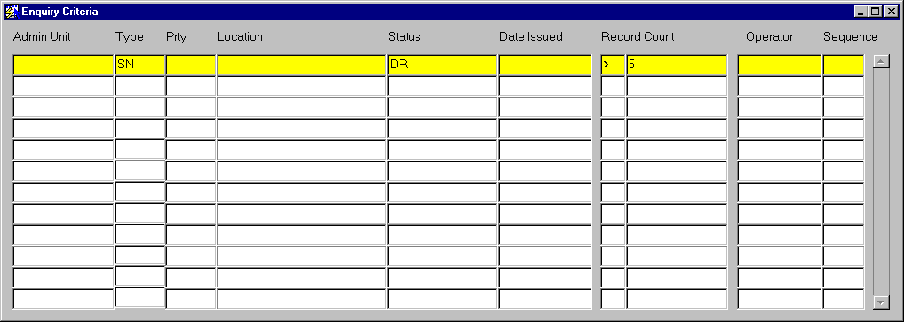
Figure 67

Enquiry Criteria
The 'Enquiry' criteria area allows Road Groups to be created based on Public Enquiries raised against a Road Section. A single selection parameter or a combination of available parameters may be used. The example in Figure 67 would select Road Sections with Enquiries regarding Signs that have had defects raised as a result of the enquiry. A threshold value has also been defined meaning that in order to be included in the Road Group, more than 5 of these enquiries must exist on a Road Section.

These are the attributes available to use as selection criteria for the Enquiry Criteria Area.

Attribute | Meaning | List Available
Admin Unit | Administration Unit | Y
Type | Enquiry Type | Y
Prty | Enquiry Priority | Y
Status | Enquiry Status | Y
Date Issued | Date Enquiry Response Issued | N
Count | Threshold Value to qualify for inclusion | N

To execute the selection, press the [Save] button on the toolbar.

Figure 68
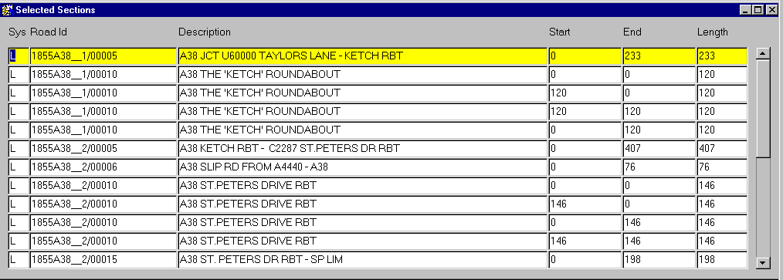

Selected Sections
To view the Road Section selected as a result of a Criteria Based Selection press the [Selected Sections] button on the form.

Chapter
4
Network
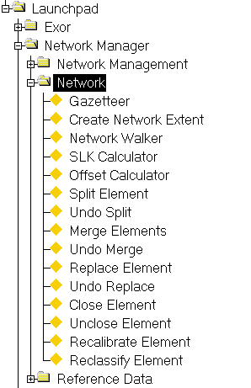
Figure 69
Network menu

This chapter describes the modules and procedures used in the management of a Network. Some of the functionality described, e.g. Gazetteer and Create Network Extent, may be used throughout the Exor Suite of products. The following modules are detailed:

- Gazetteer – NM1100
- Create Network Extent – NM0120
- Network Walker – NM0500
- SLK Calculator – NM1200
- Offset Calculator - NM1201
- LRM Tool – Spatial Data Manager
- Split Element – NM0200
- Undo Split – NM0203
- Merge Elements – NM0201
- Undo Merge – NM0204
- Replace Element – NM0202
- Undo Replace – NM0205
- Close Element – NM0206
- Undo Close – NM0207
- Recalibrate Element – NM2000
- Reclassify Element – NM0220

The form descriptions provide you with detailed information about reference data in Network Manager by Exor, including:

- an overall description of the form.
- a detailed explanation of each field, including available features (such as List of Values, default values and other characteristics).
- helpful information for using the form

Gazetteer – NM1100
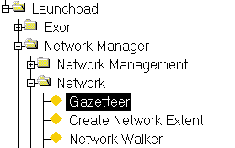
Figure 70
Gazetteer
Menu Option

The Gazetteer is the main way in which a Region of Interest is selected for querying or reporting purposes and may be called in either Standard Mode or Advanced Mode. The initial calling mode of the Gazetteer is determined by the value for User/Product Option GAZMODE. The allowable values are ‘STANDARD’ and ‘ADVANCED’. Irrespective of the initial calling mode the User may toggle between the ‘Standard’ and ‘Advanced’ modes using the appropriate button on the Gazetteer. Network Data may also be passed between the 2 modes to allow more details ‘filtering’ in the Advanced Gazetteer for example.

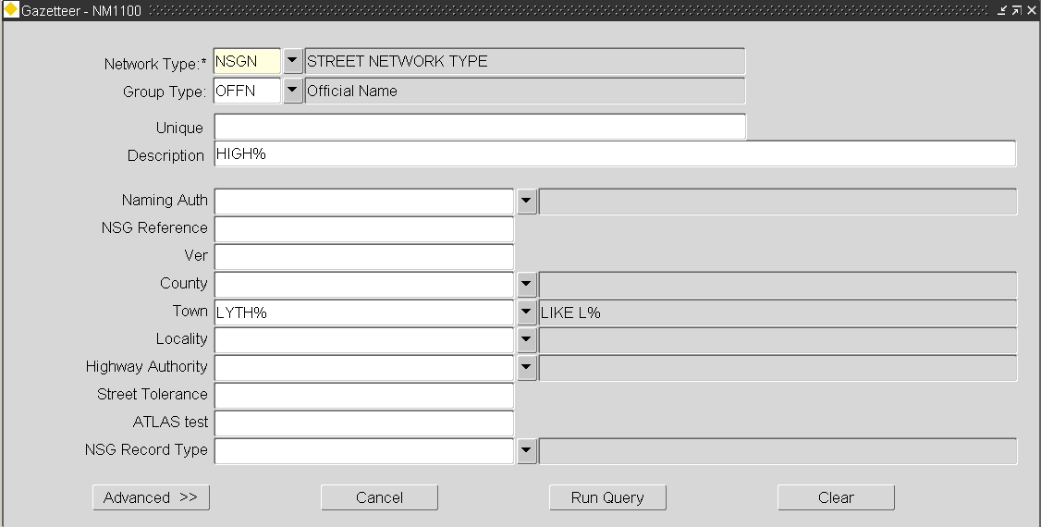
Figure 71

Standard Gazetteer
The ‘Standard’ Gazetteer is a simple yet powerful tool that allows the User to select a Road Group or Datum Network Element, e.g. an ESU, by applying a query based upon the Network Attributes defined for the selected Network Type in the NM0002 – Network Types. The available Attributes are those defined as being ‘Displayed’ as well as the Unique value and Description fields.

When more than one query criteria is used an ‘AND’ relationship is used within the query. Wildcard characters may be used in any field.

The default Network Type or Network Type/Group Type combination can be set using User/Product Option GAZ_RGT (refer to the Network Manager System Admin Guide for more details).

To switch to the ‘Advanced’ Gazetteer without running the query press the
[Advanced >>] button. The currently select Network Type and or Group Type will be ‘passed into’ the appropriate fields.

Once the appropriate criterion has been entered, press the [Run Query] button to search for all Network Groups or Elements that match the defined criteria. These will be displayed along with their Network Attributes in the ‘Results’ window (Figure 72).

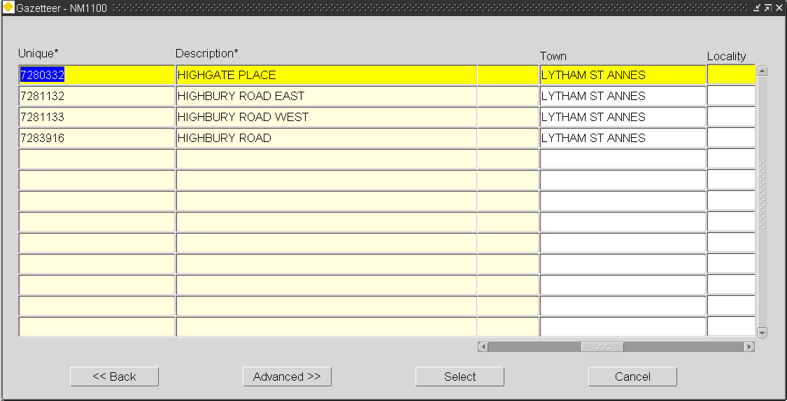
Figure 72

The Standard Gazetteer results window displays the Network Groups or Datum Elements that match the defined query criteria. The Unique Name and Description are shown along with those Network Attributes defined as being ‘Displayed’ in NM0002 – Network Types. These attributes may be viewed by using the horizontal scroll bar.

The original query may be refined by pressing the [<< Back] button that will return the User to the ‘Standard Gazetteer’ query window that will display the original query criteria.

If the required Road Group or Datum Element is to be further ‘filtered’ it may be selected and passed into the ‘Advanced Gazetteer’ by pressing the [Advanced >>] button. An example of this may be where a Maintenance Section is selected and passed into the ‘Advanced Gazetteer’ to restrict the selection to an appropriate offset range.

To select Road Group or Datum Element and pass it back to the calling form as the Region of Interest, highlight the required record and press the [Select] button.

Note that the [Select] button is not available when the Gazetteer is called directly from the Launchpad or User Favourites etc.

Figure 73
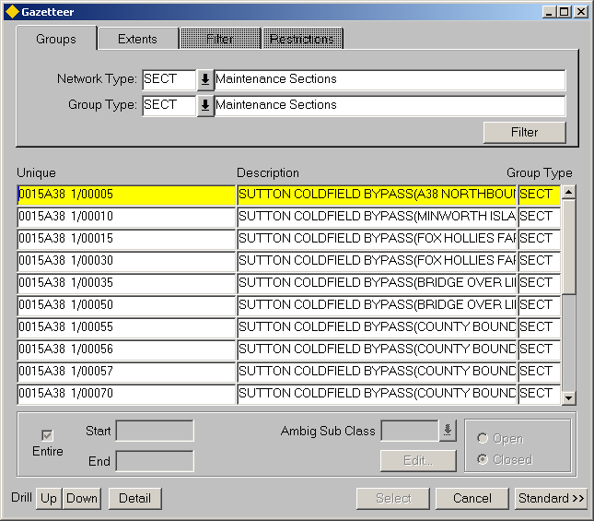

Advanced Gazetteer
The ‘Advanced Gazetteer’ allows the User to navigate through a Network Group hierarchy by Drilling up or down through the hierarchy and select a Group at any level, or continue down through the hierarchy to an individual Network Element. Once the required Group or Element is located it may be selected and the resulting ‘set’ passed back into the calling form.

Alternatively, the selected ‘set’ could be passed into a form called from the Gazetteer Function toolbar or displayed on in Locator.

Saved Network Extents may also be selected via the ‘Extents’ Tab on the form. These Saved Extents may then be displayed in Locator by using the GIS functions available on the Floating Toolbar.

Complex filters based on Asset and/or Datum Network Element Attributes may be defined to restrict the extent of Network data returned from the Gazetteer to only the Network locations within the selected Group or saved Network Extent that meet the filtered query criteria.

If a Linear Group or Route is selected the required start and end Offsets on the Route may be defined. It should be noted that if this restricted selection is used when querying continuous Events, all Events of the selected type which are either wholly or partially located within the selected extent of Network will be returned. An Asset or Network Attribute filter may be applied in conjunction with the Start/End Offset filter if required.

A filter flag may also be set to include or exclude point Events which are located coincident with a Network Node point on the selected Group or Route, but which has actually been located on an adjacient Route.

The Gazetteer can also be used as a launching platform for Create Network Extent – NM0120 . This is particularly useful when defining a Region of Interest for a PBI Query or an Asset Merge (Engineering Dynamic Segmentation) for example. The Region of Interest is selected via the Gazetteer, but if a Network Group or saved Network Extent does not match the required region, a new Network Extent may be created and automatically passed back to the Gazetteer for selection.
Figure 74
Gazetteer button
The Gazetteer may be called by pressing the [Gazetteer] button on the menu toolbar (Figure 74) or via some List of Values, for example, when defining a Region of Interest for a PBI query. It may also be called directly from the Exor menu.

Certain restriction will be imposed on the type of Network data that may be selected from the Gazetteer. The calling method or Exor form from which the Gazetteer was launched will determine this restriction. For example, a restriction will be imposed to allow only Groups at the first level of the hierarchy, i.e. Groups whose members are Network Elements, to be selected if the Gazetteer is called from within Groups of Sections - NM0110 .

These Restrictions are displayed on the Restrictions window of the Gazetteer.

A hierarchy browser may be displayed on the right hand side of the Gazetteer window. This allows the hierarchy of the selected Group to be displayed ‘pictorially’. The display of the hierarchy browser may be toggled on or off by selected the [Hierarchy] – Show/Hide Hierarchy Button on the Floating Toolbar.

Normal Admin Unit based security is enforced when using the Gazetteer, i.e. a User will only see the Network Groups and Elements for which they have sufficient Admin Unit privileges.

A User will only have access to Network Extents for which they are the ‘Owner’ or Extents that have been granted ‘Public’ Ownership.
Figure 75
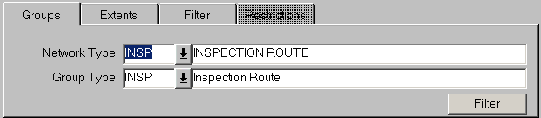
Groups

Groups
The Groups Tab allows a Network Type or Group Type to be selected. These may be used individually to display all the Network Elements of a certain Network Type or to display all of the Groups of a certain Group Type, or in combination where several Groups Types are associated with the same Network Type. If a Preferred LRM (Linear Group Type) has been defined, the Group and Network Type will be displayed as default. To select a different Network Type or Group Type press the [Clear Record] on the menu toolbar and enter the required Group and/or Network Type.

The list of Groups displayed for the Group and/or Network Type selected may be restricted by applying a simple Filter. The Filter may comprise of any combination of the flexible network attribute associated with the Group/Network Type and some fixed attributes. See page 77 for details.

Network Type (Optional) (List)
Enter the Network Type from which to select the required Network records.

Group Type (Optional) (List)
Enter the Group Type from which to select the required Network records.

When the required Network Type or Group Type has been entered click in the main table panel to view the selected Groups or Elements. The hierarchy browser will display the selected Groups and Elements in the third panel on the right hand side of the Gazetteer window if currently active.

Figure 76
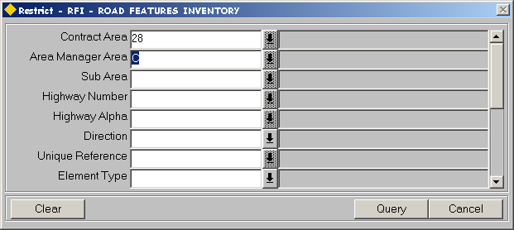

Restrict / Filter

The Restriction Filter allows the list of Groups displayed in the 'Groups' panel to be restricted based upon a combination of fixed and flexible Network attributes. This enables a simple filter to be applied without the need for complicated 'query strings' containing wildcard characters etc.

Any of the flexible Network Attributes associated with the selected Group / Network Type which have been flagged as 'Displayable' may be used along with the following 'fixed attributes.

Element Type List
This is the Type of Network Element. The available list is as follows:

- P Groups of Groups
- G Group of Sections/Datum Elements
- S Section / Datum Element
- D Distance Break

Admin Unit List
This is the Admin Unit of the Group / Element. The LOV will be restricted to those Admin Units of the Admin Type associated with the Group / Network Type to which the User has access.

Start Date
This is the start date of the Group / Element

End Date
This is the End Date of the Group / Element, if it has been closed.

Date Created
This is the internal date on which the Element (Group or Datum) was created and may differ from the Start Date

Date Modified
This is the internal date on which the Element (Group or Datum) was modified

Modified By
This is the Username (Oracle Username) of the User who last modified the record.

Created By
This is the Username (Oracle Username) of the User who created the record

Consider an example. The Unique of a Group Type comprises of the following Network Attributes, each separated with a hyphen '-':

- Contract Area, e.g. 28
- Area Manager Area, e.g. C
- Sub Area, e.g. D
- Highway Number, e.g. 00171
- Highway Alpha, e.g. 1

An example of the Unique of this Group Type is 28-C-D-00171-2. To restrict the list of Groups of this type displayed in the Gazetteer to those Groups that are in Contract Area 28 and Area Manager Area C a Filter could be applied as shown in Figure 76.

Note that widcard characters may be used when entering Attribute values.

Once the required selection criteria has been entered press the [Query] button to display the records that match the selection criteria or [Cancel] to return to the Gazetteer without executing the Filter.

To clear the current filter press the [Clear] button.

Figure 77
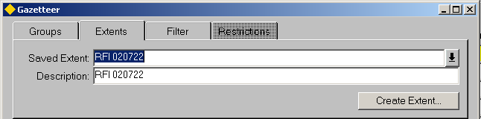
Extents

Extents
The Extents Tab allows a saved Network Extent to be selected or a new Extent to be created by calling Create Network Extent – NM0120 . Only saved Network Extents for which the current User is the ‘Owner’ or Extents that have been granted ‘Public’ Ownership will be available for selection. Although a User may have access to a Network Extent, their Admin Unit privileges will determine to which Datum Network Elements they have access within the selected Network Extent.

When the Create Network Extent - NM0120 module is called using the [Create Extent] button on the Extents tab, the resulting Extent is automatically queried as the ‘Saved Extent’ once the Extent has been saved and the Create Network Extent module is closed.

When the required saved Extent has been selected click in the main table panel to view the selected Groups or Elements. The hierarchy browser will display the selected Groups and Elements in the third panel on the right hand side of the Gazetteer window if currently active.

Figure 78
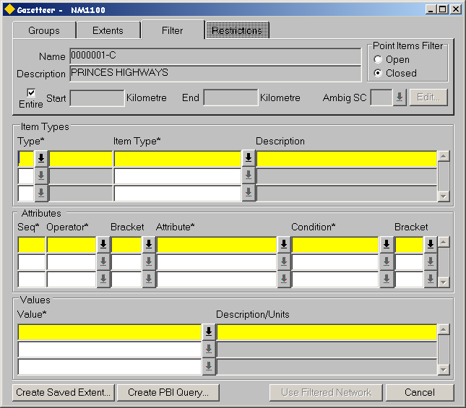

Filter
This window is used to apply a Filter to the selected Group or Network Extent. Complex filters based on Asset and/or Datum Network Element Attributes may be defined to restrict the extent of Network data returned from the Gazetteer to only the Network locations within the selected Group or saved Network Extent that meet the filtered query criteria.

If a Linear Group or Route is selected the required start and end Offsets on the Route may be defined. It should be noted that if this restricted selection is used when querying continuous Events, all Events of the selected type which are either wholly or partially located within the selected extent of Network will be returned. An Asset or Network Attribute filter may be applied in conjunction with the Start/End Offset filter if required.

A filter flag may also be set to include or exclude point Events which are located coincident with a Network Node point on the selected Group or Route, but which has actually been located on an adjacent Route.

Note that the Filter Tab will be disabled when the Filter functionality is unavailable. For example, when the Gazetteer is called directly from the Menu Toolbar.

Figure 79
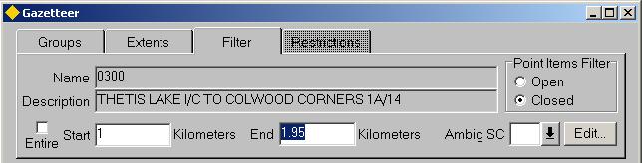

Filtering a Route between specified Start and End Offsets
If a Linear Group or Route is selected a filter may be applied so as to return only the extent of Network between specified Start and End Offsets on the Route. The default option is to return the entire Route or Linear Group. To restrict the Gazetteer query to the extent of Network between specified Start and End Offsets uncheck the 'Entire' check box and add the required start and end Offsets as required in the 'Start' and 'End' fields respectively.

If the Start and End Offsets are to be defined relative to an Intersection or Datum Element along the Route the 'Extent Limits' window (Figure 81) may be called by pressing the [Edit] button.

Note that if an entire Route is required, performance will be enhanced by ensuring the 'Entire' checkbox is selected as opposed to specifying the minimum and maximum Offsets of the Route.

Entire (Checkbox)
Uncheck this if the Linear Group or Route is to be restricted by Start and End Offsets. This option is only available if a linear Group or Route is selected.

Start
If the 'Entire' checkbox is unselected, enter the required Start Offset. The default value is the minimum Offset of the selected Route.

End
If the 'Entire' checkbox is unselected, enter the required End Offset. The default value is the maximum Offset of the selected Route.

Ambig SC (Ambiguous Subclass)
Any Ambiguous references within the selected extent limits may be automatically resolved by entering the required Network Type Sub-Class in the ‘Ambig SC’ field.

Consider the example in Figure 80.

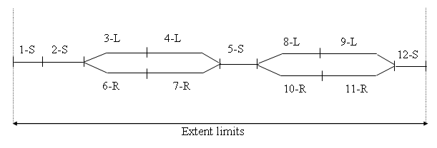
Figure 80
Extent limits

The Route displayed in Figure 80 contains a combination of Network Type Subclasses. A Gazetteer selection is required within the extent limits shown, but only where the Network Type Sub Class is either ‘S’ – Single or ‘L’ – Left.

By entering a value of ‘L’ – left in the 'Ambig SC' field, the Gazetteer selection will include ALL Elements (or parts of) with a Network Type Subclass of ‘S’ – Single and those Elements (or parts of) with a Network Type Sub Class of ‘L’ –Left. Therefore the Gazetteer selection would include the following Elements

- 1-S
- 2-S
- 3-L
- 4-L
- 5-S
- 8-L
- 9-L
- 12-S

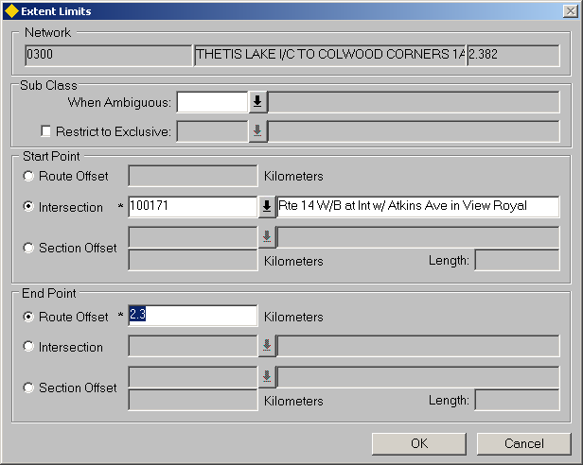
Figure 81

Extent Limits
The Extent Limits window may be called by pressing the [Edit] button on the Filter panel and allows the Start and End points on the selected Route to be defined by Route Offset, Intersection or Section Offset. For example, to select a Route extent comprising of the first Kilometer of the Route, the Start Point would be defined as having a Route Offset of ‘0’ and the End Point defined as having a Route Offset of ‘1’ (assuming the minimum Offset of the Route is Zero)

The tables below show 3 scenarios for Extent Limits, to demonstrate the possibilities.

Scenario 1

Parameters | Start Point | End Point | Result
Route Offset | 1 | 3.5 | Elements or partial Elements contained between Route Offset 1 and 3.5 Kilometers
Intersection
Section Offset

Scenario 2

Parameters | Start Point | End Point | Result
Route Offset |  | 0.24 | Elements or partial Elements contained between the Intersection at Node 82730 and Route Offset 0.24
Intersection | 082730
Section Offset

Scenario 3

Parameters | Start Point | End Point | Result
Route Offset |  | 5.6 | Elements or partial Element contained between 35m along Element H004/1-S and Route Offset 5.6 Kilometers
Intersection
Section Offset | H004/1-S  35

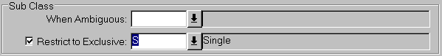
Figure 82
Network Extent
Subclass

Sub Class
The ‘Sub Class’ panel of the Extent Limits window allows the User to choose the Sub Class of the Elements, within the defined extent limits, to be included in the Network Extent. If neither the Sub Class ‘When Ambiguous’ or ‘Restrict to Exclusive’ field are populated, the Elements of all Sub-Classes within the defined extent limits will be entered into the Network Extent.
Restrict to Exclusive
Elements may be restricted to a single ‘Exclusive’ Sub Class by selecting the ‘Restrict to Exclusive’ check box and entering the required Sub-Class in the adjacent field. This will restrict the Elements selected to those that match the selected Sub Class.

Consider the example in Figure 83.

Figure 83
Extent limits

The Route displayed in Figure 83 contains a combination of Network Type Subclasses. A Network Extent is required within the extent limits shown, but only where the Network Type Sub Class is ‘L’ – Left.

By selecting the ‘Restrict to Exclusive’ checkbox and entering a value of ‘L’ – left in the adjacent field, the Network Extent will only include Elements (or parts of) with a Network Type Subclass of ‘L’ – Left. Therefore the Network Extent would include the following Elements

- 3-L
- 4-L
- 8-L
- 9-L

Ambiguous References
Any Ambiguous references within the selected extent limits may be automatically resolved by entering the required Network Type Sub-Class in the ‘Sub-Class When Ambiguous’ field.

Consider the example in Figure 84.

Figure 84
Extent limits

The Route displayed in Figure 84 contains a combination of Network Type Subclasses. A Network Extent is required within the extent limits shown, but only where the Network Type Sub Class is either ‘S’ – Single or ‘L’ – Left.

By entering a value of ‘L’ – Left in the Sub Class ‘When Ambiguous’ field of the extent limits window, the Network Extent will include ALL Elements (or parts of) with a Network Type Subclass of ‘S’ – Single and those Elements (or parts of) with a Network Type Sub Class of ‘L’ – Left. Therefore the Network Extent would include the following Elements

- 1-S
- 2-S
- 3-L
- 4-L
- 5-S
- 8-L
- 9-L
- 12-S

When the Start and End parameters have been defined press the [OK] button on the Extent Limits window.

Network (Display Only)
The Unique Route reference description and maximum Offset of the Route will be displayed.

Sub Class When Ambiguous (Optional)
Enter the required Network Element Sub Class for Elements that should be selected if any ambiguity arises.

Sub Class -Restrict to Exclusive (Optional)
Enter the required Network Element Sub Class to which the selection should be restricted.

Start Point

Select one of the following Radio button to define the Start Point along the selected Route. The default selection is by Route Offset.

Route Offset
Enter the Route Offset for the Start Point. This should be entered in the unit of measurement defined for the selected Group or Network Type. The defined Unit will be displayed adjacent to the Route Offset measure.

Intersection (List)
Enter the Node point of the Intersection for the Start Point. The list of values will display all the Intersection Node details for the selected Route.

Section Offset (List)
Enter the Unique Element reference for the Start Point. The Element description will be displayed in the adjacent field. The list of values will display all the Network Element within the selected Route.

Enter the Element Offset in the unit of measurement defined for the Datum Element in Network Types - NM0002. The measured length of the Element will be displayed in the adjacent field.

End Point

Select one of the following Radio button to define the Start Point along the selected Route. The default selection is by Route Offset

Route Offset
Enter the Route Offset for the End Point. This should be entered in the unit of measurement defined for the selected Group or Network Type. The defined Unit will be displayed adjacent to the Route Offset measure.

Intersection (List)
Enter the Node point of the Intersection for the End Point. The list of values will display all the Intersection Node details for the selected Route.

Section Offset (List)
Enter the Unique Element reference for the End Point. The Element description will be displayed in the adjacent field. The list of values will display all the Network Element within the selected Route.

Enter the Element Offset in the unit of measurement defined for the Datum Element in Network Types - NM0002. The measured length of the Element will be displayed in the adjacent field.

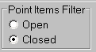
Figure 85

Point Items Filter
A Point Items Filter may be set to include or exclude point Events which are located coincident with a Network Node point on the selected Group or Route, but which has actually been located on an adjacent Route. If the Point Item Filter is 'Open' then all Point Items located on the selected Route extent or located on connected Routes, but coincident with the connecting Node point will be included in the Gazetteer query. If the Point Item Filter is 'Closed' only Point Items that are specifically located on the selected Route (within the selected Route extent) will be included.

Consider an example.

Figure 86 shows a Route (9999) that has 2 intersecting Routes, namely 9991 and 9992. Two Point Items are located on Route 9999, namely P1 and P3. Items P2 and P4 are located on Routes 9991and 9992 respectively but are coincident with the Network Node Points which provide the connectivity with Route 9999, i.e. Item P4 is located on Route 9992 at an Offset of 0.

Figure 86

Route 9991
Route 9992
P1
P2
P3
P4

Route 9999

If an 'Open' Filter is applied to Route 9999 all 4 point Items would be selected. However if the Filter was 'Closed' only items P1 and P3 would be returned.

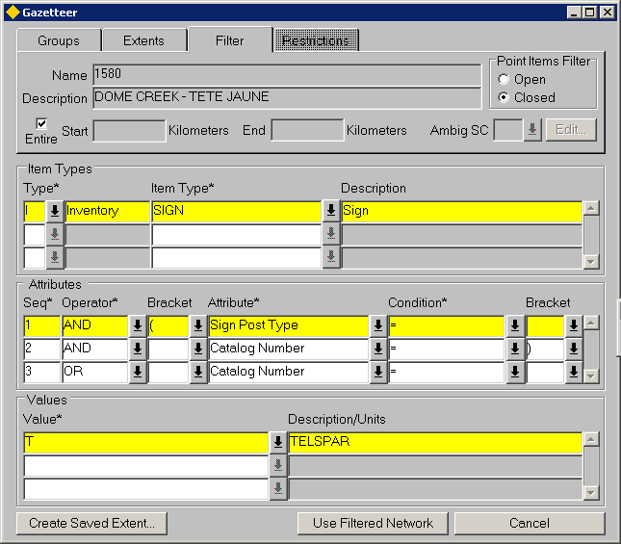
Figure 87

Filtering a Route by an Asset / Network Attribute Query
Complex filters based on Asset and/or Datum Network Element Attributes, or the existence of an Item, may be defined to restrict the extent of Network data returned from the Gazetteer to only the Network locations within the selected Group or saved Network Extent that meet the filtered query criteria. If the selected Group is a Linear Group or Route the query filter may be used in conjunction with 'Route Start/End filter' if required.

The Gazetteer Filter may be based purely on the existence of an Item within the selected Group or Network Extent. For example, a Filter may be applied to a Group representing an entire Regional Area to return the Network locations where items of Guard Rail exist. This type of Filter does not require any Attributes to be defined for the Item Type.

The Gazetteer Filter may be based upon a single Asset Type or a Datum Network Type or on a combination of several different Asset Types. If more than one Item (either Asset or Network) is used an 'AND' relationship between the Items will be established and the resulting Network locations returned from the Gazetteer will correspond to the Network locations where ALL of the Filter query criteria are met.

Each Item Type selected for the Gazetteer Filter may be queried on a single Attribute and value or Multiple Attribute and value combinations. If multiple Attributes are selected the relationship between the Attributes may be defined as an 'AND' or 'OR' relationship. Attribute criteria may also be nested with 5 levels of nesting available if required.

When a Filtered Gazetteer query is used in modules such as Asset Items - NM0510 all items that are located either wholly or partially within the ‘Filtered Network ‘ will be included.

The Network locations resulting from a Gazetteer Filter query may be saved for future use by creating a Saved Network Extent.

The following examples demonstrate some practical uses for the Gazetteer Filter query. These are not designed to be exhaustive, but instead demonstrate the functional uses.

Example 1 - Filtering on Network Attributes
This example uses Attributes of a Base Datum Network Type (LCWY - Link Carriageway) to restrict the Network locations of the selected Saved Network Extent to those Elements which have a Carriageway Code of 'C' (carriageway code is a flexible attribute) AND a length of over 150.

Selected Group / Extent |  |  |  |  | Sydney Region
Type |  | Item Type |  |  | Description
E - Element |  | LCWY |  |  | Link Carriagway
Seq | Operator |  | ( | Attribute |  | Condition | ) | Value
1 |  |  |  | Carriageway Code |  | = |  | C
2 | AND |  |  | Element Length |  | > |  | 150

Example 2 - Filtering on Single Asset Type
This example uses Attributes of an Asset Type of 'SIGN' to return the Network locations where Signs with a Sign Post Type of M (Metal) and the Sign Catalogue Number is C-031 (Reduce Speed) are located or where Signs with a Catalogue number of C-029X (Prepare to Stop), irrespective of the Sign Post Type, are located on a Route Named the H123.

Selected Group / Extent |  |  |  |  | H123 - Snowy Mountain Pass
Type |  | Item Type |  |  | Description
I - Asset |  | SIGN |  |  | Road Signs
Seq | Operator |  | ( | Attribute |  | Condition | ) | Value
1 |  |  | ( | Sign Post Type |  | = |  | M
2 | AND |  |  | Catalogue Number |  | = | ) | C-031
3 | OR |  |  | Catalogue Number |  | = |  | C-029X

Example 3 - Filtering on Multiple Asset Types
This example uses multiple Asset Types, namely FC- Functional Class and DR - Dust Range, to return the Network locations on a Route (9999 - Mountain Overpass) where the Functional Class in ''N' - Minor, and the Dust Range Warrant Type is 'S' Sign.

Selected Group / Extent |  |  |  |  | 9999 - Mountain Overpass
Type |  | Item Type |  |  | Description
I - Asset |  | FC |  |  | Functional Class
Seq | Operator |  | ( | Attribute |  | Condition | ) | Value
1 |  |  |  | Functional Class |  | = |  | N
Type |  | Item Type |  |  | Description
I - Asset |  | DR |  |  | Dust Range
Seq | Operator |  | ( | Attribute |  | Condition | ) | Value
1 |  |  |  | Warrant Type |  | = |  | S

Figure 88 shows the Network location returned from the Gazetteer Filter.

Figure 88
0
5
10
20
Functional Class = N
Dust Range = S
Gazetteer Filter Results

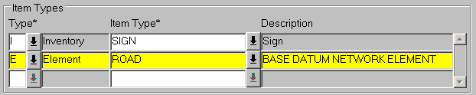
Figure 89

Item Types Panel
The Item Types panel is used to specify the Item category (Asset or Element) and the Item Type, e.g. SIGN, to be used in the Gazetteer Filter query. If more than one Item type is specified an 'AND' relationship is established between the Types.

The Gazetteer Filter may be based purely on the existence of an Item within the selected Group or Network Extent. For example, a Filter may be applied to a Group representing an entire Regional Area to return the Network locations where items of Guard Rail exist. This type of Filter does not require any Attributes to be defined for the Item Type.

Type (Required) List
Select the Item category. This will be either 'E - Element' if filtering on Datum Network Attributes or 'I - Asset' if filtering on the Attributes of an Asset Type.

The Type description will be displayed in the adjacent field.

Item Type (Required) List
Select the required Item Type for the filter. If the Item category selected is 'E - Element' the list of values will contain a list of Datum Network Types. If 'I - Asset' has been selected, the list of values will contain a list of Asset Types to which the user has Role based access including any Foreign Table Asset Types.

The Item Type description will be displayed in the adjacent field.

To add another Asset Type press the [Create Record] button on the menu toolbar.

Figure 90
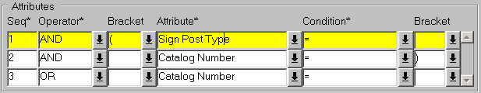

Attributes Panel
The Attributes panel is used to define the Attributes of the selected Item Type to be used in the Gazetteer Filter. If multiple Attributes are selected the relationship between the Attributes may be defined as an 'AND' or 'OR' relationship. Attribute criteria may also be nested with 5 levels of nesting available if required by using the Pre and Post brackets as required.

Seq (Required)
Enter the sequence number for the Attribute. Attributes values are resolved in the defined sequence order.

Operator (Required) List
Select the required Boolean connector.

Note that the Operator or the Sequence 1 Attribute must always be 'AND'.

Bracket List
If required select the appropriate Pre Bracket.

Attribute (Required) List
Select the Attribute of the selected Item to be used in the Gazetteer Filter.

Condition (Required) List
Enter the condition for the selected attribute. These are standard Oracle conditions and are set up and maintained using Domains - HIG9120 and updating the PBI_CONDITION option.

Bracket List
If required select the appropriate Post Bracket.

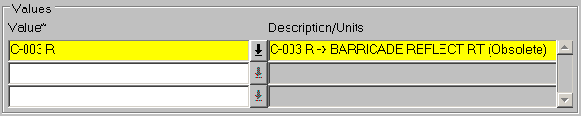
Figure 91

Values Panel
This panel is used to define the parameter values for the currently selected Attribute. For example, if Asset Type PAOR – Pavement Original was being used to Filter all Network locations with Width value of greater than 9m, a value of ‘9’ would be entered.

Value (Required) (List)
Enter the required ‘Query’ value for the currently selected Attribute. If the attribute values are held in a Domain, the List of Values may be called and the description of the selected value will be displayed. If the ‘Condition’ entered for the Attribute is ‘BETWEEN’ enter the second value in the field below.

To apply the Gazetteer Filter press the [Use Filtered Network] button.

If the Gazetteer Filter is to be re-used a saved Network Extent may be created. This will contain the Network locations that meet the Gazetteer Filter query criteria.

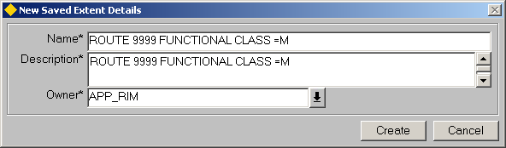
Figure 92

Create a Saved Extent from a Gazetteer Filter
To create a saved extent of the Network Locations returned from the Gazetteer Filter, press the [Create Saved Extent] button. This will call the New Saved Extent Details dialogue window as shown in Figure 92.

Name (Required)
Enter a unique name for the Network Extent. This name will be displayed in the ‘Saved Extents’ window of the Gazetteer. A maximum of 30 characters is allowed.

Description
Enter a Description for the Network Extent in the adjacent field, a maximum of 60 characters is allowed.

Owner (Required)
Enter the Owner of the extent. If the Owner is defined as PUBLIC all Users will have access to the Network Extent.

For full details on Network Extents refer to page 108 of this reference guide.

Figure 93
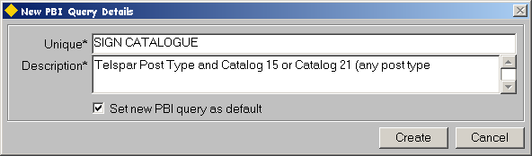

Create a PBI Query from a Gazetteer Filter

A new saved PBI Query may be created from the criteria defined within a Gazetteer Filter by pressing the [Create PBI Query…] button. This will call the 'New PBI Query Details' dialogue as shown in Figure 93.

Unique (Required)
Enter a Unique Name for the PBI query. A maximum of 30 characters are permitted.

Description (Required)
Enter a Description for the new PBI Query. A maximum of 80 characters is permitted.

Set new PBI query as default
If this checkbox is selected the new PBI query will be set as the default PBI query for use in Assets on Route - NM0560 (refer to the Asset Manager User Guide).

To create the new PBI Query press the [Create] button or [Cancel] to close the dialogue window without creating a new PBI.

When the new PBI query has been created a message will be displayed informing the User that the operation has been successful.

Figure 94
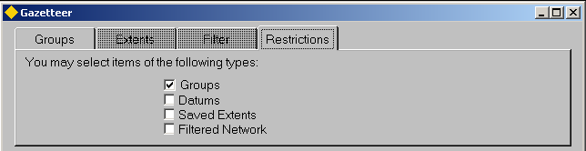
Restrictions

Restrictions
This window is for Display purposes only and displays the Item type that may be selected from the Gazetteer. Valid Item types will be determined by the calling method of the Gazetteer. For example, if the Gazetteer is called form within the Groups of Sections - NM0110 form, a Restriction will be imposed to allow only Groups at the first level of the hierarchy, i.e. Groups whose members are Network Elements, to be selected.

In cases where no Restrictions are imposed, e.g. when the Gazetteer is called from the Asset Items - NM0510 module, the Restrictions tab will be ‘grayed out’ as it is not applicable.

Figure 95
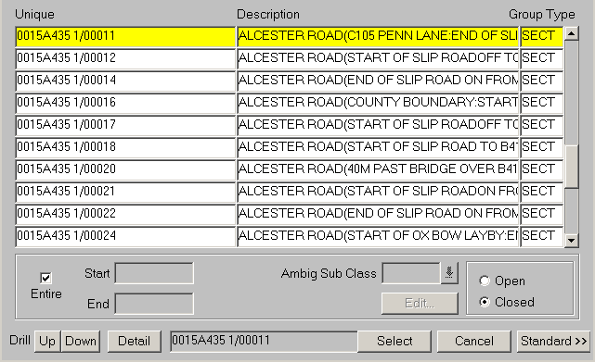
Group / Network Type
membership

Group/Network Type Membership

This window displays the members of the selected Network Group or Network Extent and is populated when any row within the panel is selected. The displayed values are:

- Unique Element Value, i.e. Unique Group or Network Element reference
- Element Description
- Group Type

The list of displayed members may be restricted using the [Filter] button. See page 77 for more information.

The hierarchy browser will display the selected Groups and Elements in the panel on the right hand side of the Gazetteer window if currently active.

If a Preferred LRM has been defined using the User Preferences window (refer to the General User Guide) the membership panel will be displayed in query mode with the Cursor focused in the 'Unique' field awaiting some selection criteria to be entered. To retrieve all Groups of the selected Network/Group Type press the [Execute Query] button on the menu toolbar.

If the ‘Unique’ reference or Description of the required Element or Group is known this may be used to query back the required record. Enter the Element/Group Unique or Description (Wildcards may be used) in the appropriate field followed by [Execute Query]. This will query back all the ‘qualifying’ Elements or Groups. For example to query a Group named ‘PEMBERTON-NORTHBROOK’ enter ‘PEMBERTON%’ in the Description field. This will query back all Elements or Groups that start with the word Pemberton.

Note that the Gazetteer is not case sensitive.

To select a Group or Element from this panel either highlight the required record and press the [Select] button or select the required record and double click the left mouse button. A Group or Element may only be selected using these methods if the Gazetteer has been called from within another Exor form.

If the selected Group is a Linear Group or Route, the selection may be restricted to a certain a Offset range on the Route by entering the appropriate Start and End Offsets in the Start and End fields respectively. For full information on the use of this functionality and the Point Item filter refer to page 81 of this User Guide.

Note that restriction may be imposed on the Item Types that may be selected. These restrictions will be displayed on the Restriction tab .

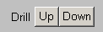
Figure 96
Drill Up / Down

Drilling through the Group Hierarchy
The Drill [Up] [Down] buttons on the Group/Network Type Membership panel allow the User to Navigate up or Down through the Group Hierarchy of the selected Element or Group. If a Group is currently selected and the Drill [Down] button is pressed, all members of the selected Group will be displayed. This may be Datum Network Elements (if the selected Group was a Group of Elements) or other Groups (if the selected Group was a Group of Groups).

When Drilling [Up] all Groups of which the selected Group or Element is a member will be displayed.

To exit the Gazetteer without selecting any records press the [Close] button.

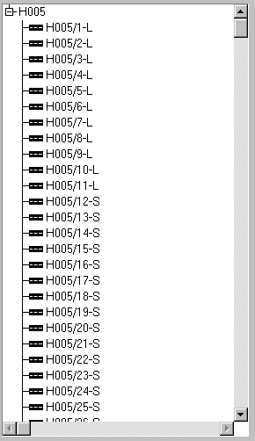
Figure 97
Network Hierarchy
Browser

Network Hierarchy Browser
The Network Hierarchy Browser provides a ‘pictorial’ representation of the Elements of the selected Network Group or Extent. It utilizes the Icon images defined for a Group Type in Group Types - NM0004 and displays these adjacent to the Unique reference of the sub member.

The display of the hierarchy browser may be toggled on or off by selected the [H] – Show/Hide Hierarchy Button on the Floating Toolbar.

To expand the ‘tree’ and show the next level of hierarchy for the selected item press the [+] symbol adjacent to the Group Reference. To collapse the ‘tree’ press the [-] symbol.

To select a Group or Element from this panel either highlight the required record and press the [Select] button or select the required record and double click the left mouse button. A Group or Element may only be selected using these methods if the Gazetteer has been called from within another Exor form.

Note that restriction may be imposed on the Item Types that may be selected. These restrictions will be displayed on the Restriction tab ( Page 98).

Further details of the selected Group or Element may be displayed by clicking the right mouse button and selecting the ‘Details’ option from the context menu. This window is for display only and no updates are allowed.
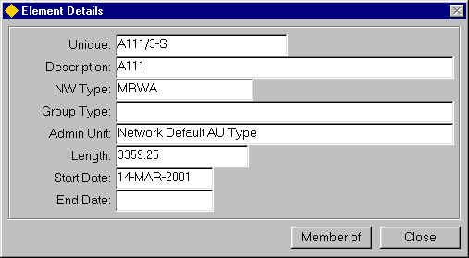
Figure 98
Element Details

The Group or Elements details displayed are:

- Unique Reference
- Description
- Network Type
- Group Type (if applicable)
- Admin Unit
- Length (if applicable)
- Start Date
- End Date

Note that End Dated Groups or Element may be viewed by setting the ‘Effective Date’ to a temporal stage where the Group or Element was not End Dated.

To exit the window, press the [Close] button.

To view the Element membership details, i.e. which Groups the selected Element is a Member Of, press the [Member Of] button on the Element Details window. The Element Members window will be displayed
Drill Up / Drill Down

The Drill Button on the hierarchy browser allows the selected Element or Group to be displayed in several different ways.

If a Network Element is selected, e.g. H001/2-S, and the [Drill Up] button is selected it will display the hierarcy for the selected Element ‘from bottom up’ with the Element at the top of the tree and the Groups of which it is a member cascading down the hierarchy as in Figure 99.

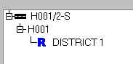
Figure 99
Drill Up

To reset the View press the [Drill Down] button or the [Refresh] button.

Figure 100
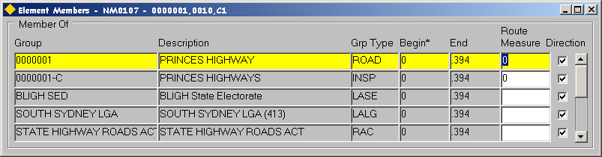
Network Element
Membership

Network Element Membership

This window is for display only, i.e. no data may be updated, and is called by pressing the [Member Of] button on the Element Details window. It displays a list of the Groups of which the selected Network Element is a member.

If the selected Element is only partially contained within the Group the start and end offsets relative to the measured Element length will be displayed in the ‘Begin’ and ‘End’ field respectively. For example, if the first 50 m of Element H001/10-L were contained within a Group the ‘Begin’ and ‘End’ field would be displayed as ‘0’ and ‘50’ respectively.

The Route Offset or SLK will be displayed for Linear Groups in the Route Measure field.

If the Element runs in the Cardinal direction of a Parent Linear Group (e.g. the Route Group) the ‘Direction’ flag will be set.

The Cardinal Direction of a Route or Linear Referencing Method is needed to configure the Datum Network Elements that form the Group in the same direction. The cardinal direction of the route is deemed to be that of increasing measure, the datum elements linear reference direction is deemed to be from start to end node and this may be a reversal of the route direction.

Figure 101
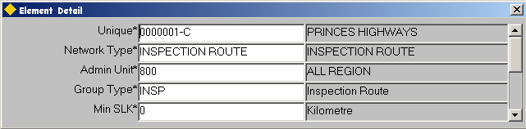

Element Details
The Details of the selected Datum Element or Group, including displayable flexible attributes, may be displayed by pressing the [Details] button at the bottom of the Gazetteer. If the selected record is a linear group the Route Details will also be displayed. This will include the Min and Max offsets and Route length.

Press the [Details] button again to close the window.

Figure 102
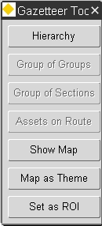
Gazetteer Toolbar

Gazetteer Toolbar

The Group functions Toolbar allows access various modules, e.g. Groups of Elements - NM0110 or Groups of Groups - NM0115 or set the Default Region Of Interest. Once you have opened the relevant module you may add, edit or delete group information before returning to the Gazetteer and the form from in which it was called. Groups may also be displayed in Spatial Data Manager by Exor via the map buttons.

Each of the Toolbar Buttons represents a different form or function within Exor.

[Hierarchy] Show/Hide Hierarchy. This toggles the display of the hierarchy browser On and Off

[Groups of Groups] Calls 'Groups of Groups' - NM0115 and makes the selected group the current group within the Groups of Groups form .
Note that this option is not available for Network Extents.

[Groups of Sections] Calls 'Groups of Sections' – NM0110 and makes the selected group the current group within the Groups of Sections form.
Note that this option is not available for Network Extents.

[Assets on Route] Calls Assets on a Route-NM0560 and makes the selected Group the current Route within the form.
Note that this option is not available for Filtered Networks.

[Show Map] Call Locator and zooms to the selected Network.

[Set as ROI] Sets the currently selected Group or Network Extent to the Default Region of Interest

Setting the Default Region of Interest
The Gazetteer is used to set the default Region of Interest (ROI) for a User. Once set this ROI will be used as the default selection in modules such as Merge Query Results, PBI Results and the Asset Item module. The Default Region of Interest selected from the Gazetteer will remain active until the User resets the ROI or clears it completely from within the User Preferences module (refer to the General User Guide). The Default ROI may be cleared within a form by pressing the [Clear Region of Interest] button on the menu toolbar.

Note that this will only clear the ROI for the current session of the active form and the Default ROI will remain active for all other forms.

The default Region of Interest may be set by pressing either the [Select] button on the Gazetteer or the [Set as ROI] button on the Gazetteer Toolbar depending on how the Gazetteer is called. The options are as follows:

Called from the menu toolbar Press [Set as ROI] button on Toolbar
Called from User Preferences module Press [Select] button on Gaz
Called from within another module Press [Set as ROI] button on Toolbar

Note that a Default Region of Interest may not be set if a 'Filter' is applied within the Gazetteer, e.g. the 'Entire' checkbox is unselected or an Asset Filter is defined.

Create Network Extent – NM0120
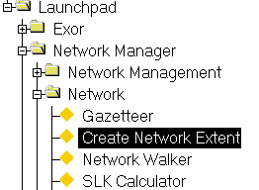
Figure 103
Create Network
Extent Menu

This module is used to create a set of Network Elements and or partial Network Elements to form an ‘area of interest’. This area of interest is known as a Network Extent.

Network Extents may contain sets of Network Elements from different Group Types or different Network Types depending on its intended use.

Network Extents may be created by selecting a set or partial set of Elements between Route Offsets, between Intersections, between Offsets within an individual Element or any combination of these. For example, if part of a Route was required to be included within a Network Extent, the Start point along the Route could be defined relative to the Route Offset and the End point could be defined as an Intersection on the selected Route. This may result in a combination of complete and partial Network Elements being included.

When creating a Network Extent the User may continually refine the selected Network Elements, by adding more Network parts, deleting Network parts from the Extent or amending the query criteria used to select existing Network parts, until the area of interest has been defined to the Users satisfaction.

Network Extents may also be created from the results of a Parameter Based Asset query that could in turn have used an existing Network Extent as the area of interest for the query, thereby creating a sub-extent. For example, a Parameter Based Inquiry could be created to select all the Asset Items of type PAOR – Pavement Original, which had a Formation Type of ‘Flat Bladed’. The PBI query could be run over a Network Extent containing the first 3.5 KM of a particular Route. The resulting Asset locations from the PBI query could then in turn be used to create a Network Extent, thus creating a sub-extent of the original.

Network Extents may be used widely throughout the Exor product set for viewing and querying data or for locating Asset on a Network.

A Network Extent may be ‘exclusive’ to the User that creating it, or may be made ‘Public’. If the ‘Owner’ of a Network Extent is made ‘Public’, then all Users will have access to the Extent.

By setting the ‘Effective Date’ field in the User Preferences form, it is possible to create a Network Extent for a Network as it was at any temporal stage..

Network Groups may also be created from Network Extents by pressing the [Create Group] button on the form. See page 124 for more information on creating a Group from a Network Extent.

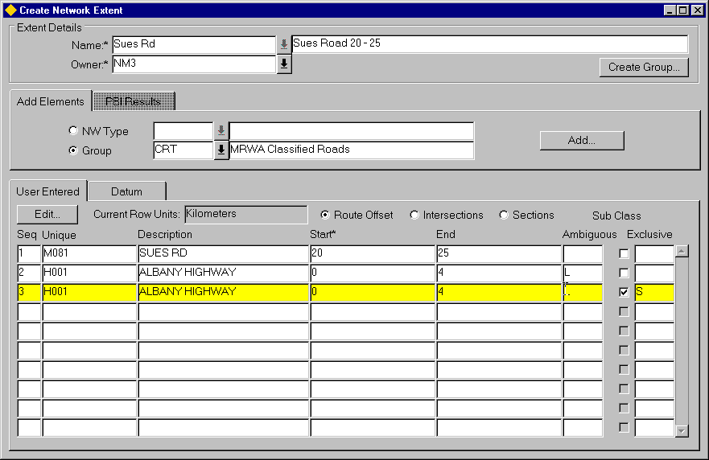
Figure 104
Network Extent

The form is comprised of 3 main panels. The Top panel is used to define the Extent Details, i.e. Network Extent name, description and Owner. The middle panel is used to select the required network data and the lower panel is used to display the selected Network Types, Groups and Datum Elements.

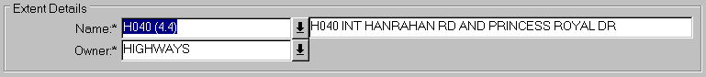
Figure 105
Extent Details

Extent Details
This panel is used to define the Network Extent Details. The fields need not be entered until the Extent has been defined and the User wishes to save the changes.

Name (Required)
Enter a unique name for the Network Extent. This name will be displayed in the ‘Saved Extents’ window of the Gazetteer. A maximum of 30 characters is allowed.

Enter a Description for the Network Extent in the adjacent field, a maximum of 60 characters is allowed.

Owner (Required)
Enter the Owner of the extent. If the Owner is defined as PUBLIC all Users will have access to the Network Extent.

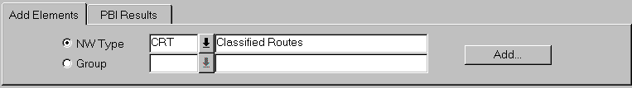
Figure 106
Add Elements
/ PBI Results

Add Elements / PBI Results
This panel is used to enter the selection parameters used to define the sets of Network Elements that make up the Network Extent.

NM Type / Group (Radio Buttons)
Network Elements may be selected by either their Network Type or by their Group Membership. Select the appropriate Radio button for the required selection method.

Enter the Network Type or Group Type from which to select the required set of Network Elements in the appropriate adjacent field. A list of values is available.

To select the Required Network Types or Groups press the [Add] button on the right hand side of the panel. This will call the Extended LOV window (Figure 107) that will display the members of the selected Group or Network Type.

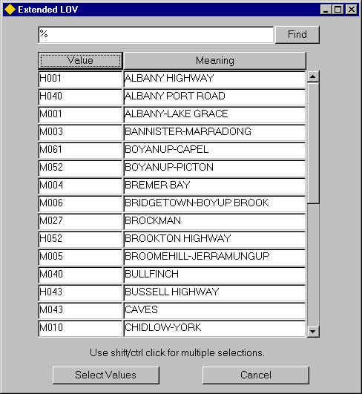
Figure 107
Extended LOV

The Display of the available Values may be ordered by the Group or Element Unique or by Its Description by pressing the [Value] button or the [Meaning] button respectively. This will also determine which field (Unique or Description) will be used when refining the search criteria to limit the available options displayed. For example, , if a Route Group were selected and the required Routes were named H0012, H0013 and H0014, pressing the [Value] button then entering H001% in the ‘Find’ field and pressing the [Find] button on the Extended LOV window, would restrict the available list to only those Routes beginning with H001.

To select an individual record, highlight the required data and press the [Select Values] button. Multiple records may be selected by using either the Shift or the Control Key.

To select several records that are displayed next to each other in a sequence i.e. contiguous:

- Click the first record to select it.
- Select the last record in the sequence by holding the Shift key on the keyboard and clicking the last record.

The selected records will be highlighted.

To select records not in contiguous order, select each record individually by holding down the Ctrl (Control) key and click on the record required. The selected records will be highlighted.

To exit the Extended LOV window without selecting any records press the [Cancel] button.

When the [Select Values] button is pressed after selecting the required Network Types or Groups, the Extent Limits window will be called, allowing the Start and End limits of the selected extent to be defined relative to a Route Offset an Intersection, between Offsets within an individual Element or any combination of these. The Extent Limits window will be displayed for each record selected from the Extended LOV window.

Note that the Extent Limits window is only called if the Selected Groups or Network Type is a linear set. When non-linear Groups are selected all of the member Datum Elements (these may contain partial Elements) are automatically added to the Network Extent in their entirety.

Figure 108
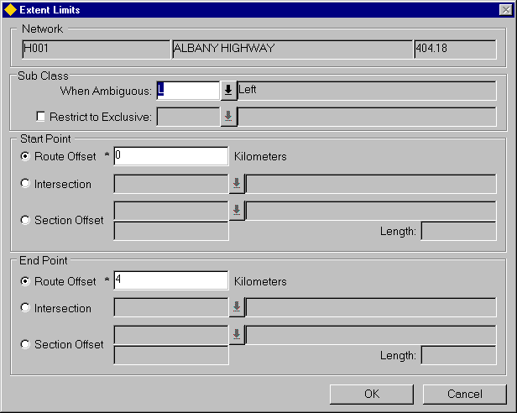
Extent Limits

Extent Limits
The Extent Limits window allows the Start and End points of a selected Route to be defined by Route Offset, Intersection or Section Offset. For example, to select a Route extent comprising of the first Kilometer of the Route, the Start Point would be defined as having a Route Offset of ‘0’ and the End Point defined as having a Route Offset of ‘1’.

The tables below show 3 scenarios for Extent Limits, to demonstrate the possibilities.

Scenario 1

Parameters | Start Point | End Point | Result
Route Offset | 1 | 3.5 | Elements or partial Elements contained between Route Offset 1 and 3.5 Kilometers
Intersection
Section Offset

Scenario 2

Parameters | Start Point | End Point | Result
Route Offset |  | 0.24 | Elements or partial Elements contained between the Intersection at Node 82730 and Route Offset 0.24
Intersection | 082730
Section Offset

Scenario 3

Parameters | Start Point | End Point | Result
Route Offset |  | 5.6 | Elements or partial Element contained between 35m along Element H004/1-S and Route Offset 5.6 Kilometers
Intersection
Section Offset | H004/1-S  35

Figure 109
Network Extent Subclass

Sub Class
The ‘Sub Class’ panel of the Extent Limits window allows the User to choose the Sub Class of the Elements, within the defined extent limits, to be included in the Network Extent. If neither the Sub Class ‘When Ambiguous’ or ‘Restrict to Exclusive’ field are populated, the Elements of all Sub-Classes within the defined extent limits will be entered into the Network Extent.
Restrict to Exclusive
Elements may be restricted to a single ‘Exclusive’ Sub Class by selecting the ‘Restrict to Exclusive’ check box and entering the required Sub-Class in the adjacent field. This will restrict the Elements selected to those which match the selected Sub Class.

Consider the example in Figure 110.

Figure 110
Extent limits

The Route displayed in Figure 110 contains a combination of Network Type Subclasses. A Network Extent is required within the extent limits shown, but only where the Network Type Sub Class is ‘L’ – Left.

By selecting the ‘Restrict to Exclusive’ checkbox and entering a value of ‘L’ – left in the adjacent field, the Network Extent will only include Elements (or parts of) with a Network Type Subclass of ‘L’ – Left. Therefore the Network Extent would include the following Elements

- 3-L
- 4-L
- 8-L
- 9-L

Ambiguous References
Any Ambiguous references within the selected extent limits may be automatically resolved by entering the required Network Type Sub-Class in the ‘Sub-Class When Ambiguous’ field.

Consider the example in Figure 111.

Figure 111
Extent limits

The Route displayed in Figure 111 contains a combination of Network Type Subclasses. A Network Extent is required within the extent limits shown, but only where the Network Type Sub Class is either ‘S’ – Single or ‘L’ – Left.

By entering a value of ‘L’ – left in the Sub Class ‘When Ambiguous’ field of the extent limits window, the Network Extent will include ALL Elements (or parts of) with a Network Type Subclass of ‘S’ – Single and those Elements (or parts of) with a Network Type Sub Class of ‘L’ –Left. Therefore the Network Extent would include the following Elements

- 1-S
- 2-S
- 3-L
- 4-L
- 5-S
- 8-L
- 9-L
- 12-S

When the Start and End parameters have been defined press the [OK] button on the Extent Limits window. The system will select the appropriate Network Datum Elements based on the query parameters entered. While this process is being undertaken, the message shown in Figure 112 will be displayed.

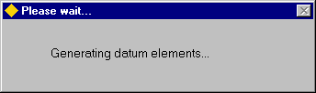
Figure 112

If more than one Route has been selected from the Extended LOV , the Extents Limit window will be displayed for each Route.

Route (Display Only)
The Unique Route reference description and Route Length will be displayed.

Sub Class When Ambiguous (Optional)
Enter the required Network Element Sub Class for Elements which should be selected if any ambiguity arises.

Sub Class -Restrict to Exclusive (Optional)
Enter the required Network Element Sub Class to which the selection should be restricted.

Start Point

Select one of the following Radio button to define the Start Point along the selected Route. The default selection is by Route Offset.

Route Offset (Default)
Enter the Route Offset for the Start Point. This should be entered in the unit of measurement defined for the selected Group or Network Type. The defined Unit will be displayed adjacent to the Route Offset measure. The Route Offset will be defaulted to ‘0’.

Intersection (List)
Enter the Node point of the Intersection for the Start Point. The list of values will display all the Intersection Node details for the selected Route.

Section Offset (List)
Enter the Unique Element reference for the Start Point. The Element description will be displayed in the adjacent field. The list of values will display all the Network Element within the selected Route.

Enter the Element Offset in the unit of measurement defined for the Datum Element in Network Types - NM0002. The measured length of the Element will be displayed in the adjacent field.

End Point

Select one of the following Radio button to define the Start Point along the selected Route. The default selection is by Route Offset

Route Offset (Default)
Enter the Route Offset for the End Point. This should be entered in the unit of measurement defined for the selected Group or Network Type. The defined Unit will be displayed adjacent to the Route Offset measure. The Route Offset of the End of the Route will be displayed as the default value.

Intersection (List)
Enter the Node point of the Intersection for the End Point. The list of values will display all the Intersection Node details for the selected Route.

Section Offset (List)
Enter the Unique Element reference for the End Point. The Element description will be displayed in the adjacent field. The list of values will display all the Network Element within the selected Route.
Enter the Element Offset in the unit of measurement defined for the Datum Element in Network Types - NM0002. The measured length of the Element will be displayed in the adjacent field.

Once the selected Datum Elements have been queried, the Extent Limits defined by the User and the resulting Datum Elements will be displayed in the bottom panel of the form.

Figure 113
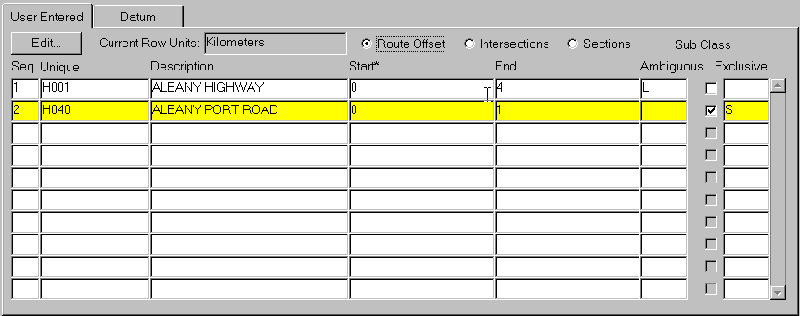

User Entered
This panel will display each of the selected Extent Limits in the ‘User Entered’ window and the resulting Datum Elements for each Extent Limit on the Datum window.

If an entire Extent Limit and the associated Datum Elements are no longer required it can be deleted from the Network Extent, by selecting the required Extent Limit in the ‘User Entered’ window and pressing the [Delete Record] button on the menu toolbar.

Further Extent Limits may be added to the Network Extent by repeating the process of selected either the ‘NW Type’ or ‘Group’ radio button, selected the required Network Type or Group, pressing the [Add] button on the ‘Add Elements’ panel and defining the Extent Limits. .

Existing Extent Limits can be amended by selecting the required record and pressing the [Edit] button on the ‘User Entered’ window. This will call the Extent Limits window and display the original selection parameter values. The resulting Datum Elements for the Extent Limit will be re-queried based on the amended selection parameter values.
Radio Buttons
3 Radio button are provided (one for each of the Extent Limits selection parameters) which may be used to display the respective selection parameter values used to define an extent limit.

Route Offset
For each Extent Limit which has a Linear measurement, e.g. an Extent Limit based on the whole or part of a Route Group, the Start and End Route Offsets of the extent will be displayed. These will be displayed in the Unit of measurement defined for the Network Type of the selected Group. The Units used for the currently selected extent limit will be displayed on the panel. If a Network Type Sub-Class has been defined to resolve any ambiguity or impose ‘exclusivity’ it will be displayed in the appropriate ‘Sub Class’ field on the right hand side of the panel.

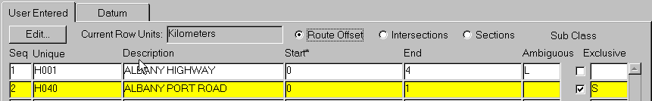
Figure 114
Current Row Units

The Route Offset measures may also be viewed in any of the other units of measurement defined for the current Unit in the 'Length' Domain in Units and Conversions - HIG1820 by pressing the [Units] button on the menu toolbar or by clicking the right mouse button and selecting the ‘Unit’ option from the context menu. This will call the Unit Converter window and display the selected measure values in the converted Units. Figure 115 shows the converted value in Meters for a Route Offset of 4.4 Kilometers.

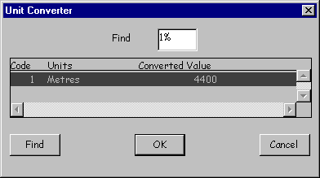
Figure 115
Unit Converter

Note that the ‘Unit’ option will only be available when either the Route Start or End fields are currently selected.

Intersections
Selecting the Intersections Radio button will display any Intersection Node point values used as a parameter for any of the extent limits in the Network Extent.

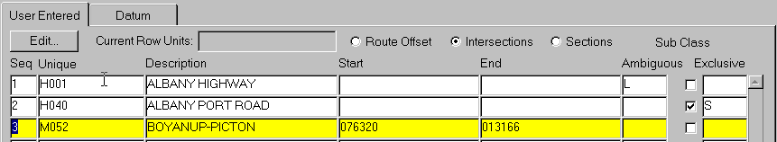
Figure 116
Intersections

Sections
Selecting this Radio button will display the extent limits selected, relative to the Network Element. The Unique Element reference will be displayed along with the Element Offset in the adjacent field.

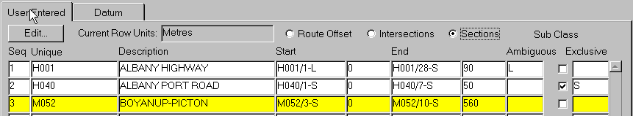
Figure 117
Sections

Other Field Definitions

Seq (Display Only)
The sequence number of the Extent Limit will be displayed. Extent Limits are sequenced in the order in which they were created. Each of the resulting Datum Elements selected within the Extent Limit will display this User Sequence number.

Unique (Display only)
The Unique reference of the selected Network Type or Group will be displayed.

Description (Display Only)
The description of the Network Type or Group will be displayed
Figure 118
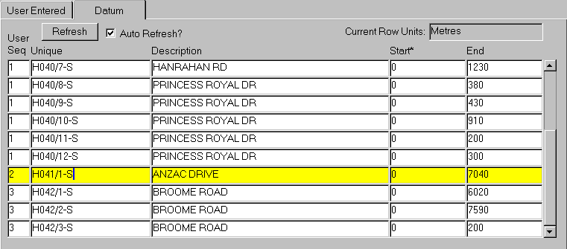
Datum

Datum
This window displays the Datum Network Elements selected from the Extent Limits defined by the User.

The User Sequence of the Extent Limit from which an Element was selected will be displayed in the ‘User Seq’ field.

If the ‘Auto Refresh?’ flag is checked, any new Datum Elements added to the Extent as a result of Adding further extent limits will be automatically displayed. If this flag in unchecked, pressing the [Refresh] button will cause the new Datum Elements to be displayed.

The Start and End Element Offsets included in the Extent Limit will be displayed in the Start and End field respectively. For example if the first 200 meters of an Element was included, the Start Offset would be ‘0’ and the End Offset would be ‘200’. The Unit of measurement used for the Datum Network Type is displayed, in the Current Row Units field at the top of the panel.

The Element Offset measures may also be viewed in any of the other units of measurement defined for the current Unit in the 'Length' Domain in Units and Conversions - HIG1820, by pressing the [Units] button on the menu toolbar or by clicking the right mouse button and selecting the ‘Unit’ option from the context menu. This will call the Unit Converter window and display the selected measure values in the converted Units. Figure 119 shows the converted value in Kilometers, Centimeters and Miles for an Element Offset of 430 meters.

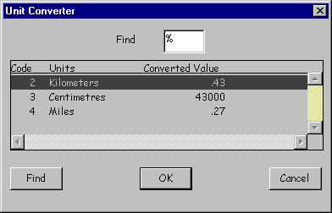
Figure 119
Unit Converter

Note that the ‘Unit’ option will only be available when either the Start or End fields are currently selected.

The User Sequence number is useful when querying Datum Element sets for a particular Extent Limit. For example, to view only the Datum Elements within the extent limit represented by ‘User Sequence’ 2 do the following:

- Press [Enter Query] on the menu toolbar.
- Enter a value of ‘2’ in the ‘User Seq’ field.
- Press [Execute Query] on the menu toolbar.

To re-query all of the Datum Elements press the [Refresh] button on the panel.

Figure 120
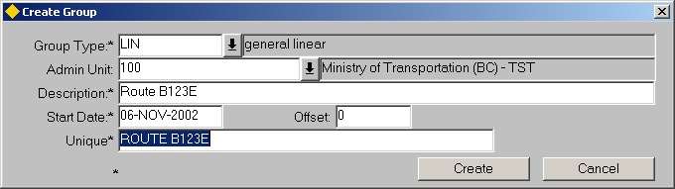
Create Group

Create Group
Network Extents may be used to create Network Groups. These Groups could then be used for querying data, reporting or used for creating further Network Extents.

When a Group is created from a Network Extent, normal Admin Unit based security applies to the Group. Therefore if the Network Extent had a ‘private’ Ownership, the Group created would be in the ‘Public Domain’.

When selecting the Group Type for the Group to be created, a check is carried out to ensure that if the Network Extent contains partial Network Elements, only those Group Types flagged as allowing partial Elements, in Group Types - NM0004 may be selected.

If the selected Group Type is a Linear Group Type the resulting Group will be rescaled and Route Offset measures calculated. The Start Offset of the Route may be entered in the 'Offset' field.

Note that if the Network Type associated with the selected Group Type has had flexible attributes defined in Network Types – NM0002, these will be displayed at the bottom of the window. If the Network Type has been flagged as automatically generating the unique reference, (by checking the ‘Pop Unique’ option in Network Types - NM0002) based on the attribution of a Group (set up using the Type Columns window of Network Types - NM0002), the ‘Unique’ field will be greyed out and the reference will be displayed once all of the appropriate Attribute values have been added. If this is not the case the Unique reference should be manually added.

Note that a Group of a Type where the associated Network Type has had a Node Type defined cannot be created from a Network Extent.

To create a Group based the selected Network Extent press the [Create Group] button.

Group Type (Required) (List)
Enter the Group Type for the Group. Group Type will have been previously defined in Group Types - NM0004. The Group Type description will be displayed in the adjacent field.

Network Type (Display Only)
The Network Type associated with the selected Group Type will be displayed.

Admin Unit (Required) (List)
Select the Admin Unit for the Group. The Admin Unit must be of the Admin Type associated with the Network Type selected. Admin Types are associated with Network Types in Network Types - NM0002.

Description (Required)
Enter a description for the Network Group.

Start Date (Required)
Enter the date from which the Group is valid.

Offset
If the selected Group Type is Linear the required Start Offset of the Group may be entered. The default value is zero.

Note that this field is only displayed if the selected Group Type is flagged as Linear in Group Types - NM0004.

Unique (Variable)
If required enter a Unique reference for the Group.

To exit the window without creating a new Group press the [Cancel] button.

To create the Group press the [Create] button on the ‘Create Group’ window. The Groups of Sections form will be automatically called and the new Network Group will be displayed.

Figure 121
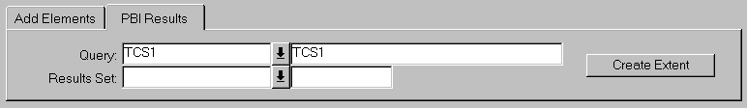
PBI Results

Creating a Network Extent from a PBI query

Network Extents may be created from the results of a PBI query using the PBI Results window. For example, a Parameter Based Inquiry could be created to select all the Asset Items of type PAOR – Pavement Original, which had a Formation Type of ‘Flat Bladed’. The PBI query could be run over a Network Extent containing the first 3.5 KM of a particular Route. The resulting Asset locations from the PBI query could then in turn be used to create a Network Extent, which could be used as the Area of Interest in a subsequent PBI query, thus creating a Sub Extent.

A Network Extent created from the results of a PBI query cannot be refined, i.e. no further Route Extents may be added or deleted.

When the PBI Query and the required Results Set are selected press the [Create Extent] button to create the new Network Extent. The Extent Name will be generated by the system and use the following convention:

PBI Query Name – PBI Job Id

For example, a Network Extent created from the sixth job of a PBI query called PAOR12 would have a name of PAOR – 6.

A description will also be generated. Both the Extent Name and Description may be amended to give the Network Extent a more meaningful identity.

The Network Extent Owner will default to the current User. This may be changed to give Public access to the Extent if required.

Query (Required) (List)
Enter the PBI Query that was used to create the required Results set. The PBI Query description will be displayed in the adjacent field.

Results Set (Required) (List)
Select the Results set of the Query from which to create the Network Extent.

Network Walker – NM0500
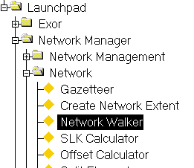
Figure 122
Network Walker
Menu Option

This module is used to view Intersection or Junction details at the Start and End Nodes of a Network Element and also allows a User to traverse a Network by ‘walking’ down a specified Intersection Leg. This is achieved by utilizing the connectivity of Network Elements at a Node Point.

The form comprises of 3 main panels. The top panel displays details of the currently selected Network Element. The middle panel displays a schematic representation of the Intersection details of the selected Elements and the lower panel displays the Intersection details for the selected Element. The Intersection details at the Start Node of the currently selected Network Element are displayed on the left hand Side of the form and the details for the End Node on the right hand side.
Figure 123
Compass
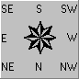
If the Intersection Leg Orientation is known for both the Start and End Nodes of the selected Network Element, the Element will be symbolized be a Red Line on the schematic diagram. If the Intersection Leg Orientation of the Start Node of the Element is Unknown then only the End Node Intersection details will be displayed on the schematic diagram. The same applies for an unknown Intersection Leg Orientation at the End Node of an Element.

A compass depicting the relative Intersection Leg Orientations will be displayed for both the Start and End Node Intersection details.

Figure 124
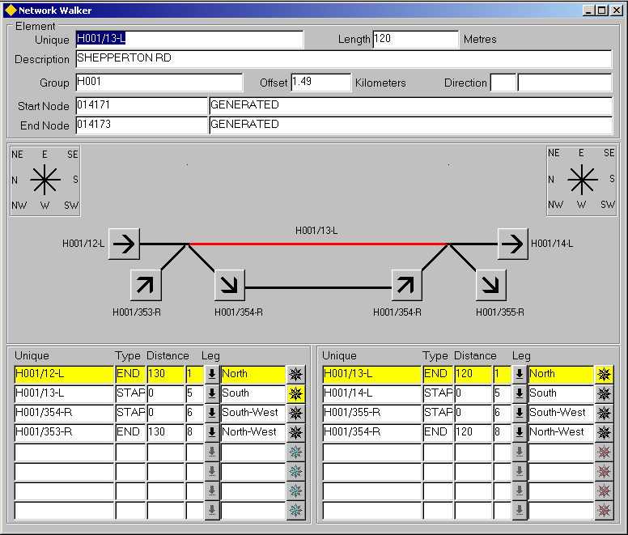
Network Walker

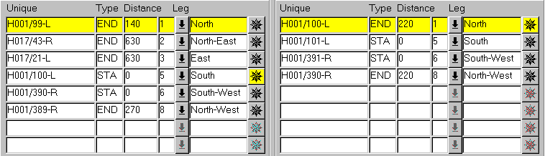
Figure 125
Intersection Details

Intersection Details Tables
These tables display the Intersection details for the selected Network Element. The Intersection details at its Start Node are displayed on the left hand Side and the details for its End Node on the right hand side.

Unique (Display Only)
The Unique reference of any Elements that are connected to the appropriate Node point will be displayed. If a route contains any distance breaks, these will also be displayed.

Type (Display Only)
The Node Type of the connected Element will be displayed. For example, if Element reference H001/99-L ‘ended’ at the Intersection, the Node Type displayed would be ‘END’.

Distance (Display Only)
The distance along the Element at which the Node is located will be displayed. If the Element is Conected to the Intersection at its Start Node, the Distance will be ‘0’. If connected at it’s End Node, the distance will equate to the length of the Network Element.

Leg (Required) (List)
The Intersection Leg number will be displayed. Each Leg number represents a compass point bearing which allows the Orientation to be derived. Leg numbers and their associated compass point bearings are defined using Domains – HIG9120 and Domain Name LEG_NUMBERS. The required number of compass bearing may be set up in this Domain. For example if 8 legs are defined, this allows fro 8 half quadrant compass points, i.e. North, North East, East, South East, South etc. The sequence number given to a Domain value is used for ordering the Leg Orientations.
The Leg Orientation description will be displayed in the adjacent field.
Compass Button
The Node Details for the currently selected Network Element are symbolized by a Yellow Compass Button adjacent to the Leg Orientation description for the Node. Compass buttons may also be used to select the Intersection Leg on which to ‘walk’. For more information on Network Walking refer to page 131.
Walking a Network
The Network Walker form may be called from within another Exor form, such as Elements - NM0105 via the Network Element Function toolbar or may be called directly from one of the Exor menus.

If the form is called from within the Network Elements form for example, the currently selected Network Element will be displayed in the top panel of the Network Walker form and its Intersection details displayed.

Starting the Network Walker form independently from one of the Exor menus enables the User to query the required Elements or Route using the standard query techniques, or select a Network Group or Network Extent via the Gazetteer.

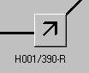
By setting the ‘Effective Date’ field in the User Preferences form, it is possible to ‘Walk’ a Network as it was at any temporal time..
110
Figure 36
Leg Orientation button

When a query is executed, either through a standard query or via the gazetteer, the resultant Element set is held in a ‘buffer’. The details of the ‘first’ Element of the query set will be displayed in the top panel and the Intersection details for its Start and End Nodes will be displayed. To view the next Element, and it associated Intersection details, from the query set press the [Next] button on the menu toolbar, or scroll using the vertical Scrollbar to the right hand side of the top panel. The next Element will be displayed in the top panel and the Intersection details displayed relative to it. This process may be repeated as required.

Any Elements ‘connected’ to an Intersection may be selected and traversed, by either clicking on the required ‘Leg Orientation’ button (Error: Reference source not found) on the schematic diagram or by pressing the Compass button (Figure 126) adjacent to the required Intersecting Leg on the Details table in the bottom panel.
Figure 126
Compass button

Note that when the mouse pointer is ‘hovered’ over a Leg Orientation button on the Schematic ‘Walker’, the Unique Element reference and Leg Orientation will be displayed (Figure 127).

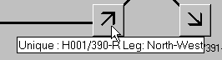
Figure 127
Hint text

When an Element is selected for traversal, the Network Walker form will be ‘re-called’ and the selected ‘traversed’ Element will be displayed in the top panel and its Intersection details displayed in the schematic Network walker in the Intersection Details table. The ‘original’ Element will remain selected in the ‘Buffer set’ and may be returned to by selecting the appropriate Network Walker window. When the traversal is complete and the form is closed, the User will be returned to the current Element in the original query set buffer.
SLK Calculator – NM1200
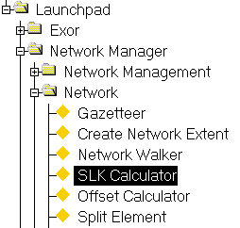
Figure 128
SLK Calculator
Menu

This module allows the Calculation of the SLK (Straight Line Kilometre) of a known point, relative to the Datum Element or Route/Group on which the point exists.

By entering the Route and Offset relative to the Route of a point and pressing the [<-Section] button, the position can be displayed relative to the Datum Element at which the point is located. The same applies if the Element and Offset are entered.

If the Route Offset specified is ambiguous, e.g. the Offset exists both on a Left and Right Carriageway of a Dual Highway a dialogue will be displayed from which the User must select the required Element.

To calculate an Offset measure relative to a Route or an Element press the ‘Drop Down List’ icon adjacent to the appropriate option (either Element or Route) and select the required Route / Element. Once the Route Offset or Element Offset required have been entered, press the [Route - >] or [< - Section] button to calculate the SLK measure.

To calculate the Offset of another point on the same Element or Route simply edit the Route or Element as required and press the [Enter] key to recalculate.

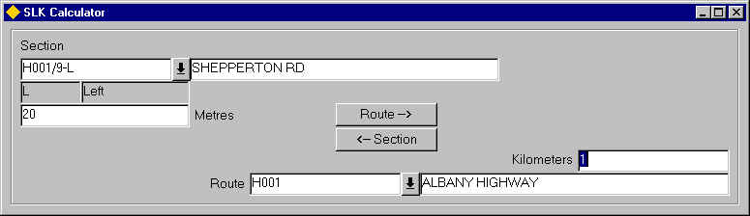
Figure 129
SLK Calculator

Offset Calculator - NM1201
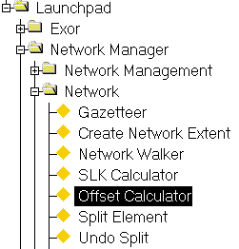
Figure 130
Offset Calculator
Menu Option

The Offset Calculator allows the calculation of Linear Offsets of a known point along a Route or Datum Element relative to all LRM's or Elements which exist at the specified point. For example, entering a Datum Element and Offset will result in all the LRM's and relative Offsets being displayed of which the Datum Element and Offset combination is a member.

If a Route and Offset are specified the results would include the Datum Element and Offset at the specified Route Offset as well as any other LRM's and Offsets which exist at the specified point.

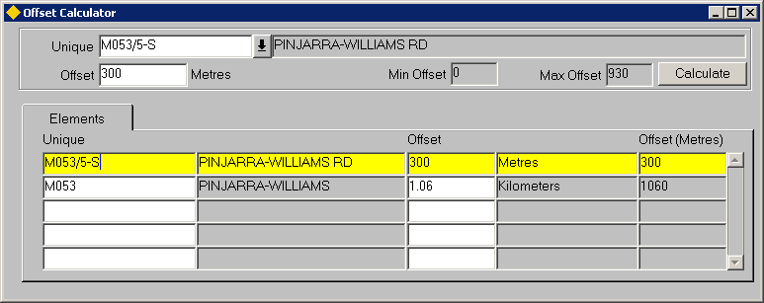
Figure 131

Unique (Required) List, Gaz
Enter the required Element or Route Unique reference.
The Element / Route description will be displayed in the adjacent field.

Offset (Required)
Enter the required Offset relative to the selected Route or Element. The Units of measurement displayed will be determined by the Units associated with the Network Type of the selected Element/Route.

The Minimum and Maximum Offsets allowable will be displayed adjacent to this field.

To display the Relative Offsets press the [Calculate] button on the form. The Relative Offsets will be displayed in the 'Elements' panel. The following information is displayed:

- Route/Element Unique
- Route/Element Description
- Relative Offset
- Unit of Measurement relative to the Network Type of the Element/Route
- Relative Offset in the User Preferred Unit of Measurement

If the User Preferred Unit of Measurement is changed using User Preferences (see General User Guide) the calculation must be refreshed to display the 'new' values.

Split Element – NM0200
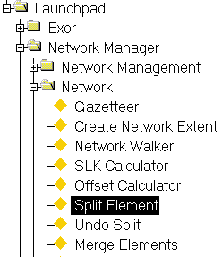
Figure 132
Split Element
Menu Option

Network Elements may need ‘Split’ in order to carry out some Network Maintenance operations. For example, when a new Route is added to a Network, which does not start at an existing Intersection. To ensure Network connectivity is maintained an Element may need to be split to create a new Node Point at which the new Intersection will be formed.

Network Splits may be carried out on either Datum Elements or Linear Groups such as Maintenance Sections. If a Linear Group is Split any affected underlying Datum Elements will also be split therefore maintaining both the Group Type network and the underlying Base Network.

Linear Groups may be split at an Offset value along the Group or at an ‘intermediate’ Node along the Group. ‘Intermediate’ Nodes are the Nodes used by the Groups member Datum Elements.

The following validation is carried out to ensure that the Split operation can be conducted:

- The User must have Role and Admin Unit based Access to all Asset data on the affected Network or be flagged as an ‘Unrestricted’ User in the HIG1832 – Users Module
- The Network to be Split is either a Datum Element or a Linear Group
- When splitting a Group the Group Type cannot be a ‘parent’ in a Network Type Inclusion (Autoinclusion parent)
- When splitting a Group that the Start and End Offset values of the Group are not ambiguous
- When splitting a Group the member Datum Elements must have their Unique name (ne_unique) derived from a Database Sequence, i.e. the pop_unique flag must be selected and the appropriate attribute must get its value from a sequence. This is defined within the NM0002 – Network Types Module
- When splitting a Group the Node Types of the Group and member Datum Elements are the same
- When splitting at an existing Node along the Group the selected Node is not the start and end Node of the Group
- The start/end date of an Elements membership of a Group or Group of Groups has not changed since the selected start date of the Split Operation
- Any Asset Items have not been placed on the Element to be Split since the date selected as the Split Date.

All violations of the above validation check will be reported on the screen. A failure of any validation check will result in the prevention of the process taking place.

When an Element is Split the resulting Elements may ‘inherit’ their Network Attributes if the ‘Inherit’ field has been selected for the Attribute in the Type Columns window of the Asset Metamodel – NM0410 module for the Datum Network Type being Split. The values for any Network Attributes not flagged as ‘Inheritable’ can be entered for each of the 2 new Elements, created as a result of the Split operation, in the appropriate ‘New Element x’ panel at the bottom of the form.

Note that this panel will not be shown if all the displayable Network Attributes of the selected Network Type are flagged as ‘inheritable’.

If the Datum Element or Group being Split has any additional attribute data defined as the ‘Primary Additional Data’ Type in NM0700 – Maintain Additional Data, the attributes may be updated within the appropriate Forms module, namely NM0105 – Elements for Datum Elements and NM0110 – Group of Sections for Groups.

The new Elements will retain the Group memberships of the original Element. If any Datum Elements are split the sequence within any linear Groups of which the ‘Split’ Element was a member and the SLK of the new Elements along with Intersection Leg numbers will be derived from the Original Split Element.

Asset Items located on any Split Datum Element will be ‘re-located’ and referenced relative to the new Datum Elements created as a result of the split operation.

Figure 133 shows an example of the Locations of a continuous Asset Item on a Datum Element (M037/165-S) before a Split operation and the resulting Locations after the Split.

Figure 133
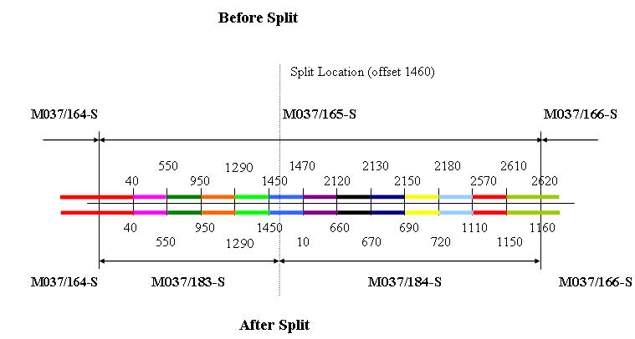
Note that the

Network and all associated Asset Items may be displayed as they existed prior to the Split operation by setting the ‘Effective’ date, in the User Preferences window, to a date which preceeds the Split operation.

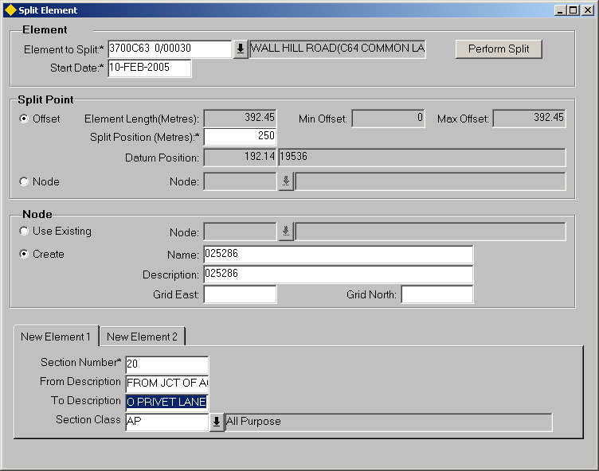
Figure 134
Split Element

Split Element
When you enter this module the cursor sits in the ‘Element to Split’ field waiting for the required Network Element reference to be added. The required Element may be selected from the Gazetteer, called by pressing the ‘Drop Down List’ icon adjacent to the field or if known manually entered.

Element to Split (Required) List
Enter the Unique reference of the Element to be Split.
The Element Description will be displayed in the adjacent field.

Start Date (Required)
Enter the date at which the Split operation is to be effective.
This will become the Start Date for the 2 new Elements created as a result of the Split and the membership date for new group members of which any new Elements created are a member.

Note that the date may be selected from the calendar by right clicking the mouse and selected the appropriate option from the context menu.

Split Point Panel

When Splitting a Linear Group 2 methods are available, namely Split and Offset and Split at Node. The Offset and Node radio buttons determine which method is used.

Offset Method

The Offset method of Splitting allows the User to select the Offset on the Datum Element or Linear Group at which to Split. If Splitting a Linear Group the underlying Base Datum Element at the selected Offset will also be Split as shown in Figure 135.

Figure 135
Section 2700A123 1/01
Linear Group
Base Datum
80156
80157
80158
Split Point
Before Split
Section 2700A123 1/02
Linear Group
Base Datum
80156
80159
80158
After Split
Section 2700A123 1/03
80160

The example in Figure 135 shows a Linear Group, e.g. a Maintenance Section, being Split and the resulting Network configuration. Splitting Section 2700A123 1/01 at an Offset along the Group will cause the Section to be end dated and 2 new Sections to be created. Splitting the Group at an Offset will also mean that the underlying Base Datum Network will be Split at the corresponding location. In the example Datum Element 80157 has been Split with Elements 80159 and 80160 being created as a result of the Network Operation.

Element Length (Display Only)
The selected Element Length will be displayed in the unit of measurement defined for the Network Type in NM0002 – Network Types.

Min and Max Offsets (Displayed Only if Splitting a Linear Group)
If the selected Element is a Linear Group the Minimum and Maximum Offsets of the Group will be displayed. The specified Split Position (if using Split at Offset) must be within the range of the min and max offset values.

Split Position (Only required if Splitting at Offset)
Enter the position at which the Element is to be Split.

Datum Position (Display Only)
If Splitting a Linear Group the corresponding Datum Offset and Unique Datum Name will be displayed. This will remain blank when Splitting a Datum Element.

Node Method

The Node method of Splitting allows a Linear Group to be Split at an existing ‘Intermediate’ Node. ‘Intermediate’ Nodes are the Nodes used by the Groups member Datum Elements. Splitting a Group using the Node method has no impact on the Underlying Base Datum Network other than the reassignment of relevant Group members.

shows an example where a Section (2700A123 1/01) is being Split at Node 3. This will Split the Section but the underlying base Datums will not be Split. This Method is only available when Splitting Linear Groups.

Node
Select the appropriate Node at which to Split.

Figure 136
Section 2700A123 1/01
Linear Group
Base Datum
80156
80157
80158
Before Split
Node 1
Node 2
Node 3
Node 4
Split Section at Node 3

After Split

Section 2700A123 1/02
Section 2700A123 1/03

Linear Group

Base Datum
80156
80157
80158
Node 1
Node 2
Node 3
Node 4

Node Panel

When the Split operation is carried out the newly created Elements will share a common Node Point. The Split operation can create a new Node Point or the User may wish to select an existing Node at which to Split.

To use an existing Node select the ‘Use Existing’ radio button. A list of available Nodes may be displayed by pressing the ‘Drop Down List’ icon adjacent to the Node field.

If the list of values is called a Nodes window will be displayed as in Figure 137.

Figure 137
Nodes

This list will display the Nodes of the Node Type associated with the Network Type selected in the ‘Type’ field.

The available Nodes may be ordered by the Node Name or by the Node Description by pressing the [Value] button or the [Meaning] button respectively.

This will also determine which field (Node Name or Description) will be used when refining the search criteria to limit the Nodes displayed. For example, to search for all Node points of the Selected Node type that begin with ‘01’, press the [Value] button then enter 01% in the ‘Find’ field and press the [Find] button on the Nodes window.

Click on the required Node Point to select, and press the [Select Values] button on the Nodes form. To close the window without selecting a Node press the [Cancel] button.

To create a new Node Point at which to Split the Element select the ‘Create’ radio button. A new Node Number and Description will be automatically generated and displayed in the appropriate fields. The Node number will adhere to the Node Format defined for the Node Type in the Node Types – NM0001 module (refer to Network Manager System Administration manual for more details). The description may be edited as required.

Enter the Grid References of the Node Point if required.

Enter the values for any ‘Non Inheritable’ Network Attributes as required.

To conduct the Split operation press the [Perform Split] button on the form. The appropriate Network module will be called and the 2 newly created Elements displayed. To save the new Elements and complete the Split Operation press the [Save] button on the menu toolbar.

Note that the Split operation will be cancelled if the called Forms module is closed without first saving the new Elements.

Any linear Groups of which the Split Element was a member may need to be ‘Resequenced’.
Undo Split – NM0203
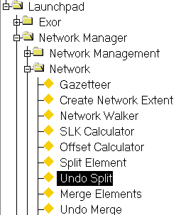
Figure 138
Undo Split
Menu Option

This module is used to reverse a previous Split Operation carried out on a Network Element. This should only be used as an ‘Error Correction’ tool, i.e. to restore the Network to it’s original state if an element has been erroneously Split.

When a Undo Split operation is carried out, no history is kept of the 2 New Elements created from the erroneous Split operation. All ‘event’ or ‘object’ locations (e.g. an Asset Item or Accident Item) and Group memberships for the originally Split Network Element will be reinstated.

The following validation will be carried out when an Unsplit Operation is carried out.

- The start/end date of either of Elements membership of a Group has not changed since the selected date.
- Any Items have not been placed on the Element to be Split since the date selected as the Split Date.

All violations of the above validation check will be reported on the screen. A failure of any validation check will result in the prevention of the process taking place.

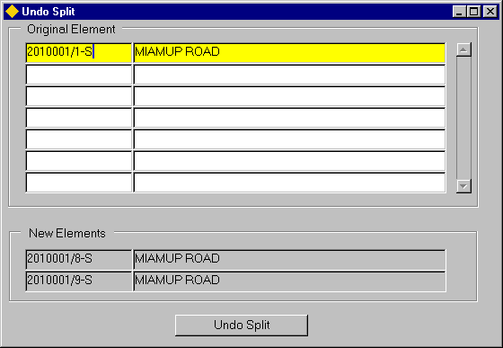
Figure 139
Undo Split

Undo Split
When you enter this module the cursor sits in the ‘Original Element’ field. To query back the required Network Element press the [Enter Query] button on the menu toolbar, enter the Unique Network Element reference then press the [Execute Query] button on the menu toolbar. The Element description will be displayed in the adjacent field.

The Unique Reference and description of the 2 new Elements created as a result of the Split operation will be displayed in the ‘New Element’ panel at the bottom of the form. To reverse the previous Split operation press the [Undo Merge] button on the form.

The appropriate Network module will be called and the original Element displayed. To save the Undo Split operations press the [Save] button on the menu toolbar.

Note that the Undo Split Operation will be cancelled if the Elements – NM0105 module is closed without first saving the new Elements.

Any linear Groups of which the Split Element was a member may need to be ‘Resequenced’.

Merge Elements – NM0201
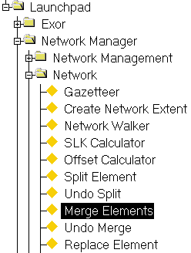
Figure 140
Merge Elements
Menu Option

This module allows 2 connected Network Elements (Base Datum or Linear Groups) that share a common Node Point to be ‘merged’ to form a new single Element.

When 2 Elements are merged the resulting Element may ‘inherit’ the Network Attributes of the ‘first’ Network Element if the ‘Inherit’ field has been selected for the Attribute in the Type Columns window of the Asset Metamodel – NM0410 module Network Type being Merged. The values for any Network Attributes not flagged as ‘Inheritable’ can be entered for the new Element, created as a result of the Merge operation, in the ‘New Element’ panel at the bottom of the form.

If the ‘Pop Unique’ flag is Unchecked for the Network Type of the selected Datum Network Element, a field will also be displayed to allow the User to enter the Unique reference of the new Element.

Note that this panel will not be shown if all the displayable Network Attributes of the selected Network Type are flagged as ‘inheritable’and the ‘Pop Unique’ flag is checked for the Network Type of the selected Element.

The new Element will retain the Group memberships of the ‘First’ original Element. The sequence within any linear Groups of which the ‘Merged’ Elements were members and the SLK/Offset of the new Element along with Intersection Leg numbers will be derived from the Original Merged Elements.

Asset Items located on the Merged Elements will be ‘re-located’ and referenced relative to the new Element.

The following validation will be carried out when Elements are merged:

- The start/end date of an Elements membership of a Group has not changed since the selected date.
- Any Items have not been placed on the Elements to be merged since the date selected as the Merge Date
- The are no Defects on an ‘open’ Works Order located on the affected Elements
- The User must have Role and Admin Unit based access to all Asset Items located on the affected Element, or by flagged as an ‘Unrestricted’ User in the HIG1832 – Users module.
- The Network Types and Group Types (when Merging Linear Groups) must be the same
- The Admin Unit of both Elements must be the same
- Where used, the sub-class of the 2 Elements must be the same
- Groups which are a parent in a Network Type Inclusion (Autoinclsuion) cannot be merged

All violations of the above validation check will be reported on the screen. A failure of any validation check will result in the prevention of the process taking place.

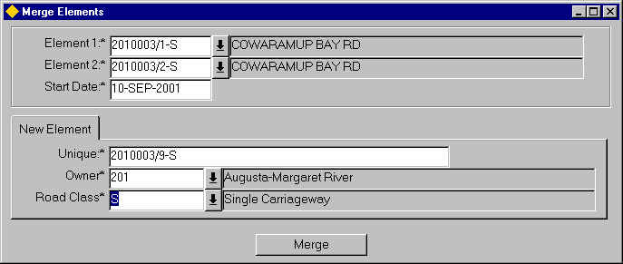
Figure 141
Merge Elements

Merge Elements
When you enter this module the cursor sits in the ‘Element 1’ field waiting for the first Unique Element reference to be entered.

Note that Elements must share a common Node in order to be Merged.

Element 1 (Required) List,Gaz
Enter the Unique Element reference of the first Element to be Merged.

Note that if any of the ‘displayable’ Network Attributes of the selected Element Network Type are ‘non inheritable’ or the ‘Pop Unique’ flag in Unchecked in the Network Types module, the Attributes and/or Unique Reference will be displayed in a panel at the bottom of the form, where the appropriate value(s) may be entered.

Element 2 (Required) List,Gaz
Enter the Unique Element reference of the second Element to be Merged.

Start Date (Required)
Enter the date at which the Merge operation is to be effective.
This will become the Start Date for the new Element created as a result of the Merge and the membership date for all Groups of which the new Element is a member.

Note that the date may be selected from the calendar by right clicking the mouse and selected the appropriate option from the context menu.

To conduct the Merge operation press the [Merge] button on the form. The relevant Network Management module will be called and the newly created Element displayed. To save the new Element and complete the Merge Operation press the [Save] button on the menu toolbar.

Note that the Merge operation will be cancelled if the Forms module is closed without first saving the new Element.

Any linear Groups of which the Merged Elements were a member may need to be ‘Resequenced’.

Undo Merge – NM0204
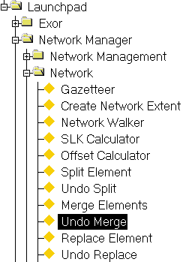
Figure 142
Undo Merge
Menu Option

This module is used to reverse a previous Merge Operation carried out on 2 Network Elements. This should only be used as an ‘Error Correction’ tool, i.e. to restore the Network to it’s original state if Elements have been erroneously Merged.

When an Undo Merge operation is carried out, no history is kept of the new Element created from the erroneous Merge operation. All ‘event’ or ‘object’ locations (e.g. an Asset Item or Accident Item) and Group memberships for the originally Merged Network Elements will be reinstated.

The following validation will be carried out when an Undo Merge Operation is carried out.

- The start/end date of the Elements membership of a Group has not changed since the selected date.
- Any Items have not been placed on the Element since the date selected as the Undo Merge Date.

All violations of the above validation check will be reported on the screen. A failure of any validation check will result in the prevention of the process taking place.

Figure 143
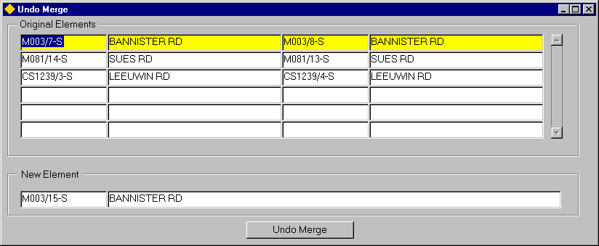
Undo Merge

Undo Merge
When you enter this form the cursor sits in the ‘Original’ Element field. To query back the required Network Elements press the [Enter Query] button on the menu toolbar, enter the Unique Network Element reference then press the [Execute Query] button on the menu toolbar. The 2 Merged Elements details will be displayed.

The Unique Reference and description of the new Element created as a result of the Merge operation will be displayed in the ‘New Element’ panel at the bottom of the form. To reverse the previous Merge operation, press the [Undo Merge] button on the form.

The Network Elements – NM0105 module will be called and the original Elements displayed. To save the Undo Merge operation press the [Save] button on the menu toolbar.

Note that the Undo Merge Operation will be cancelled if the Elements – NM0105 module is closed without first saving the new Elements.

Any linear Groups of which the Merged Elements were a member may need to be ‘Resequenced’.

Replace Element – NM0202
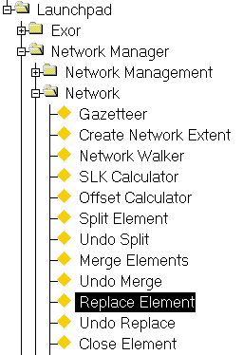
Figure 144
Replace Element
Menu Option

This module allows a Datum Network Element to be ‘replaced’ by a new Element. When a Replace Operation is carried out all Asset and other ‘events’ associated with the Element are transferred to the new Element created as a result of the Replace operation. The new Element will follow the adopt the same naming convention as the selected Element (or if the ‘Pop Unique’ flag is unchecked for the Network Type of the selected Element, the Unique Reference may be manually entered). The new Element will ‘inherit’ any Network Attributes and Group memberships of the ‘Replaced’ Element.

The Replaced Element is end – dated, thus ensuring a full historical record is kept of the Network.

Note that the Network and all associated Asset Items may be displayed as they existed prior to the Replace operation by setting the ‘Effective’ date, in the User Preferences window, to a date which preceeds the Replace operation.

This functionality could be used to re-digitise a badly digitised Element or used in conjunction with a Recalibrate operation to remodel a piece of Network after some minor re-alignment has taken place. This would be beneficial as the ‘Replaced’ Element would be retained for historical purpose. The Asset Items and other Events on the new Element could then be recalibrated using Recalibrate – NM2000 changing the Element length and event locations as required.

The following validation will be carried out when an Element is replaced:

- The start/end date of the Elements membership of a Group has not changed since the selected date.
- Any Items have not been placed on the Element to be Replaced since the date selected as the Replace Date.

All violations of the above validation check will be reported on the screen. A failure of any validation check will result in the prevention of the process taking place.

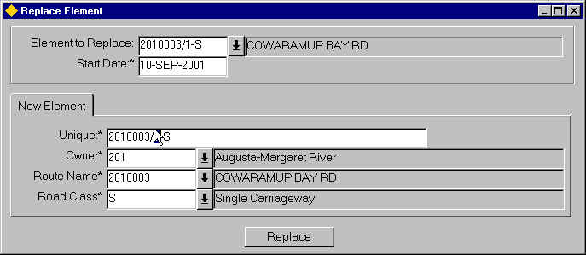
Figure 145
Replace Element

Replace Element
When you enter this module the cursor sits in the ‘Element to Replace’ field awaiting for the Unique Element reference to be entered.

Element to Replace (Required) List,Gaz
Enter the Unique Element reference of the Element to be Replaced.

Note that if any of the ‘displayable’ Network Attributes of the selected Element Network Type are ‘non inheritable’ or the ‘Pop Unique’ flag in Unchecked in the Network Types module, the Attributes and/or Unique Reference will be displayed in a panel at the bottom of the form, where the appropriate value(s) may be entered.

Start Date (Required)
Enter the date at which the Replace operation is to be effective.
This will become the Start Date for the new Element created as a result of the Replace and the membership date for all Groups of which the new Element is a member.

Note that the date may be selected from the calendar by right clicking the mouse and selected the appropriate option from the context menu.

To conduct the Merge operation press the [Replace] button on the form. The Network Elements – NM0105 module will be called and the newly created Element displayed. To save the new Element and complete the Replace Operation press the [Save] button on the menu toolbar.

Note that the Replace operation will be cancelled if the Elements – NM0105 module is closed without first saving the new Element.

Any linear Groups of which the Replaced Element was a member may need to be ‘Resequenced’.

Undo Replace – NM0205
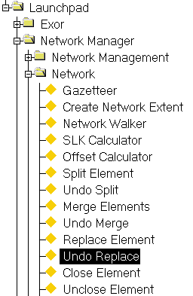
Figure 146
Undo Replace
Menu Option

This module is used to reverse a previous Replace Operation carried out on a Network Element. This should only be used as an ‘Error Correction’ tool, i.e. to restore the Network to it’s original state if an Element has been erroneously Replaced.

When an Undo Replace operation is carried out, no history is kept of the new Element created from the erroneous Replace operation. All ‘event’ or ‘object’ locations (e.g. an Asset Item or Accident Item) and Group memberships for the originally Replaced Network Element will be reinstated.

The following validation will be carried out when an Undo Replace Operation is carried out.

- The start/end date of the Elements membership of a Group has not changed since the selected date.
- Any Items have not been placed on the Element since the date selected as the Undo Replace Date.

All violations of the above validation check will be reported on the screen. A failure of any validation check will result in the prevention of the process taking place.

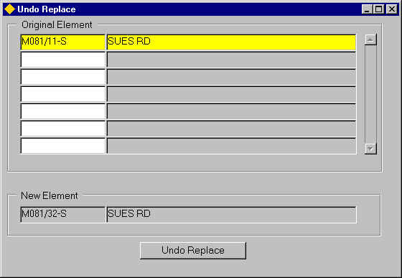
Figure 147
Undo Replace

Undo Replace
When you enter this form the cursor sits in the ‘Original’ Element field. To query back the required Network Elements press the [Enter Query] button on the menu toolbar, enter the Unique Network Element reference then press the [Execute Query] button on the menu toolbar. The new Element details, created as a result of the Replace Operation will be displayed in the bottom panel of the form.

To reverse the previous Replace operation press the [Undo Replace] button on the form.

The Network Elements – NM0105 module will be called and the original Element displayed. To save the Undo Replace operation press the [Save] button on the menu toolbar.

Note that the Undo Replace Operation will be cancelled if the Elements – NM0105 module is closed without first saving the Element.

Any linear Groups of which the Replaced Element was a member may need to be ‘Resequenced’.

Close Element – NM0206
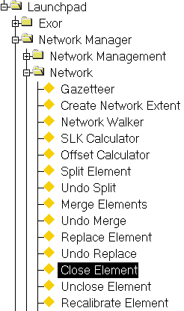
Figure 148
Close Element
Menu Option

The Close Element – NM0206 form is used to ‘Close’ Network Elements. When an Element is Closed, it is End Dated and is effectively removed from the system. To view the an End Dated Network Element set the ‘Effective Date’ field in the User Preferences Window to a date which precedes the Close Operation.

Asset Items on a Closed Network Element will either be ‘End Dated’ (if the ‘Replaceable’ flag is selected for the Asset Item Type in the Asset Types Module), or the Locational references will be End Dated and the Asset Item will remain open, but no longer ‘pinned’ to a Network (if the ‘End Location Only’ flag is set in the Asset Metamodel’ form).

Note that a Network Element cannot be ‘Closed’ (End-Dated) if any Asset Items which are either wholly or partially located on the Element are of an Asset Type which HAS NOT been flagged as ‘Replaceable’.

If an Asset Item is only partially located on the ‘Closed’ Network Element, only the Location reference relative to the Closed Element will be end dated and not the Asset Item itself.

Consider the example below.

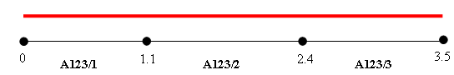

A continuous Asset Item has been located over the entire extent of Route A123, Elements 1,2 and 3. Its location relative to the Route would be as follows.

Unique Start End
A123/1 0 3.5

If Element A123/2 was subsequently Closed (note that this will cause a discontinuity along the Route which may be ‘bridged’ by using a Distance Break) the location relative to the Route would now as as follows.

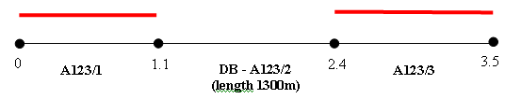

Unique Start End
A123/1 0 1.1
A123/1 2.4 3.5

The following validation checks will be carried out when a section is closed:

- The start/end date of a Elements membership of a group has not changed since the selected date.
- Asset has not been created or deleted since the selected date.

Note that only Users who have been flagged as ‘Unrestricted’ in HIG1832 – Users may carry out a Network Close operation. If an ‘restricted’ User attempts this operation the message displayed in Figure 149 will be displayed.

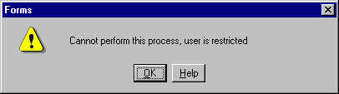
Figure 149

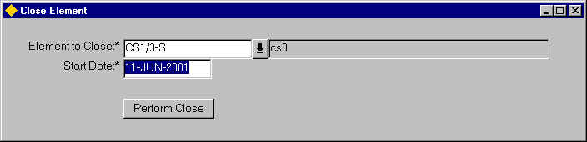
Figure 150
Close Element

Close Element
Element to Close (Required) List, Gaz
Enter the Element which is to be Closed.

Start Date (Required)
Enter the Date the Element is to be closed. Note that a Date may be selected from the Calendar by right clicking the mouse button and selecting the ‘Calendar’ option from the context menu.

To close the selected Element press the [Perform Close] button on the form.

A dialogue will be displayed as shown in Figure 151.

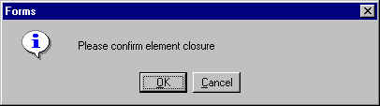
Figure 151
Confirm Closure

Press the [Cancel] button to cancel the Closure or [OK] to confirm that the Element Closure should be carried out. If the Closure is confirmed the Network Element – NM0105 form will be called and selected Element displayed.

Undo Close – NM0207
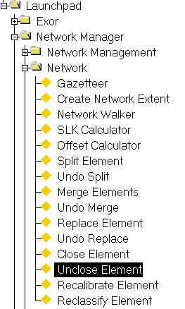
Figure 152
Unclose
Menu Option

The Unclose Element – NM0207 module is used to re-open or un-end date a previously ‘closed’ Network Element and should only be used for error correction, i.e. if a Network Element has been erroneously closed.

Elements that have been closed using split, merge or replace cannot be unclosed using this option.

When an Element is ‘Unclosed’ all Asset Items affected by the ‘Close’ operation will be reinstated.

Note that only Users who have been flagged as ‘Unrestricted’ in HIG1832 – Users may carry out a Network Close operation. If an ‘restricted’ User attempts this operation the message displayed in below will be displayed.

Figure 153

When you enter this form press the [Enter Query] button on the menu toolbar.

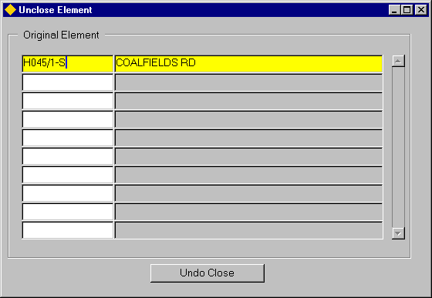
Figure 154
Undo Close

Unclose Element

Original Element (Required)
Enter the Unique Element Reference to be ‘Unclosed’.

To Undo the Close operation press the [Undo Close] button. The Elements - NM0105 module will be called and the selected Element details will be displayed. To Unclose the selected Element press the [Save] button on the menu toolbar.

Note that the Unclose Operation will be cancelled if the Elements – NM0105 module is closed without first saving the Element.

Recalibrate Element – NM2000
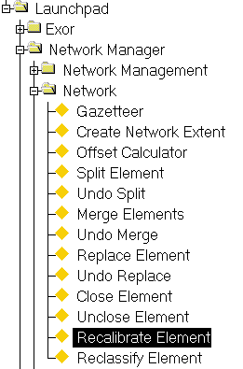
Figure 155
Recalibrate Element
Menu Option

If since the time of the initial survey, the length of the Element and hence the location of the Asset or other objects located within the extent of the Element is found to be incorrect you can recalibrate the Elements length. This will allow you to either increase or decrease the length of a Element. All the Assets and other objects (e.g. Accidents) will move in proportion to the change in length.

Note that no history is recorded of the Original Element Length or event locations subsequent to a Recalibrate operation.

If history is required a Replace Operation should first be carried out on the Element and the ‘new’ Element subsequently ‘Shifted’.

The following rules apply to Asset Items and other events located on an Element when a Shift / Recalibrate Operation is carried out:

- If Asset runs to the end of an Element a Shift or Recalibrate operation should maintain the Asset location at the end of the Element, i.e. not cause an ‘overhang’. The start of the Asset will be Shifted or Stretched according to the defined parameters.
- If the Asset is not located at either the start or end of the Element the Shift or Recalibrate will operation at both the start and end of the Asset Item.
- A Shift is not allowed if it would result in the start or end of an Asset Item would be located beyond the end of the Element.
- A Shift is not allowed if it would result in a continuous Asset Item having a Zero length.
- If an Item spanned the entire length of an Element a Shift or Recalibrate operation would maintain this relative location.

Recalibrate
Figure 156 to Figure 158 show an example of a 2 Recalibrate operations carried out on a Datum Network Element and its effect on events located on the Recalibrated Element.

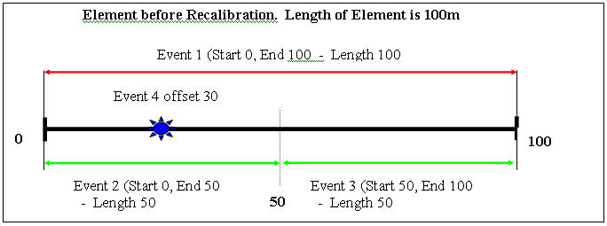
Figure 156

The first Recalibration Operation will shorten the Element Length by 10m to an overall Length of 90m.

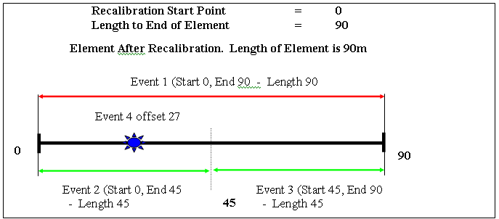
Figure 157

The second Recalibration Operation will stretch the Element Length by 5m to an overall Length of 95m, but only from an offset of 30m.

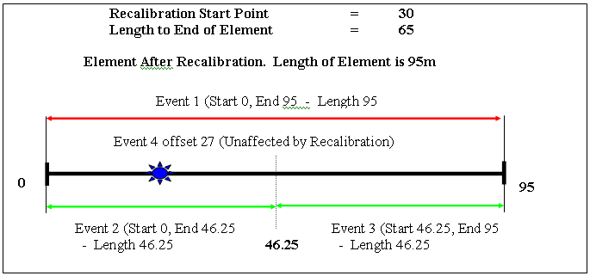
Figure 158

Figure 159
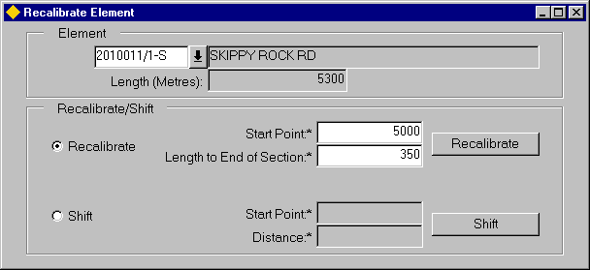
Recalibrate Element

When you enter this form the cursor sits in the ‘Element’ field awaiting the Unique Reference of the Datum Network Element to be Recalibrated to be entered.

Element (Required) List, Gaz
Enter the Unique Reference of the Element to be Recalibrated. To call the gazetteer press the adjacent ‘Drop Down Icon’.
The Element Description and length will be displayed in the relevant fields.

To specify a Recalibrate Operation select the ‘Recalibrate’ radio button.

Start Point (Required)
Specify the offset from which the Recalibrate Operation will be carried out.

Length to End of Element (Required)
Enter the length from the selected ‘Start Point’ to the end of the Element.

To conduct the Recalibration operation, press the [Recalibrate] button on the form. The Network Elements – NM0105 module will be called and the Element displayed. To save the Element and complete the Recalibrate Operation press the [Save] button on the menu toolbar.

Note that the Recalibrate operation will be cancelled if the Elements – NM0105 module is closed without first saving the Element.

Shift
A Shift Operation on a Network Element allows the locations of all events placed on the Element to be moved from a specified offset by entering an adjustment length. This adjustment length may be positive, e.g. 10 or negative e.g. –20. When a Shift Operation is carried out it DOES NOT change the Element Length and no history is kept of the event locations prior to the Shift. If history is required a Replace Operation should first be carried out on the Element and the ‘new’ Element subsequently ‘Shifted’.

Figure 160 to Figure 162 show an example of a 2 Shift operations carried out on a Datum Network Element and its effect on events located on the Element.

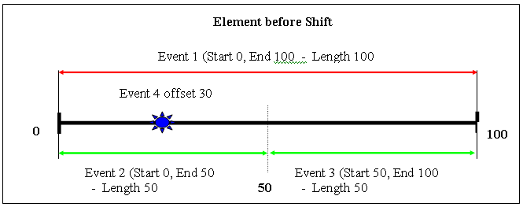
Figure 160

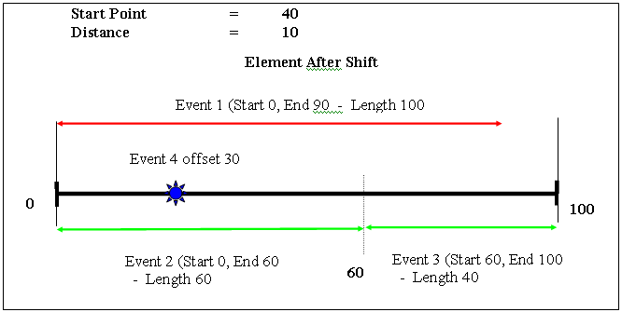
Figure 161

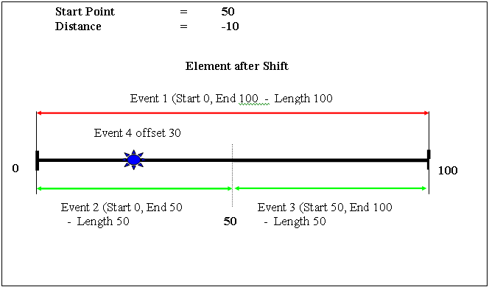
Figure 162

When you enter this form the cursor sits in the ‘Element’ field awaiting the Unique Reference of the Datum Network Element to be ‘Shifted’ to be entered.

Element (Required) List, Gaz
Enter the Unique Reference of the Element to be ‘Shifted’. To call the gazetteer press the adjacent ‘Drop Down Icon’.
The Element Description and length will be displayed in the relevant fields.

To specify a Shift Operation select the ‘Shift’ radio button.

Start Point (Required)
Specify the offset from which the Shift Operation will be carried out.

Distance (Required)
Enter the adjustment figure.

To conduct the Shift operation, press the [Shift] button on the form. The Network Elements – NM0105 module will be called and the Element displayed. To save the Element and complete the Shift Operation press the [Save] button on the menu toolbar.

Note that the Shift operation will be cancelled if the Elements – NM0105 module is closed without first saving the Element.

Reclassify Element – NM0220
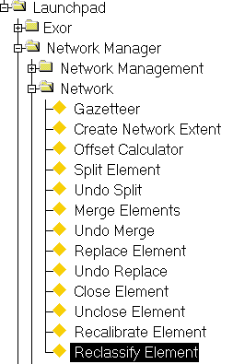
Figure 163
Reclassify
Menu Option

The Reclassify Element – NM0220 form is used to change the Network Type, Group Type and / or the Values of the Network Element Attributes that are used to form part of the Unique Element Reference, as defined in Network Types – NM0002.

If Datum Network Elements have been set up within a Network Type Inclusion, the Route to which an Element belongs may be changed by selecting the new ‘parent’ Route in the appropriate Attribute, i.e. Group.

The Reclassify – NM0220 form also allows the reclassification of Network Types. For example, all or part of a Classified Route may be reclassified as a Local Route. The affected Elements would therefore need to have their associated Network Type and Attribution amended to conform to the new Local Route.

An entire Route or Group may be renamed by selecting the required Route or Group and adding a new Route or Group Name in the Unique field.

A different Start or End Node may also be selected for a Network Element using the Reclassify – NM0220 form.

When an Element is Reclassified a new Element is created with a Unique Reference derived from the values added for the Network Type Attributes and all Group memberships of any Groups of which the Element was a member are amended accordingly. A full historical record is retained of the Element(s) / Route Reclassified and can be viewed by using the ‘Effective Date’ functionality.

Validation is carried out on Asset Items that are located or partially located on any Elements that are Reclassified. If an Item of Asset is wholly located within the extent of an Element that is being reclassified, the location of the Item will be updated to reflect the ‘new’ Element, providing that the Asset Type may be located on the Network Type associated with the ‘new’ Element. If this is not the case the Asset Item will be ‘End Dated’ if the Asset Type has been Flagged as ‘Replaceable’ in Asset Types – NM0410.

Figure 164 provides examples of several different scenarios relating to Asset Locations on Reclassified Elements.

Figure 164
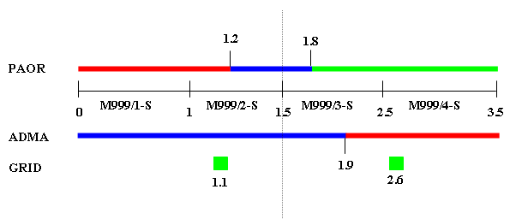

Figure 164 represents a Route (M999) comprising of 4 Network Elements. Asset Items of 3 different Types have been located on the Route. PAOR and ADMA are continuous whilst GRID is a point Item. The table below shows the Asset locations for the Route

Item | Route | Start | End
PAOR | M999 | 0 | 1.2
PAOR | M999 | 1.2 | 1.8
PAOR | M999 | 1.8 | 3.5
ADMA | M999 | 0 | 1.9
ADMA | M999 | 1.9 | 3.5
GRID | M999 | 1.1
GRID | M999 | 2.6

Part of the Route is to be Reclassified as a Local Route. The new local Route will encompass Elements M999/3-S and M999/4-S. These Elements must be Reclassified to change their Network Type and Attribution values. All Item Types have been defined as ‘Replaceable’ and the ADMA and GRID Item types have been defined as being allowed to be located on both Classified Routes and Local Routes. Asset Type PAOR is only allowed to be located on Classified Routes.

The Asset locations after the Reclassify operation has been conducted are as follows:

Item Item | Route | Start | End
PAOR | M999 | 0 | 1.2
ADMA | M999 | 0 | 1.5
 | L999 | 0 | 0.4
ADMA | M999 | 0.4 | 2
GRID | M999 | 1.1
GRID | L999 | 1.1

Note that only Users who have been flagged as ‘Unrestricted’ in HIG1832 – Users may carry out a Network Close operation. If an ‘restricted’ User attempts this operation the message displayed in will be displayed.

Figure 165

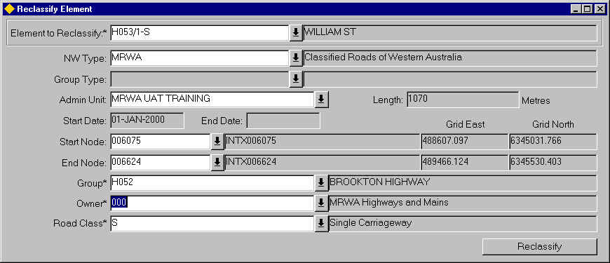
Figure 166
Reclassify Element

Change the Sub-Class of an Element

The Sub-Class of an Element may be changed using Reclassify – NM0220. Changing the Element Sub Class will not have any effect on the Group Memberships of the Element.

To Change the Sub-Class of an Element do the following:

- Navigate to the Reclassify-NM0220 form.
- Press the ‘Drop Down List’ icon adjacent to the ‘Element to Reclassify’ field.
This will call the Gazetteer from where the required Element may be selected.
- Once selected press the [Enter] button or Click in any field.
The Element Details will be displayed along with the flexible Network Element Attributes associated with the Network Type of the selected Element.
- To change the Network Type Subclass, press the ‘Drop Down List’ icon adjacent to the ‘Road Class’ field and select the Appropriate value.
- To Reclassify the Element press the [Reclassify] button.
This will call the Network Element-NM0105 form and display the new Element.
- To save the Element and complete the Reclassify operation press the [ Save] button on the menu toolbar.

Note that if the Elements-NM0105 form is closed without saving the changes, the Reclassify operation will be cancelled.

Change the Parent Route of an Element

The Parent Route to which an Element belongs may be changed using Reclassify – NM0220.

The New Route may be of the same Network Type or may be of a different classification, e.g. changing from a Classified Road to a Local Road.

To Change the Parent Route of an Element within the same Network Type, do the following:

- Navigate to the Reclassify-NM0220 form.
- Press the ‘Drop Down List’ icon adjacent to the ‘Element to Reclassify’ field.
This will call the Gazetteer from where the required Element may be selected.
- Once selected press the [Enter] button or Click in any field.
The Element Details will be displayed along with the flexible Network Element Attributes associated with the Network Type of the selected Element.
- To change the Parent Group, press the ‘Drop Down List’ icon adjacent to the ‘Group’ field and select the Appropriate value.
- To Reclassify the Element press the [Reclassify] button.
This will call the Network Element-NM0105 form and display the new Element.
- To save the Element and complete the Reclassify operation press the [ Save] button on the menu toolbar.

Note that if the Elements-NM0105 form is closed without saving the changes, the Reclassify operation will be cancelled.

To Change the Parent Route of an Element to a different Network Type, e.g. from a Classified Road to a Local Road, do the following:

- Navigate to the Reclassify-NM0220 form.
- Press the ‘Drop Down List’ icon adjacent to the ‘Element to Reclassify’ field.
This will call the Gazetteer from where the required Element may be selected.
- Once selected press the [Enter] button or Click in any field.
The Element Details will be displayed along with the flexible Network Element Attributes associated with the Network Type of the selected Element.
- Press the ‘Drop Down List’ icon adjacent to the ‘NW Type’ field and select the new Network Type for the Element.
The flexible Network Element Attributes associated with the selected Network Type will be displayed.
- Add the appropriate values for the Network Element Attributes as required.
- To Reclassify the Element press the [Reclassify] button.
This will call the Network Element-NM0105 form and display the new Element.
- To save the Element and complete the Reclassify operation press the [ Save] button on the menu toolbar.

Note that if the Elements-NM0105 form is closed without saving the changes, the Reclassify operation will be cancelled.

Rename an Entire Route (within the same Group Type)

A Base Network Route (i.e. a Group of a Type which has been specified as a Parent in a Network Type Inclusion) may be renamed using Reclassify – NM0220.

To Rename a Route within the same Group Type do the following:

- Navigate to the ‘Reclassify Element – NM0220’ form
- Press the ‘Drop Down List’ icon adjacent to the ‘Element To Reclassify’ field.
This will call the Gazetteer from where the required Route may be selected.
- Once selected press the [Enter] button or click in any of the available fields.
The Group Detail, e.g. Network Type, Admin Unit, Start Date will be displayed.

If the ‘Pop.Unique’ Flag is unchecked for the Network Type (in Network Types - NM002) associated with the selected Group, a field will be displayed at the bottom of the form, where the New Unique reference of the Group may be added.

- In the ‘New Unique’ field enter the new name for the Route.
- To Rename the Route, press the [Reclassify] button on the form.
This will call the Groups of Elements - NM0110 from where the newly renamed Route may be viewed.
- To save the reclassify operation press the [Save] button on the menu toolbar.

Note that if the Groups of Elements - NM0110 form is closed without saving the changes, the Reclassify operation will be cancelled.

Index

AD Types 15, 29, 51
Add Connected Section 40
Additional Data 10, 15, 20, 29, 51, 126
Advanced Gazetteer 68, 69
Ambig SC 77, 78
Ambiguous References 81, 108
Ambiguous Subclass 77
Cardinal direction 6, 17, 25, 98
Cardinal Direction 26, 98
Cardinality 23, 26
Close Element 67, 145, 147
Close Route 12, 22, 26, 34
Closing a Group of Groups 47, 52
create a saved extent 90
Create Network Extent 66, 71, 75, 102
Create Node 36
Creating a Network Extent from a PBI query 117
Default Region of Interest 100, 101
Distance Breaks 8, 24, 33, 34, 35, 41, 42
Elements - NM0105 10, 121, 149
Extend Route at End 19
Extend Route at Start 16, 18
Extended LOV 104, 105, 109
Extent Limits 77, 79, 80, 81, 105, 106, 107, 108, 110, 111, 112, 113
Extents 11, 70, 71, 75, 90, 100, 102, 103, 109, 115, 117
EXTRTEDATE 18, 19
Filter 72, 73, 74, 76, 79, 83, 84, 85, 86, 87, 88, 89, 90, 91, 93, 101
GAZ_RGT 69
Gazetteer 10, 11, 20, 21, 23, 44, 45, 46, 47, 66, 68, 69, 70, 71, 72, 74, 75, 76, 77, 78, 83, 84, 85, 86, 87, 88, 89, 90, 91, 92, 93, 94, 95, 99, 100, 101, 103, 121, 129, 158, 159, 160, 161
GAZMODE 68
Group Function Toolbar 100
Group Hierarchy 45, 46, 48, 52, 53, 55, 56, 94
Groups Attributes 28, 50
Groups of Groups 7, 14, 45, 48, 52, 73, 100
Groups of Groups – NM0150 7
Groups of Sections 7, 20, 21, 41, 45, 71, 92, 100, 116
Groups of Sections – NM0110 7, 20, 41
Linear Datum 5, 6
Linear Referencing) Methods 2
Local Rescale 32
location referencing 2
Merge Elements 66, 136, 137
Network Element Function toolbar 10, 16, 18, 19, 121
Network Element Membership 16, 98
Network Elements – NM0105 7, 140, 142, 144, 152, 154
Network Hierarchy Browser 95
Network Type Columns 10
Network Types - NM0002 8, 10, 11, 12, 13, 18, 19, 82, 109, 110, 115, 116
Network Walker 66, 118, 119, 121
Node Details 26, 27, 120
Nodes - NM0101 8, 12, 13, 28, 36
Nodes – NM0101 7
Offset Calculator 66, 123
Partial Groups 24, 44
POE 23, 25, 26, 27, 30, 35
Point Item Filter 83
Point of Equation 23, 25, 32
Primary Additional Data 14, 20, 28, 50, 126
Recalibrate Element 67, 150, 152
Recalibrate 151
Shift 153
Reclassify Element 67, 155, 158, 161
Replace Element 66, 141, 142
Rescale 26, 30, 31, 32, 43
Resequence 32, 38, 42, 43
Resize Route ii, 37, 38
Restrict to Exclusive 80, 82, 107, 109
Reverse Allowed 26
Route Check 35
Route Details 35, 99
Show/Hide Hierarchy 48, 71, 95, 100
SLK 16, 18, 19, 23, 24, 25, 26, 30, 31, 32, 35, 41, 42, 43, 66, 98, 122, 126, 136
Split Element 66, 125, 126, 129, 133, 135
Node Method 131
Offset Method 130
Sub Groups 46, 49, 52, 53, 56
Type Inclusions 10, 18, 19
Undo Close 67, 148, 149
Undo Merge 66, 135, 139, 140
Undo Replace 67, 143, 144
Undo Split 66, 134, 135
Unit Converter 111, 113, 114
User Preferences 12, 93, 101, 102, 121, 124, 128, 141, 145

